The Life Box


• Grade Level:
Lower Elementary, Upper Elementary
• Subject Areas:
Life Science
• Duration:
Preparation time: 30 minutes
Activity time: 50 minutes : Classroom
• Skills:
Analyzing (identifying relationships and components); Interpreting (deducing)
• Charting the Course
This is a foundation activity and can be used to introduce other activities on water and how water is needed for life. For example, in "Aqua Bodies" students learn that a large percentage of the human body is water. They are introduced to how the body uses water in "Aqua Notes."
• Vocabulary
Water-H2O hydrogen and oxygen, colorless, odorless; refers to liquid state but also has gaseous state (vapor or steam) and solid (ice); water covers 71% of earth’s surface
Soil-mineral and organic matter
Sunlight-Illuminates, warms, helps with photosynthesis
Air-gases of nitrogen, oxygen and carbon dioxide
Capillary Action- because of adhesion and cohesion, water can defy gravity by crawling up a paper towel
Transpiration-process where moisture is carried through plants from roots to small pores on underside of leaves where it changes to vapor and is released into the atmosphere; essentially evaporation of water from plant leaves
Organic Matter-matter form once living things, residue from dead plants and animals

Plants and animals have four things in common; can you guess what they are?
Objectives
Students will:
- identify four essential factors neces
sary for life.
- explain how living things use these
four factors.
Materials
- Potted plant | - Rock
- Cups of soil | - Bottles of water
- Life Boxes (Assemble several boxes,  each with 1 cup [240 ml] of soil and a  bottle of water inside. Label each box  "The Life Box." Place lids securely on boxes) | - 1 half-pint (240 ml) milk carton for each  student (Wash cartons and pull apart  the top flaps so the cartons completely  open up.) (optional)
- Soz7 (optional) | - Water (optional)
- Glue (optional) | - Scissors (optional)
- Drawing materials (optional)
Making Connections
Most students know that they require water and air to survive. Some may have learned that plants also require water, air, minerals found in soil, and sunlight. Through deduction, students learn that animals and plants depend upon four crucial factors, an awareness that heightens students' appreciation of these resources.

Background
Why all this fuss about water? Why worry? The answer is really quite simple: the availability of water is a matter of life and death. Throughout history people have engineered ways to secure quantities of water to meet their needs and to protect themselves from water-related natural events like floods and droughts. You cannot simply snap your fingers and get water. You cannot wish water out of the sky or locate it below the ground where it does not exist. Plants, wildlife, and human communities have formed around water.
Four factors are necessary for life to exist:
SOIL
Soil is the result of rock that has been broken down by physical and/or chemical processes called weathering. Soil contains organic matter from decomposed plants and animals. Soil provides plants with minerals and nutrients, and it helps transport water to plants' roots.
SUNLIGHT
Radiant energy from the sun illuminates and warms Earth's surface. Plants use the sun's energy to make sugar from carbon dioxide and water—a process called photosynthesis.
Sunlight and soil are used directly by plants and indirectly by animals. Plants get minerals from the soil. Animals get their nutrients and energy from plants (or from animals that eat plants).
AIR
Air is a mixture of numerous gases that make up Earth's atmosphere, including nitrogen, oxygen, hydrogen, carbon dioxide, argon, neon, helium, and others. During plant photosynthesis, carbon dioxide is used to build sugar. Oxygen helps many plants and animals metabolize sugar in their cells. This burning of sugar, or respiration, supplies energy to living things.
WATER
Water is the combination of two colorless and odorless gases— hydrogen and oxygen. It is needed to dissolve and carry nutrients in solution for transport of food and waste within organisms. The process of photosynthesis also requires water.
Soil erosion and air or water pollution compromise the life-supporting properties of these resources. Through awareness of our dependence on clean water, soil, and air, and perhaps through more direct use of sunlight for energy resources, we can learn to sustain the quality of our resources for future generations.

Procedure
T Warm Up
Show students a live potted plant, a rock, and a child selected from the class. Ask them to identify the two things that are "living." Tell students that they will discover what is needed for life.
V The Activity
- Circulate the Life Boxes among your students. Ask each student to
open a box and note what is inside. (Older students can list items on a
sheet of paper.) After each student has examined the contents, he or she
should place the cover back on the box and give it to the next student.
- Ask students what they found in each box. They will likely answer
soil and a bottle of water. Their interest should grow when you tell
them that each box contains two more items.

- Circulate the boxes again and repeat the question: "What is in the
box?" If, after a short brainstorming session, your students still have not
identified air and light, provide the answer.
- Tell students that each box contains the four things necessary
for most life. Actually, three things are in the box—water, soil, and air.
The fourth, light, entered when the box was opened!
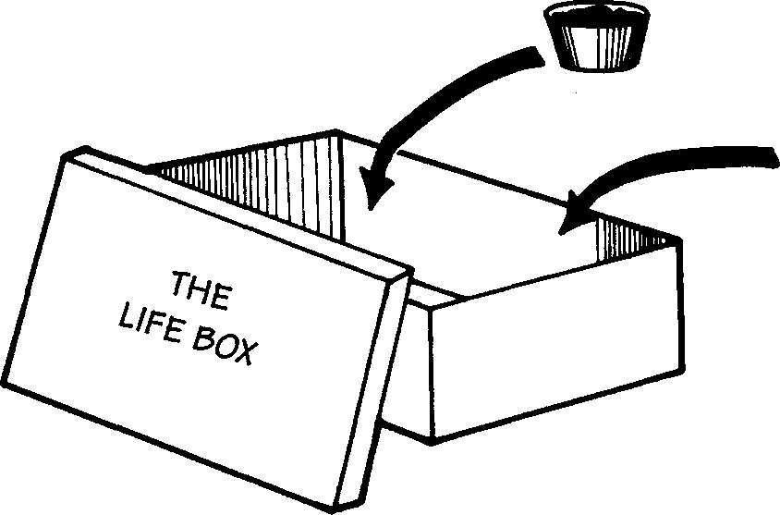
CUP OF soil
Bottle of water
- Soil BOTTLE OF WATER

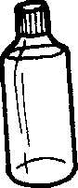

- Explain how each of these factors is used by living things.

- Have the students create their own ‘Life Box’ to take home by using the following:
  - one small plastic bag which holds the air and lets light through
  - one cotton ball – represents soil
  - water – soak the cotton ball
  - one soybean
  - using string create a necklace and attach to the little bag
NOTE: An alternative is to have each student make his or her own Life Box. Students can put soil and water into a milk carton and try to guess which four things needed for life are in the box. After identifying these factors, they can decorate the outside of the box. For example, the carton can be covered with construction paper and each of the factors illustrated. Or they could cover each side of the box with drawings or photographs of their favorite people or things (e.g., parents, siblings, pets, food). Challenge them to explain how each pictured person or thing needs (or once needed) the four life factors.
T Wrap Up and Action
Bring the selected student back to the front of the room; also display the potted plant. Ask the class how each of these organisms uses the four life factors.
Encourage students to take a Life Box home and test their family members about the four factors needed for life.
Assessment
Have students:
- identify four essential factors of life (step 3).
- describe how living things use the four factors of life (Wrap Up).
Upon completing the activity, for further assessment have students:
• create an experiment to prove or disprove that water, sunlight, air, and soil are essential for life.

Extensions
In addition to the four essential life factors, discuss with students the important concept that living things require a healthy environment: food, shelter, water, and adequate space. Then have the students plant two or three seeds or beans in each Life Box and water them lightly each day, thus verifying that the four factors necessary for life will cause dormant seeds to germinate and grow. Remind students that they must keep open the top of the carton to allow sunlight to enter.
Resources
Caduto, Michael, and Joseph Bruchac. 1989. Keepers of the Earth. Golden, Colo.: Fulcrum, Inc.
<§ Leutscher, Alfred. 1983. Water. New York, N.Y.: Dial.
<§ Williams, Jay. 1980. The Water of Life. New York, N.Y.: Four Winds Press.

