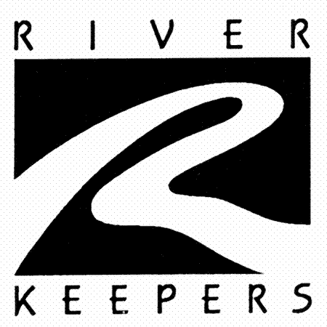
Golden Currant
(Clove Currant)
(Ribes odoratum)

Native Riparian Plants Series

The Golden Currant is a small shrub that is well adapted to North Dakota’s climate. It is noted for its yellow, clove-scented flowers. This shrub is fairly drought tolerant and can tolerate saline soils. Plant in full sun to partial shade.

Crown height: 3-6 ft.; crown width: 3-6 ft.

Practical uses:
- Use as a windbreak or to stabilize riverbanks.
- Can be used for a hedge.
- Bird watching: roosting, loafing, and nesting cover for songbirds who will eat the berries.
- Eat the fruit fresh or use it to make jam or jelly.

Buds: Creamy tan, ¼ inches

Leaves: 3-5 lobes, smooth, 1 ½ to 2 inches long, 1 to 1 ½ inches wide
Color: light green
Autumn color: yellow

Flowers: Golden yellow

Fruit: Black or purplish-brown berry

Diseases and pests: Defoliation due to currant worm, anthracnose, or leafspots.

For more information:
River Keepers
325 7th St. S. Ste 2A
Fargo, ND 58103-1846
(701) 235-2895
info@riverkeepers.org
www.riverkeepers.org

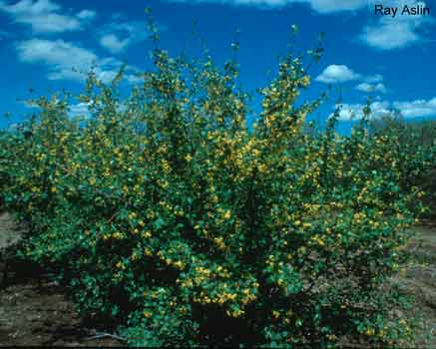
Golden Currant

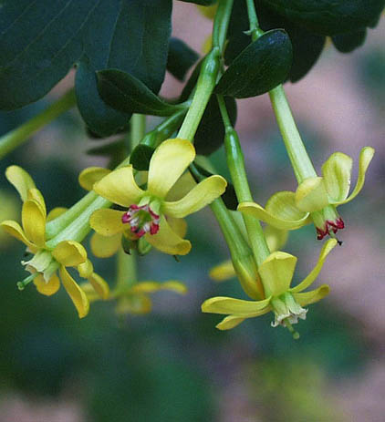
Golden Currant flower

September 27, 2006

