
False Indigo
(Amorpha fruticosa)

Native Riparian Plants Series

The False Indigo is a legume that grows well in moist soils. It prefers above-average moisture in full sun or light shade.

Crown height: 8-12 ft.; crown width: 6-10 ft.

Practical uses:
- Use to preserve riverbanks.

Buds: Brownish-gray, 1/8 inches long

Leaves: Pinnately compound (6-12 inches long, 2-3 inches wide) with 13-33 leaflets (1-1 ½ inches long, 1/3 to ¾ inches wide)
Color: Dark green
Autumn color: yellow

Flowers: Bluish-purple, 3-6 inches

Fruit: Light green turning dark brown in August, ¼ to 3/8 inches long

Diseases and pests: Rust, leaf spot, powdery mildew, twig canker.

For more information:
River Keepers
325 7th St. S. Ste 2A
Fargo, ND 58103-1846
(701) 235-2895
info@riverkeepers.org
www.riverkeepers.org

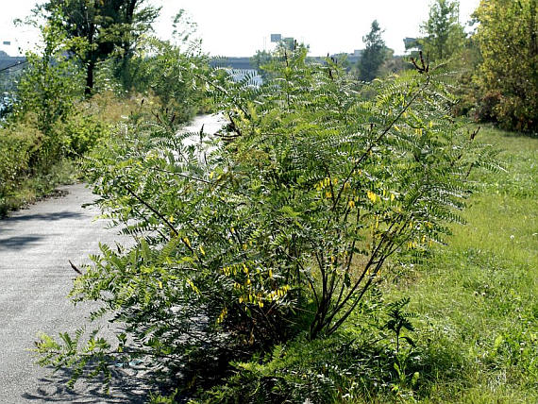
False Indigo

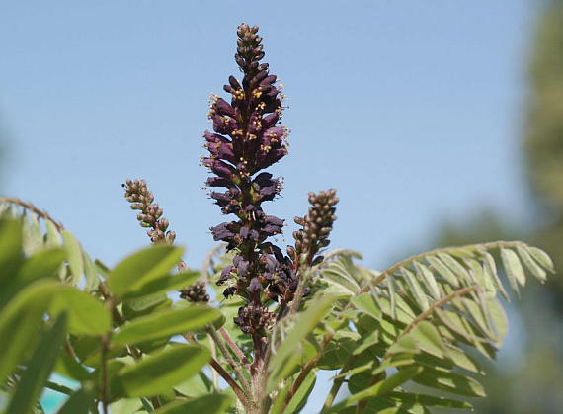
False Indigo fruit and leaves

September 27, 2006

