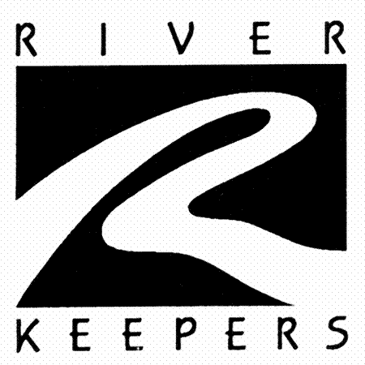
Cottonwood
(Populus deltoides)

Native Riparian Plants Series

The Cottonwood is the largest, fastest-growing native North Dakota tree. The largest Cottonwood in North Dakota is 110 feet tall with a 94-foot-wide canopy. It thrives in moist soils along rivers and in wetlands and prefers loam or sandy soil. Requires moist soil and full sun.

Crown height: 50-100 ft.; crown width: 40-75 ft.

Practical uses:
- Use as a windbreak or to stabilize riverbanks.

Buds: Chestnut-brow, conical, ½ to ¾ inches long.

Leaves: Triangular-chordate, coarsely dentate, curved teeth, 3-5 inches long, 3-5 inches wide
Color: Bright green
Autumn color: golden yellow

Flowers: Tiny, brownish-red

Fruit: Light brown capsule in a mass of “cotton”

Diseases and pests: Melampsora leaf rust, Septoria leaf spot and canker, Cytospora canker, wetwood, stem decay, poplar borer, aphids, poplar bud gall mite, poplar vagabond aphid, poplar leaf beetles.

For more information:
River Keepers
325 7th St. S. Ste 2A
Fargo, ND 58103-1846
(701) 235-2895
info@riverkeepers.org
www.riverkeepers.org

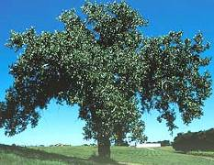
Cottonwood tree

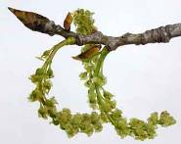
Cottonwood bud and flower

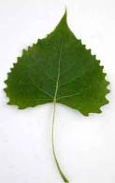
Cottonwood leaf

September 27, 2006

