Bur Oak

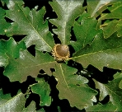
The Bur Oak (Quercus macrocarpa) is a long lived tree with very stout branches. Its round to wide, radiating form can reach a height of 40-70 feet. The largest tree in North Dakota measures 85 feet tall with a canopy spread of 61 feet. It is well adapted to a wide range of soil and environmental conditions. While the Bur Oak ranges from Texas to Canada, in North Dakota, it is found throughout the state, with the exception of the northwest corner.

The Bur Oak has 5-8” long fiddle shaped leaves with rounded lobes that are alternately arranged. Leaves are glossy green with pale undersides changing yellow-brown to reddish in the fall. Flowers are yellow-brown to reddish and yield brown acorn fruit in the fall. The bark is dark gray and rough with deep furrows and ridges.

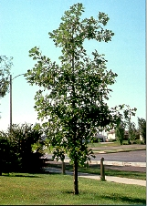
The Bur Oak can thrive in a variety of soils, but prefers fertile loams. It is drought tolerant, but prefers moist, well drained soils in full sun. Root zones of established trees are very sensitive to disturbances. Soil compaction and changes in drainage patterns can quickly kill these trees. This root zone sensitivity also makes the tree very difficult to transplant. The Bur Oak is somewhat resistant to oak wilt and can take many years to die once infected.

Major uses of the Bur Oak include conservation wind breaks, wildlife food and habitat, and landscaping in yards and parks. This tree has a variety of values in agroforestry products. Wood is used for lumber and acorns for food. Native Americans appreciated the Bur Oak for medicinal values and used it as an antiseptic and to treat dysentery.

