
Boxelder
Manitoba maple)
(Acer negundo)

Native Riparian Plants Series

The Boxelder is an irregular-shaped tree with a short, crooked trunk that commonly divides into several stout, wide spreading branches to form a rounded or irregular-spreading crown. The tree grows fast but can be short-lived. It is native to river bottoms, hillsides, and ravines and thrives in well-drained, moist soils along riverbanks.The Boxelder can grow to be quite large and the largest Boxelder in North Dakota is 61 feet tall with a 63-foot-wide canopy. It is moderately drought tolerant.

Crown height: 30-60 ft.; crown width: 30-60 ft.

Practical uses:
- Use as a windbreak or to stabilize riverbanks.
- Bird and animal watching: tree is food and cover for birds and mammals.
- Sap can be used to make syrup.
- Wood can be used for firewood.
- Not a good shade tree; boxelder bugs, which can be a nuisance, are associated with this tree.

Buds: Gray, ¼ inch

Leaves: Leaflets (2-3 inches long, 1-2 inches wide), 3-7 per leaf (3-7 inches long, 2 ½ - 4 inches wide), coarsely serrated with pointed tips,
Color: light green above, pale green below
Autumn color: yellow

Flowers: Yellowish-green to reddish-orange

Fruit: Tan to light brown double-winged samara

Diseases and pests: Stem decay.

For more information:
River Keepers
325 7th St. S. Ste 2A
Fargo, ND 58103-1846
(701) 235-2895
info@riverkeepers.org
www.riverkeepers.org

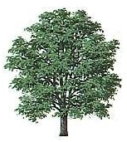
Boxelder tree

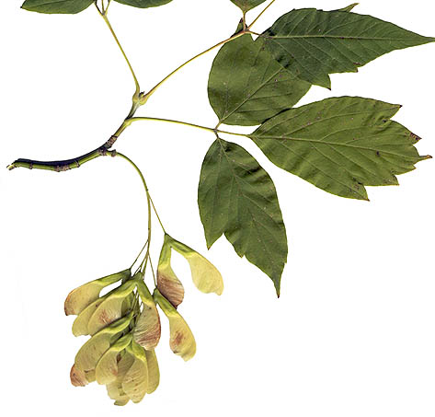
Boxelder leaves and fruit

September 27, 2006

