
Arnold Hawthorn
(Crataegus arnoldiana)

Native Riparian Plants Series

The Arnold Hawthorn thrives well in North Dakota, including in its larger cities. It is an attractive tree with white flowers, red fruit, and thorny stems. It is low-branched and round with dense branches that spread wide and vertically to horizontally. It prefers well-drained soils and can tolerate a moderate drought. Plant in full sun.

Crown height: 15-20 ft.; crown width: 15-20 ft.

Practical uses:
- Use as a windbreak or to stabilize riverbanks.
- Bird and animal watching: fruit is eaten by a variety of song and game birds and the branches are used for nesting. Browed by deer.
- Fruit can be eaten fresh or used to make jam or jelly.

Buds: Small, round, bright red to reddish-brown

Leaves: Oval and sharply serrated with a furry underside, 1-3 inches long and ¾ to 1 ½ inches wide
Color: dark glossy green
Autumn color: yellow

Flowers: White with pink anthers, foul odor, ½ to 2/3 inches in diamter

Fruit: Bright red, ¼ to ½ inch in diameter

Diseases and pests: Cedar-hawthorn rust

For more information:
River Keepers
325 7th St. S. Ste 2A
Fargo, ND 58103-1846
(701) 235-2895
info@riverkeepers.org
www.riverkeepers.org

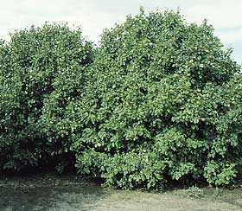
Arnold Hawthorn tree

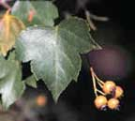
Arnold Hawthorn leaf and fruit

September 27, 2006

