
American Plum
(Prunus americana)

Native Riparian Plants Series

The American Plum is native to North Dakota and Minnesota and produces edible fruit. It grows in thickets as a thorny tall shrub or small tree with a round-headed crown. It is winter-hardy and can tolerate short droughts. Plant the shrub in full sun to partial shade. Shoots from underground roots will develop freely and profusely.

Crown height: 8-10 ft.; crown width: 8-10 ft.

Practical uses:
- Use as a windbreak or to stabilize riverbanks.
- Birds and small animals use the shrub for nesting, loafing, and bedding. Deer browse twigs and foliage.
- Eat the fruit fresh or use it to make preserves, jam, or jelly.
- Poor home landscape plant due to root suckers.

Buds: Brown to dark brown, 1/8 to 1/4 inches in diameter.

Leaves: Elliptical and smooth to slightly hairy with sharp serrated edges, 2-4 inches long, 1-2 inches wide
Color: medium green
Autumn color: yellow to red

Flowers: White

Fruit: Red to yellow compressed stone

Diseases and pests: Stem decay, branch cankers, black knot, plum pockets

For more information:
River Keepers
325 7th St. S. Ste 2A
Fargo, ND 58103-1846
(701) 235-2895
info@riverkeepers.org
www.riverkeepers.org

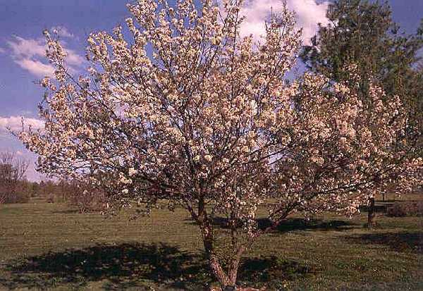
American Plum tree

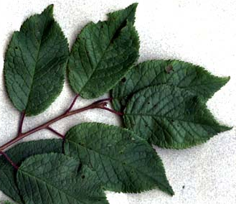
American Plum leaf

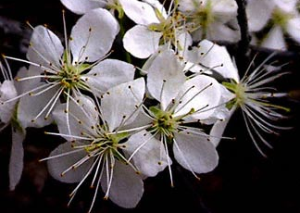
American Plum flower

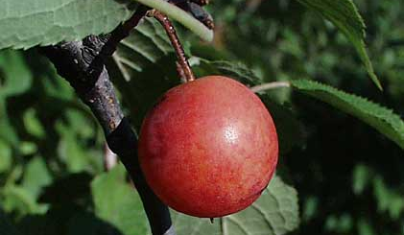
American Plum fruit

September 27, 2006

