
American Linden (Basswood)
(Tilia americana)

Native Riparian Plants Series

The American Linden (a.k.a Basswood) is a large tree native to North Dakota and Minnesota. It has a wide-spreading root system and grows well in deep, fertile, well-drained loam and clay soils. It is tolerant to flooding and isn’t drought resistant. Plant in full sun.

Crown height: 50-70 ft.; crown width: 30-50 ft.

Practical uses:
- Shade tree
- Use as a windbreak or to stabilize riverbanks
- Can be used for lumber
- Flower pollen used by bees to produce world class honey

Buds: Reddish-brown, slightly flattened, smooth or downy, 1/8 inches long

Leaves: Heart-shaped, coarsely serrated with long, pointed teeth, leathery with tufts of hair, 3-6 inches long, 3-6 inches wide
Color: green
Autumn color: yellow

Flowers: Creamy white to pale yellow

Fruit: Thick-shelled, pea-sized nutlet

Diseases and pests: Verticillium wilt, leaf blight, mites, aphids, leaf miners and borers

For more information:
River Keepers
325 7th St. S. Ste 2A
Fargo, ND 58103-1846
(701) 235-2895
info@riverkeepers.org
www.riverkeepers.org

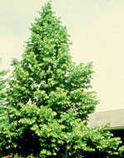
American Linden (Basswood) tree

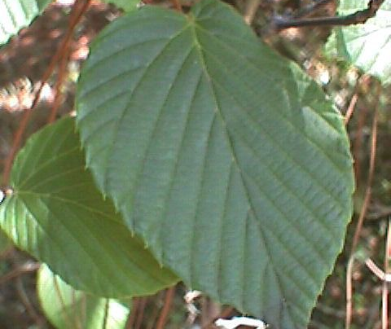
American Linden leaf

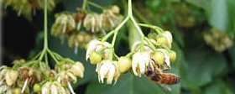
American Linden flower

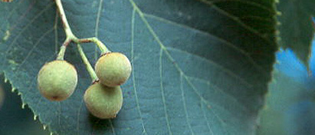
American Linden fruit

September 27, 2006

