Properly Dispose of Pet Waste
Do you have a dog or cat?
Are you disposing their waste properly? You may have received dirty looks from a homeowner when your canine has just done his business on their lawn.
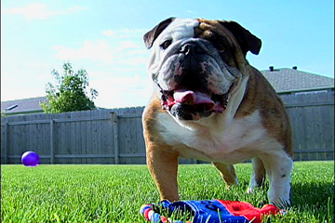
Leaving animal waste is doing more than annoying the neighbors; it may actually cause pollution or health problems. Pollutants from improperly disposed pet waste can be washed into storm drains by rain or melting snow. Storm drains empty directly into our lakes and rivers without any treatment.
Once in the river, pet waste can decrease the quality of water. This is a concern because Fargo-Moorhead gets most of its drinking water from the Red River. As pet waste decays it uses up oxygen in water, then releases ammonia. This combined with warm temperatures can kill fish. Pet waste also contains nutrients that stimulate the growth of algae and weeds. When algae and weeds are present, the water becomes cloudy and green, which makes the water unattractive for swimming, boating and fishing. Pet waste may also contain bacteria which can make water unsafe for swimming.
Here are a few things you can do to prevent pollution:
• Flush your pet's waste down the toilet. The waste from your toilet goes to a septic system or waste water treatment plant that removes pollutants before the water reaches a lake or stream. To avoid plumbing problems associated with cat litter, dump it in a trash bag.
• Bury pet waste. The hole must be about five inches deep, away from your gardens, and away from any lake, stream, ditch or well. Don't ever add pet waste to your compost pile. The pile doesn't get hot enough to kill disease organisms in pet waste. It is actually illegal in Moorhead to put meat, bones, whole eggs, dairy products, and human or pet feces in your compost pile.
• Put pet waste in the trash. Be sure to check with local ordinances in your city, sometimes it is against the law. This is the easiest way to get rid of pet waste.
Don't forget to pick up your pet's waste, even in your yard. Carry a pooper-scooper when walking your dog to help protect our river!

