INTER-CONNECTEDNESS
Grade Level: MN: 5th
ND: 4th

Time Required: 20 minutes

MN Standards: 5.4.2.1.1
5.4.2.1.2
5.4.4.1.1

Fargo Standards: 4.4.3
4.7.1

RECOMMENDED LOCATION
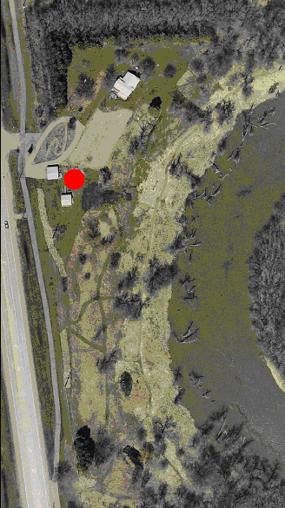

OBJECTIVES
- Students will understand that ecosystems are a system and that all elements are important.
- Students will learn that all species are dependent upon other species for survival.

METHOD
Students will play a quick game to learn how all elements of an ecosystem are interconnected.

BACKGROUND
It is easy to think that elements of an ecosystem can be isolated. For instance, many people think that if you cut down a tree, nothing else is affected. However, this is not true. Cutting down that tree affects all the birds that lived in it, all the vegetation growing beneath it that depended on its shade, etc. This game demonstrates this interconnectedness of all species.

MATERIALS
- A ball of string.

PROCEDURE
- Have students stand in a circle. The teacher should be in the middle of the circle holding a ball of string.
- Ask the students who can name a plant that lives at the Living Lab. Hand the first student to name a plant the end of the string, and instruct them to hold on to it.
- Ask the students to name something that is dependent on that plant, be it for food, shelter, etc. Hand the first student to name something the string. Explain that this student is connected to the student holding the end of the string by his dependence on the first student for nourishment/shade/pollen/etc.
- Ask the students to name something that is dependent on the previous species. Hand the first student to name something the string. Now three students should be holding parts of the string.
- Continue in this fashion until all students are holding on to a piece of string. If students cannot think of something that depends on the previous species, get creative! Ticks depend on deer for their food, squirrels depend on oak trees for its acorns, etc. Explain that all parts of an ecosystem are interconnected and depend on each other.
- To demonstrate how each individual is important to the whole community, take away a member of the web. If you take out a tree, say that it was logged. If you take out a deer, say a hunter shot it. If you take out a flower, say that a child picked it. Whatever member you take out of the web, have a plausible explanation for why it disappeared.
- When this member leaves the web, have them gently tug the strings they are holding on to. Anyone who feels this tug is somehow affected by the death of this member. Have the people who felt the original tug gently tug on their strings. More people should feel this tug. Have them also tug their strings. Continue this process until all members in the circle have felt a tug.
- Explain to the students that this shows how ALL members of the ecosystem were affected by the disappearance of the first member.

EVALUATION
Have students make a diagram showing how two seemingly unconnected members of an ecosystem are related. For instance, tell them to connect a bear to the soil, or a rabbit to an oak tree. A bear eats berries, which are planted in soil. A rabbit eats grass, which is planted in the soil, which drinks the same water as the oak tree. They can use their imaginations for this exercise!

