CAMOUFLAGE
Grade Level: MN: 3rd / 5th
ND: 3rd / 4th

Time Required: 20 minutes

MN Standards: 3.4.3.2.2
5.4.1.1.1

Fargo Standards: 3.4.1
3.4.3.b
4.4.2
4.4.3

RECOMMENDED LOCATION
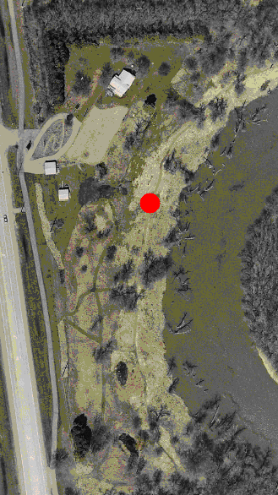

OBJECTIVES
- Students will learn what characteristics are necessary for an animal to successfully camouflage itself.
- Students will understand that camouflage helps protect animals from their predators.
- Students will learn that different habitats require different types of camouflage.

METHOD
Students will learn how to successfully camouflage themselves through an active game, and learn how animals do the same in different habitats.

BACKGROUND
Camouflage is a method of concealment that allows an otherwise visible organism or object to remain invisible from the surrounding environment. It is necessary for animals to be able to conceal themselves. It helps prey hide from predators, and it helps predators sneak up on prey undetected. Coloration is the most common form of camouflage. An example is the earth-tone coloration of deer and squirrels. An animal’s texture can also help it camouflage itself. For instance, the bumpy skin of frogs and toads help them hide in their environment. Different animals use different methods of camouflage depending on the habitat that they live in and what types of animals they are trying to hide from.

MATERIALS
- An open space with tall grasses or trees.

PROCEDURE
- Ask students how they think camouflage helps animals to survive. Ask students what types of camouflage animals in prairies, in forests, and in wetlands utilize.
- For each of the three aforementioned habitats (prairie, forest, wetland), ask students what a successfully adapted animal should look like.
- You are now ready to play the game. In this game, the teacher is the predator and the students are the prey. The teacher and students should begin in the middle of an open clearing surrounded by trees or tall grasses.
- When the teacher yells “Thicket 360!” the students run and hide in the prairie grasses while the teacher closes his/her eyes and counts to 10.
- When the teacher has counted to 10, he/she yells “Thicket!” again and looks around in all directions to see which students have done a good job of hiding themselves.
- The teacher calls out the names of all the easily visible students. These students are then “out” and must come sit by the teacher.
- After the “out” students are seated, the teacher yells “Thicket 360!” again, and the remaining students have 5 counts to run TOWARD the teacher with the objective of tagging him/her.
- At the end of the 5 counts, the teacher should not have been tagged yet. The teacher then yells “Thicket!” and the running students crouch down into the prairie grasses and try to conceal themselves as best as possible, since they are now much closer to the teacher.
- The teacher points out the easily visible students again, and these students come and join the other “out” students.
- This procedure repeats until the teacher is tagged by a student and a winner is declared.
- Gather the students for a class discussion.
  - Who was really good at hiding? Probably the students wearing neutral colors and those who were very still.
  - Who was really easy to see? Probably those wearing bright colors.
- Clarify that color, size, stillness, and use of surroundings are what make animals good at camouflaging themselves, just the same as it made the students good at camouflaging themselves in the game.
- Review that camouflage requirements are different for different habitats.

EVALUATION
Back in the classroom, give students a photo or a description of a habitat. Have them draw a picture of an animal that would be well-suited to live in that habitat. Their drawings should take into account size and color of the animal, and whether the habitat would provide its food and shelter needs.

