THE WATER CYCLE
Grade Level: MN: 4th
ND: 3rd / 4th

Time Required: 45 minutes

MN Standards: 4.2.1.2.1
4.3.2.3.1

Fargo Standards: 3.2.3
4.1.3

RECOMMENDED LOCATION
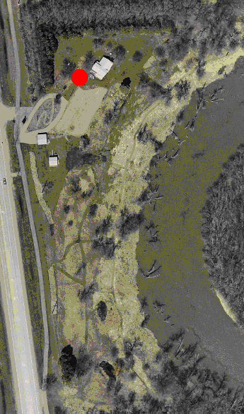

OBJECTIVES
- Students will understand that water can be a liquid, solid, or gas.
- Students will understand that water is recycled and reused over and over through the water cycle.
- Students will understand the function of infiltration, condensation, evaporation, transpiration, run-off, and precipitation.

METHOD
Students will learn about the water cycle through observation of their surroundings and then create informational skits about their observations.

BACKGROUND
About 70% of the earth's surface is covered in water. Water also exists in the air as vapor and in aquifers as groundwater. The same water that is on Earth today existed thousands of years ago. Water can be re-used countless times, and the water cycle allows for the reuse of water. Run-off is when water moves along the top of the ground, such as in glaciers. Infiltration is when water falls to the ground and soaks back into the soil, eventually ending up as groundwater. Evaporation is the process of turning liquid water on the surface of the earth into water vapor. This evaporated water then goes through condensation, where water vapor turns back into liquid. This leads to precipitation, which is when the liquid water falls to the earth in the form of rain or snow. Transpiration is the process where plants and other organisms suck water from the ground into their roots and then release it again through their leaves. The same molecule of water can go through each of these stages of the water cycle numerous times for thousands of years.

MATERIALS
- Paper and writing utensils for each group of students.

PROCEDURE
- Explain that the water on Earth today is the same water that was on Earth historically and that it is continuously reused and recycled through the water cycle.
- Ask students to brainstorm the three different forms that water can take on. These are liquid water, water vapor, and ice.
- Split students into small groups of 2 to 4 and give each group paper and pencil. Have the groups walk around the Living Lab trying to find as many places where water exists as they can.
- After 10 minutes, call the groups back together and have them share lists. Many groups will have listed the river, any puddles they may have seen, and perhaps clouds. However, remind the groups that water is everywhere – inside every tree and blade of grass, inside the soil, in groundwater, and in their own bodies.
- Explain that there is a water cycle that helps water to get into all areas of the environment. Tell the students that they are going to help act out the water cycle.
- Split students into 6 groups as equally as possible. Label one group run-off, one infiltration, one evaporation, one transpiration, one condensation, and one precipitation. Hand each group of students their corresponding definition, as included here:

Run-off: Some of the water moves along the top of the ground and is called run-off. Rain that hits roads and runs into the ditch is run-off. So is water from melting snow or glaciers.
Infiltration: When rain hits the earth’s surface, some of it sinks into the ground in a process called infiltration. When snow melts in spring and the ground gets soggy, it is because some of the melted snow is sinking into the soil through infiltration.
Evaporation: Energy from the sun changes liquid water into water vapor. This process is called evaporation. The water is now a gas and becomes part of the air around us. Think of evaporation as the sun sucking up some of the water from the ground and the river into the air.
Transpiration: Transpiration occurs when water in the ground enters plants through the roots, moves up into the plants, and then exits by evaporating from the leaves. This is how plants get their water and stay alive.
Condensation: Water vapor in the air travels as a gas until it meets cooler air. The water vapor changes back into liquid water in a process called condensation. If the air is very cold, snow or ice may form. This usually happens in areas we call clouds.
Precipitation: The force of gravity pulls the water droplets or ice crystals in the clouds down to the earth’s surface. Rain, snow, sleet, and hail are all forms of precipitation.

- Have each group of students put together a one or two minute explanatory skit of their part of the water cycle. Ask them to include where their part of the water cycle can be seen in the Living Lab. Encourage them to be as creative as possible! Have the groups go immediately one after another to demonstrate that all of these processes are interconnected and part of the same cycle.
- Reiterate that this water cycle is the reason that the same water that the dinosaurs drank is still around today. None of the water that we use every day is “new.”

EVALUATION
Back in the classroom, give students a quiz with the following questions:
  - Question: Run-off is when water moves along the top of the ground. YES
  - Question: Infiltration is when water filters through the soil to become ground water. YES
  - Question: Evaporation changes water from liquid to water vapor. YES
  - Question: Transpiration changes water from liquid to water vapor. YES
  - Question: Condensation changes liquid into water vapor. NO, it changes vapor into liquid.
  - Question: Precipitation is the movement of water from the ground to the sky. NO, it moves water from the sky to the ground.

