SEED SOCKS
Grade Level: MN: 3rd
ND: 3rd

Time Required: 20 minutes

MN Standards: 3.1.3.4.1
3.4.1.1.1

Fargo Standards: 3.4.1
3.4.3.a
(PLAY AFTER “ALL ABOUT SEEDS” LESSON)

RECOMMENDED LOCATION
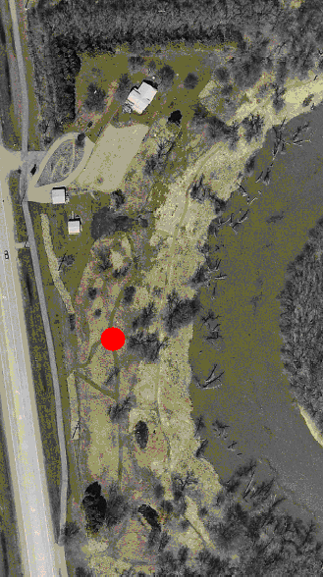

OBJECTIVES
- Students will understand how animals carry seeds.
- Students will understand that wildlife is critical for seed dispersal and the consequent flourishing of plant life.

METHOD
Students wear socks over their shoes and walk around to collect seeds.

BACKGROUND
Many seeds are carried by animals, whether in the coats of fur-bearing animals or dropped by birds. Animals distribute seeds in other ways too. For example, some creatures gather seeds and store them. Some of those seeds are not eaten and the seed store becomes a plant nursery. Many seeds are eaten but not fully digested. In those cases, animal droppings can fertilize seeds. This activity will teach students how wildlife contributes to healthy ecological systems.

MATERIALS
- One large sock per student participating.
- Magnifying glass.

PROCEDURE
- Ask each student to put a sock over one of their shoes. Wearing the socks over the shoes, go on a walk through a grassy area.
- After walking through the area, gather the class together and look carefully at the socks. Have the students make observations about the kinds of things they picked up. Some students may enjoy using a magnifying glass to examine their findings. It’s likely that they will pick up grass bits and sticks, but they will probably have picked up some seeds as well!
- Ask students how animal fur might be similar to their socks. Talk with the students about how animals carry seeds. Seeds may stick to an animal’s fur in one location and fall off in another. Discuss why this is important to environmental diversity.

EVALUATION
Have students write a paragraph on how fur-bearing animals are important to the dispersal of seeds.

