SEDGES, GRASSES, AND RUSHES
Grade Level: 3rd
Time Required: 20 minutes

MN Standards: 3.1.1.2.3
3.1.3.4.1
3.4.1.1.1
3.4.1.1.2

Fargo Standards: 3.2.1
3.2.3
3.2.3.a
3.4.1
3.4.3.a
3.4.3.b

RECOMMENDED LOCATION
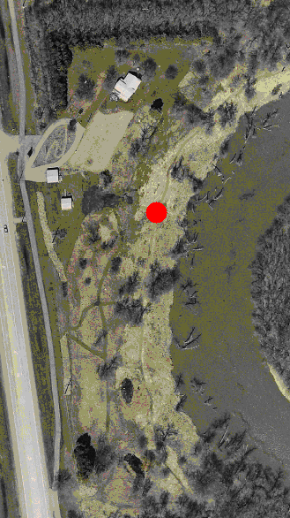
Near the interpretive sign on sedges, grasses, and rushes

OBJECTIVES
- Students will learn the difference between sedges, grasses, and rushes
- Students will clearly record observations

METHOD
Students will learn how to identify sedges, grasses, and rushes by examining all three types of plants with a magnifying glass and recording their observations.

BACKGROUND
Sedges, grasses, and rushes grow worldwide. There are hundreds of different species of each. All three types of plants are very similar to each other in appearance, and are therefore difficult to differentiate. They are all generally long with thin stems and leaves, and oftentimes grow in the same area. These similarities cause many people to simply call all three plants “grasses” without realizing that sedges and rushes are different.
All three plants share several similarities beyond appearance. For instance, they are flowering plants and enclose their seeds in ovaries, which are surrounded by bracts. In most flowering plants, bracts take the form of colorful petals. However, grasses, sedges, and rushes are wind-pollinated and consequently have no use for flashy petals to attract insect pollinators. As a result, all three plants produce very inconspicuous flowers that are usually yellow, green, or tan in color.
Grasses are set apart by their flat stems and flat leaves. Their stems are hollow. Near the crown or base of grasses, the flat leaves start to curl around each other. Therefore, the stems may appear slightly rounded. Another distinctive feature of grasses is the swollen nodes that they develop on their stems. The ovary of a grass produces a single-seeded grain.
Rushes have stems that are clearly cylindrical or round. When cut from the plant, the stems are hollow and look like miniature soda straws. These hollow stems bring air to the base of the plant, since its roots are often submerged in mud and unable to get sufficient oxygen. The leaves of rushes are flat, like grasses. Most rushes are found in wet, boggy conditions. The ovary of a rush develops a many-seeded capsule.
Sedges exhibit triangular stems. If you hold one in your hand and slowly turn it, you will notice three prominent edges and a triangular shape. The leaves of sedges are flat and have a ridge running down the middle. Sedges are mostly perennial and evergreen, and prefer to grow in moist conditions. Their ovaries produce a single seed.

MATERIALS
- Magnifying glasses
- Paper and pens

PROCEDURE
- Explain to students that many plants that look like grass are not grass. Sedges and rushes look very similar to grasses. Tell them that although the three plant types are different, they serve similar functions. They all grow to be about the same height and color and they are all wind pollinated.
- Explain the differences in appearance between sedges, grasses, and rushes. Grasses have flat stems and leaves. Rushes have round, hollow stems. Sedges have triangular stems with a ridge running down the middle.
- Tell students that the main difference between the three plant types other than stem and leaf shape is the way they produce their seeds. Grasses and sedges produce one seed at a time while rushes produce a capsule containing many seeds. Sedges and rushes also prefer wetter conditions than grasses.
- Instruct students to take out their magnifying glasses so that they can study the plant types in the area. Tell them to look at and record observations of stem types. If a stem is flat, it’s a grass. If it’s round and hollow, it’s a rush. If it’s triangular and has a ridge running down the middle, it’s sedge.
- Once most students have found examples of all three plant types, gather for discussion. Ask students why they think these three different plant types have different shaped stems. Explain to them that it is to help the plant get water all the way up the stem. Sedges, grasses, and rushes all prefer slightly different conditions and as a result need slightly different stem shapes. For instance, sedges and rushes live in wetter conditions while grasses prefer it slightly drier.
- Review the similarities and differences between sedges, grasses, and rushes. An easy way to do this would be to gather around the interpretive sign on sedges, grasses, and rushes and read it together.

EVALUATION
Have examples of sedge, grass, and rush on display. Have each student identify which plant is which by looking at the stem shape.

