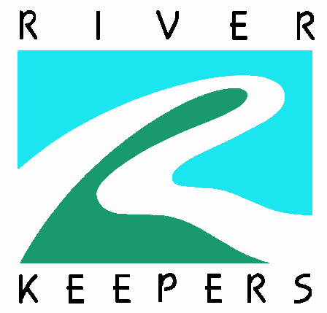
Living Lab
Scavenger Hunt

There are so many things to see, hear, smell, and touch at the Red River. See if you can check off everything on the list below. Remember - you should not pick up anything living… just mark it off on the list.

Things to see:
___ A feather
___ A hole in a tree
___ Scat (animal droppings)
___ Animal tracks
Things to feel:
___ Wet mud
___ Tree bark
___ The wind
___ Rotten wood Things to smell:
___ A flower
___ Green grass
___ Pine needles
___ The mud
Things to hear:
___ A bee or mosquito
___ Leaves in the wind
___ A frog croaking
___ A bird singing Things happening:
___ An ant moving something
___ A spider web with a bug in it
___ A woodpecker digging for insects
in a tree
___ A fish jumping

The Living Lab located at 5508 South University drive in Fargo demonstrates a variety of riparian restoration techniques, serves as an outdoor lab for students of all ages, exhibits wildlife habitat improvements and more.

