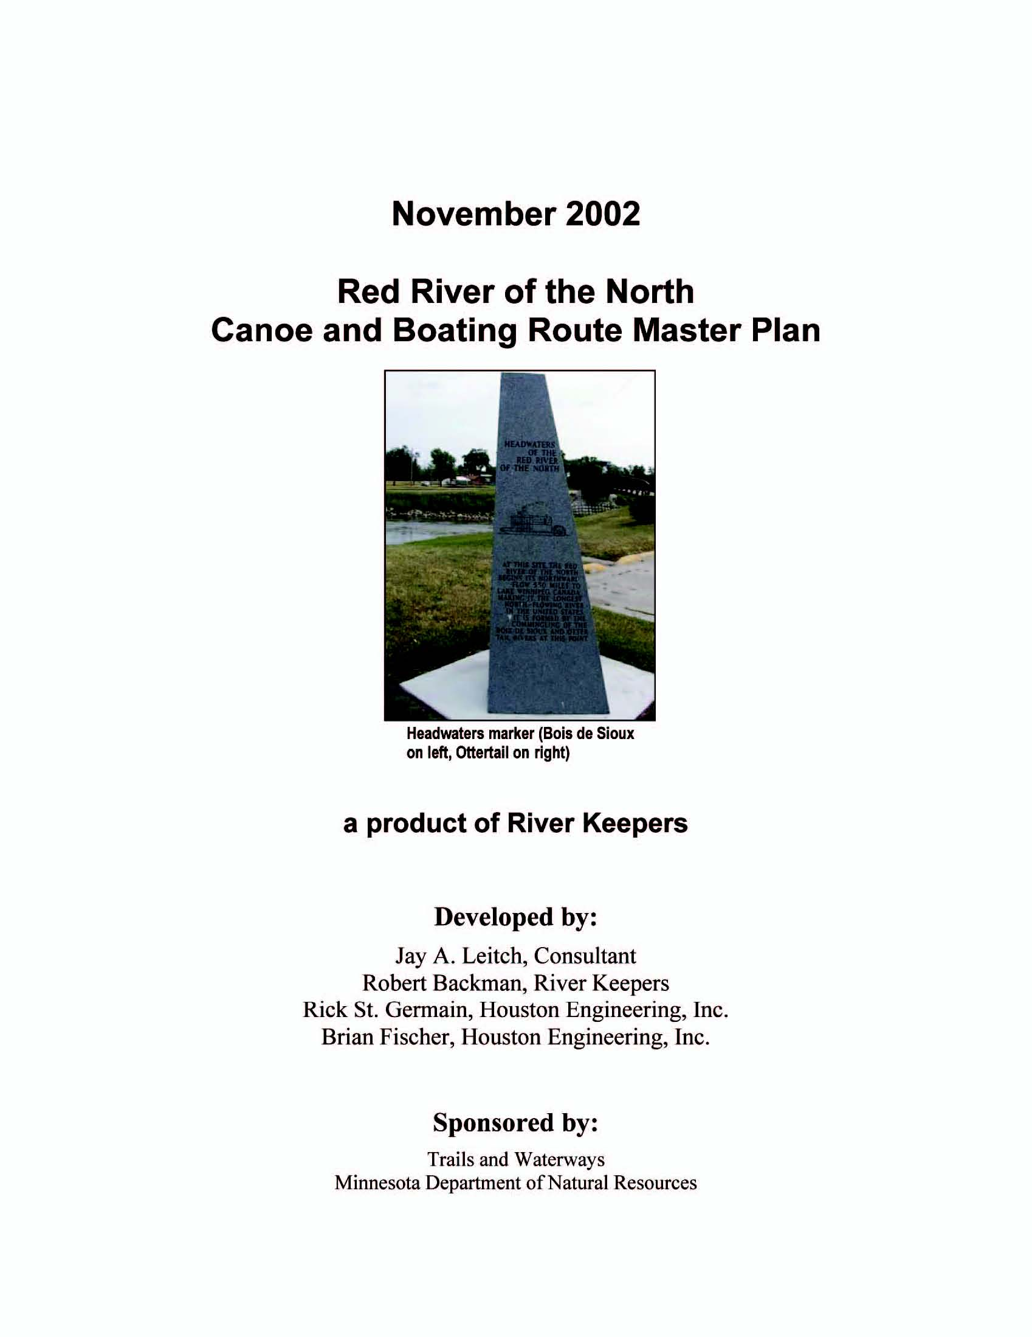
Page
Executive Summary with Goals and Recommendations ES-1
I. Introduction I-1
A. Justification I-1
1. Planning I-1
2. Canoeing and Boating on the Red River I-1
B. The Resource I-3
1. Red River Physical Features I-3
2. Human History I-5
II. Red River Master Plan for a Canoe and Boating Route II-1
A. Getting Started II-1
1. Authorization II-1
2. Public Input II-2
B. Encouraging Stakeholder Buy-In II-4
C. Describing Current Situation II-4
1. Organization II-4
2. Economic Contributions II-6
3. Recreational Opportunities II-6
a. Access II-8
b. Canoeing II-10
c. Boating/Fishing II-15 1) Boating Regulations II-18 2) Fishing Regulations II-20 3) Fish Contaminants II-21 4) Invasive Aquatic Species II-21
D. Crosscutting Issues II-22
1. Development/Operations Funding II-22
2. Signage II-23
3. Public Safety and Emergency Response II-24
4. Public Land II-24
5. Multi-Purpose Visits/Achieving Critical “Attraction Mass” II-25
6. Water Quality II-26
7. Stream Flows II-26
8. Historical Artifacts II-26
E. Promoting Public Use and Strategic (and Opportunistic) Development II-28
1. Plan Implementation Strategy II-28
a. Information and Education II-30
b. Canoeing II-31
c. Boating/Fishing II-32
-i-

- Plan Maintenance Strategy II-33
- What Next? II-34

III. References III-1
IV. Web Addresses IV-1
APPENDICES
(These are part of the plan) A-1. Dams A-2. Landmarks A-3. Boat Launch Ramps and Canoe Access Sites A-4. Parks and Campgrounds A-5. Road Crossings A-6. Tributaries A-7: River Keeper’s Fargo-Moorhead canoeing map A-8: Red River Log, Headwaters to Georgetown A-9. 42 Photo Base Maps with Annotations A-10. CD w/42 Photo Base Maps, Master Plan, and Pictures Referenced in Appendices (These are part of the report to MN DNR; bound separately) B-1. RiverKeepers contract with MN DNR B-2. Public Input B-3. Stakeholders B-4. Clay County Lease of Georgetown Park to Blackpowder Club
FIGURES
1 Red River of the North with Major Tributaries (includes gaging stations) I-4 2 Sample Photo Base Map II-7 3 Boat Ramps, Dams, and Campgrounds II-11 4 Canoe Trips II-12 5 Sample Content of Signs for Red River Canoe and Boating Route II-22
TABLES
1 Angler Activity (hours) on the Red River, 1994 and 2000 II-16 2 Standards for Selected Canoe Uses of the River II-14 3 Standard for Boating/Fishing Uses of the Red River II-18 4 Plan Implementation II-29
-ii-
EXECUTIVE SUMMARY WITH GOALS AND RECOMMENDATIONS
The Red River of the North Canoe and Boating Route Master Plan briefly discusses the impetus, justification, and authorization for the plan, which was funded by the Minnesota Legislature through the Division of Trails and Waterways, Department of Natural Resources. The plan was drafted by River Keepers, a Fargo-Moorhead based 501(C)(3) organization dedicated to encouraging sustainable uses of the Red River.
Public input, an important element of the planning process, was accumulated prior to the formal start of the plan, actively sought during the planning process, and should be an intimate component of plan implementation. Public input was instrumental in developing a vision statement for the plan: Increased canoeing and boating uses of the Red River of the North with emphasis on safety; interpretive, historical, and environmental awareness; and economic development.
There are currently no basin-wide, organized, comprehensive attempts to plan for canoeing and boating uses of the Red River, which flows 394 miles from its headwaters in Breckenridge, Minnesota, to the Canadian border. However, many components of a plan can be found at various levels of government and throughout the private sector. Infrastructure to support expanded boating, fishing, and canoeing is almost nonexistent outside of three or four urban areas. Even within the urban areas, the infrastructure is generally not amenable to “family” canoeing nor accessible to handicapped canoe/boat users. A master plan will help guide development to maximize sustainable use, encourage safety, and contribute to economic development.
Fishing currently accounts for about 150,000 hours of activity per year, about evenly divided between shore and boat fishing. Canoeing accounts for another 10,000 hours/year of activity on the Red River. Inventories of recreational use infrastructure (e.g., access sites, 8 dams, 21 tributaries, 32 road crossings) were made and are cataloged and depicted on photo base maps. Many general and site-specific goals related to enhancing current uses and facilitating additional uses are made. Examples include repairing boat ramps, developing portages around dams, developing canoeing rest stops and overnight camp sites, increasing public knowledge through information and education efforts, and identifying an entity to implement the plan.
A three-phase development process is suggested, which would include state-local-private partnerships: 1) The first phase (about $1.1 million over the next three to five years) is the 133mile “Headwaters to Georgetown” route which needs on-the-ground infrastructure maintenance and development, information and education materials (I&E), and identification of a key responsible entity for sustaining the route; 2) A second phase (about $2.2 million, over years 3 to 8) would include extending the route (i.e., infrastructure, I&E, and leadership) the remaining 264 miles from Georgetown to the Canadian border; 3) A final phase (about $2.2 million) includes enhancing the route’s infrastructure to encourage destination visits for recreational purposes, connecting with other trails/routes and attractions, ultimately tripling existing on-the-water recreational uses of the Red River over the next ten years. Finally, ongoing plan management and maintenance of infrastructure could cost from $200,000 to $700,000, or more, per year (a combination of hard dollars and in-kind services).
ES-1
YEAR: 1 2 3 4 5 6 7 8 9 10 11+
<====================>
1) PHASE I: Headwaters to Georgetown
(RM 548.7 to RM 415.9) Estimated cost: I&E, $165,000; Canoe, $870,000; Boating/Fishing, $65,000
<======================>
2) PHASE II: Georgetown to Canadian Border
(RM 415.9 to RM 155) Estimated cost: I&E, $75,000; Canoe, $1,725,000; Boating/Fishing, $425,000
<================================>
3) PHASE III: Enhance Infrastructure
(RM 548.7 to RM 155) Estimated cost: I&E, $100,000, Canoe, $1,500,000; Boating/Fishing, $575,000
<===========================================> Ongoing plan management and infrastructure maintenance Estimated cost: $200,000 to $700,000+/year
One characteristic of planning for development of the Red River Canoe and Boating Route that is different than some other resource development plans is that almost all of the components of the plan can be accomplished as stand-alone developments.
Several issues are raised and discussed briefly, including funding for the plan, boating regulations on interstate waters, signage for the route, user safety, water quality and stream flow, and historical and natural artifact collection. Corresponding goals are identified related to each of these issues. The plan is meant to be stable in its vision, yet dynamic in detail, responding appropriately to change.
Finally, suggestions for sustaining the plan through state-local-private partnerships are made, including information and education, implementation strategy, and maintaining the plan.
General Goals
G-1
Have information about the Red River readily available to the public in printed, electronic (Internet), and human response (i.e., 1-800-number) format (pg. II-3). •
G-2
Clarify interstate boating regulations on the Red River (pg. 11-3).
ES-2
G-3
Involve stakeholders in periodic, ongoing assessment and implementation of the plan (pg.
II-4).
G-4 Involve entities in both Minnesota and North Dakota in planning for and implementing recreational infrastructure along the Red River (i.e., public-public, and public-private partnerships)(pg. II-5).
G-5 Develop base-line estimates of the economic impact of Red River recreation to use in project feasibility analysis and overall route development justification (pg. II-6).
G-6 Maintain air photo base maps with photography updated as significant changes are
evident (pg. II-8).
G-7 Develop and maintain Internet “Red River Canoe and Boating Route” site (pg. II-8).
G-8 Include Red River criteria and designs in the MN DNR’s River Operations Manual (pg.
II-8).
G-9 Develop paper copies of maps of selected river segments (e.g., RK’s FM map) (pg. II-13).
G-10 Develop and legalize all portages, primarily at low-head dams (pg. II-13).
G-11 Encourage others to include canoeing information on all printed/electronic trip planning
materials (pg. II-13).
G-12 Maintain the existing 17 boat launching facilities and develop new facilities as needed (pg. II-15).
G-13 Conduct research and development efforts to design facilities compatible with physical
characteristics of the Red River (e.g., varying flows, muddy banks) (pg. II-15).
G-14 Include boating/fishing information on all printed/electronic materials (pg. II-16).
G-15 Keep the Red River fishing guide up-to-date and make it available in alternative
languages (pg. II-16).
G-16 Develop, promote, and enforce boating rules and regulations on the Red River between Minnesota and North Dakota that are clearly understood (pg. II-20).
G-17 Develop a one-stop-shop for individuals/groups interested in obtaining financial assistance for developing canoeing and boating infrastructure on the Red River (pg. II23).
G-18 Key all planning elements to a river mile (RM) to minimize repetition and facilitate user needs (pg. II-23).
G-19 Develop a logo for the Red River Canoe and Boating Trail and use on all signage and electronic/printed material (pg. II-24).
G-20 Develop safety and information signs using standard icons to be seen from the water (pg.II-24).
G-21 Develop information signs to assist users from major roadways to river access sites (pg. II-24).
G-22 Develop an emergency response system/network for the river with it clearly identified as to who is responsible for the first response (pg. II-24).
ES-3
G-23 Key emergency response requests to river mile (RM) and/or GPS location (pg. II-24). G-24 Develop road access to all dams for emergency purposes (pg. II-24). G-25 Clearly identify public lands (where feasible) on canoeing and boating route maps (pg.
II-25).
G-26 Acquire river shore access through easements or fee title to meet the recreational and safety needs of Red River canoers and boaters (pg. II-25).
G-27 Identify and support a single responsible entity, existing or new, to implement and sustain the plan (pg. II-29).
G-28 An active, comprehensive web site for the Red River (www.rrbdin.org) exists and should be used to disseminate the plan and display informational materials (e.g., maps) (pg. II
34)
G-29 Double 2002 canoeing use of the Red River in five years and triple it in ten years.
G-30 Develop day trips with complete access, including American Disabilities Act (ADA)
accessibility near population centers. G-31 Develop initially overnight campsites every 12 to 15 miles for the first 130 miles
(Headwaters to Ruperts Landing, Georgetown).
G-32 Double fishing activity on the Red River in five years and triple it in ten years.
G-33 Encourage development of private guiding and outfitting businesses.
G-34 Develop more shore fishing access sites, especially in urban areas.
G-35 Develop infrastructure that is resilient (NOT resistant) to flooding, able to quickly,
efficiently bounce back after a flood.
G-36 Keep public involved by establishing a stakeholder/public advisory group and maintaining a comprehensive stakeholder directory and mailing list.
G-37 Ensure that the development of this Canoe and Boating Route provides for multi use of this recreational resource.
G-38 Encourage organization of an active river users group.
ES-4

I. INTRODUCTION
This report covers the development of an initial Red River of the North Canoe and Boating Route Master Plan. It includes: (1) an Executive Summary; (2) the plan, and (3) recommendations regarding plan implementation.

A. Justification
The justification for planning in general is appreciated by most, and essential for a complex resource such as the Red River managed by multiple entities. Justification for this specific plan is based on resource capacity and the demand for both economic development (including tourism) and enhanced recreational opportunities for local residents.
1. Planning
Planning is essential for any organization to be able to clearly articulate its vision, identify means for accomplishing that vision, and determine milestones, benchmarks, and responsible persons (positions). This plan is necessary for the initiating agency, the Minnesota Department of Natural Resources (MN DNR), for those reasons and, in part, as a mechanism to demonstrate needs and priorities to agency decision makers and to the Minnesota Legislature. The plan is necessary for those interested in making the best uses of the Red River – from both the user and the developer perspectives – because it articulates the vision and provides a framework and a process for accomplishing that vision while remaining flexible and sensitive to the need for change and changing business, political, and social environments.
2. Canoeing and Boating on the Red River
The justification for this specific plan is three-fold. First, it helps guide resources that will lead to expanded recreational opportunities for the 350,000 residents living in the counties adjacent to the Red River. Second, it helps identify priorities, opportunities, and public and private investments that will lead to enhanced economic development in the region. Finally, there is a broad-based call for more river-related activity, both as a destination activity and as an activity combined with other opportunities in the area.
Population of Counties Adjacent to the Red River in 2000
Minnesota |  |  | North Dakota
Wilkin Clay Norman Polk Marshall Kittson |  | 7,034 51,609 7,358 31,160 10,025 5,150 |  | Richland Cass Traill Grand Forks Walsh Pembina | 17,701 124,021 8,392 64,390 12,081 8,408
State totals |  | 112,336 |  |  | 234,993
Total |  |  |  | 347,329

Source: U.S. Census Bureau, www.quickfacts.census.gov
While there has been occasional reference to canoeing the Red River in the literature, it has been more often ignored. One of the first documented recreational uses of the Red River was Eric Sevareid’s trip from Fort Snelling to Hudson Bay via the Minnesota and Red Rivers in 1930 (Sevareid 1968). Carter (1980) traveled from Wahpeton to Pembina and recorded the trip in an interesting 4-page magazine article. An article in 1987 even refers to the Red River as “The Rodney Dangerfield River” (Pich and Ryckman 1987). The Red River gets only 1-½ pages in Paddling Minnesota (Breining 1999) and is not even mentioned in a list of canoe trips in a 1994 Minnesota Atlas, although the Red Lake River, a tributary of the Red River, is listed.
More recently, publications and articles about canoeing and boating on the Red River have began to appear more frequently (Schlueter 1995). For example, a 10-page Red River Anglers’ Guide was produced in 1996 (MN DNR & ND Game and Fish, 1996), and an updated version, Fishing on the Red River of the North, was available in 2002. River Keepers1 has been actively promoting canoeing and boating on the Red River for several years, including a Red River Millennium Tour in 20002 that included 200 canoeists that traveled all or part of the 545 miles of the river. The tour generated considerable media coverage, including an article in the Minnesota Volunteer, and seemed to have sparked interest in canoeing along the Red River. The United States Geological Survey (USGS) has published brochures and maintains a web site – Canoeing North Dakota’s Rivers (nd.water.usgs.gov/canoeing/) – which include information on the Red River.
Although recreational use of the Red River continues to expand pretty much ad hoc and unguided, there is a need for a more comprehensive, forward looking assessment of recreational uses (Connecting w/Minnesota’s Urban Rivers; Red River Basin Board: Inventory Process Final Reports). North Dakota’s 1996-2000 State Comprehensive Outdoor Recreation Plan (Prchal et al. 1995) shows the need for more recreational opportunities statewide and more boat ramps, campgrounds, and trails in the counties bordering the Red River. For example, Parks Canada, in a report about the Canadian Heritage River System, suggested “...that the Government of Manitoba and Canada initiate discussions with U.S. federal and state governments leading towards preparation and implementation of a comprehensive management plan for the Red River and its watershed (Hilderman et al. 1998, p. 47).” They go on to say (p. 28) “One of the identified limitations of the Red River Background Study is the lack of a national recreation framework....”
While there are scant data specifically on recreational uses of the Red River, anecdotal evidence (i.e., inquiries directed to River Keepers) suggests on-the-water
1River Keepers is a 501(C)(3) established in 1990 whose mission it is to promote sustainable uses of the Red River, primarily in the Fargo-Moorhead metro area.
2The White House Millennium Council included the Red River of the North as a “Community Millennium
Trail” (White House Millennium Council, 2001). A certificate is on display in the Breckenridge City Council
Chambers.
uses, primarily canoeing, have increased considerably over the past decade. Two creel surveys within the past eight years (1994 and 2000) help to establish a baseline for shore and boat fishing (ND Game & Fish, 2002; MN DNR, 1996). Total angler hours on the Red River are estimated to be approximately 150,000/year, about evenly split between shore and boat fishing.
Clearly, interest in canoeing and fishing on the Red River is growing, with both individuals and organizations calling for more access, infrastructure, and information. A conservative estimate for establishing a baseline activity for canoeing is roughly 10 percent of fishing, or about 10,000 recreational hours/year.

B. The Resource
The Red River of the North is rich in history – from Native Americans, to fur traders, and European settlement – which is extensively documented in the literature. It is hydrologically somewhat unique, having once been a large inland lake and now flowing almost straight north. The Red River’s hydrology has been studied extensively, especially since the flood of 1997 (IJC 2000).
1. Red River Physical Features 3:
The Red River of the North flows north about 545 miles from its source – the confluence of the Bois de Sioux and Otter Tail Rivers in Breckenridge, Minnesota – to Lake Winnipeg, of which 394 miles border Minnesota (Figure 1). It drops only 233 feet in elevation, or less than 6 inches per river mile, over that distance. Channel widths vary from under 200 feet to over 500 feet, with average depths at bank-full stage from 10 to 50 feet. The Red River drains a basin of about 17,000 square miles, much of which is the lake bed of former glacial Lake Agassiz. During its northward flow, waters of the Red River are joined by flow from 21 named tributaries (Ap. A-6).
The Red River basin lies nearly at the center of the North American continent which results in wide weather extremes, with temperatures of over 100 degrees F in the summer and less than minus 30 degrees F in winter. While the river may flow over 100,000 cubic feet per second (cfs) for short times in the spring or following heavy summer rains, the winter flows may be only a few hundred cfs with most of the river’s surface covered with ice. Precipitation averages about 20 inches, most of which falls as rain in spring and early summer. Due to these precipitation extremes, the Red River’s flow can vary from overflowing its banks to occasionally not flowing at all.
The physical resource of the Red River offers many opportunities for water-based recreation, from canoeing and kayaking, to pleasure boating and fishing. Its strengths are its relatively untouched 545 miles of placid flow with scenic, historical, cultural, and wildlife amenities along the way, all easily accessed from an extensive and nearby road network. Weaknesses include its widely fluctuating flows, muddy banks, and several low-head dams (Appendix A-1). The opportunities are many, from urban canoeing to extended trips, and from novice fishing to tournaments for trophy catfish.
3This section was excerpted largely from A River Runs North, Krenz and Leitch, 1998. Three informative web sites are: www.ijc.org, www.rrbdin.org, and www.redriverbasinboard.org.
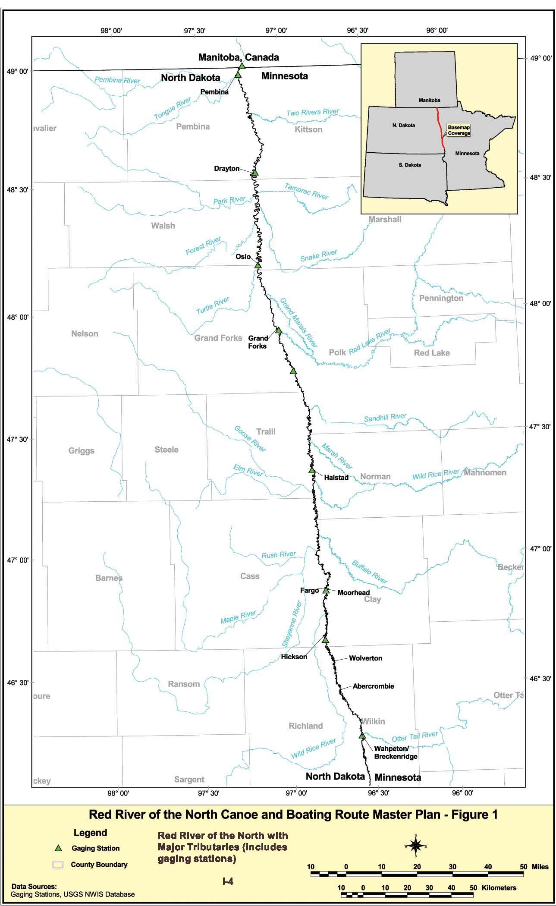
2. Human History
European settlement of the Red River area began to occur in the early 1800s, starting from the north and moving south. Hilderman-Thomas-Frank-Cram (1998) provide an overview of the human heritage associated with the Red River north of the international border. Red River carts were the primary means of transportation in the mid-1800s, with cart trails from Winnipeg to Minneapolis-St. Paul. Early settlement centered around the fur trade, with settlement in the mid- to late-1800s largely comprised of homesteaders seeking land to farm. The first steamboat on the Red River was in 1859, followed by just over 50 years of steamboat travel. At their height, steamboats moved a variety of trade goods, commodities, and people up and down the river. The railroad opened the basin to settlement by about 1875, with lines connecting Winnipeg to Minneapolis-St. Paul and Duluth to Moorhead, putting an end to most steamboat travel on the Red River.

Dommer’s Boat House on the Red River
1920 – Youth Canoeing on the Red River

Pluck at Dock on the Red River
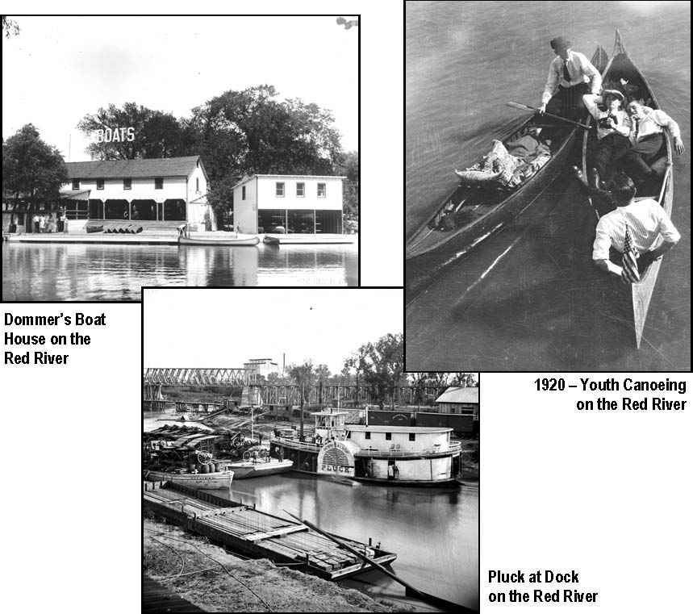
Photos provided by Clay County Historical Society

II. RED RIVER MASTER PLAN FOR A CANOE AND BOATING ROUTE
This master plan for a canoe and boating route was developed in response to increasing interest in recreational uses of the Red River, which led to the State of Minnesota Legislative authorization to develop a plan, followed by public input, leading to an inventory of existing opportunities and identification of goals, and concluding with suggestions for implementation and plan sustainability. The plan is meant to be stable in its vision, yet dynamic in detail, to respond appropriately to change.

A. Getting Started
Authorization to develop a plan by the 2001 Minnesota Legislature occurred in mid2001, which was shortly followed by selection of a consultant. The consultant, River Keepers, with a strong history of working specifically on the Red River began by soliciting public input.
1. Authorization
The 2001 Minnesota Legislature passed HF 10 and SF 10 on June 25, 2001, which was later signed by the Governor. The legislation directed the Minnesota DNR and others to develop a Red River canoe and boating plan. Of the appropriated $100,000, half was to be used to develop a master plan and the other half to develop the first 130 miles from Breckenridge to Georgetown.
Section 88. Minnesota Statutes 2000, section 85.32, is amended to read:
Subdivision 1. The commissioner of natural resources is
authorized in cooperation with local units of government
and private individuals and groups when feasible to mark
canoe and boating routes on the ... Red River of the North ...
which have historic and scenic values and to mark
appropriately points of interest, portages, camp sites, and all
dams, rapids, waterfalls, whirlpools, and other serious
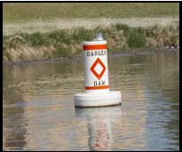
hazards which are dangerous to canoe and watercraft Dam warning buoy
travelers (MN Statutes, 2000).
The first year, $100,000 from the water recreation account in the natural resources fund will be used for an inventory of the Red River of the North, to make recommendations to the legislature on the canoe and boating route on the river, and for mapping and signing the lower portion of the river from Breckenridge to Georgetown.
River Keepers was asked to submit a proposal for development of a Red River Canoe and Boating Master Plan to MN DNR Trails and Waterways (Appendix B-1). River Keepers was selected to develop the plan and began work in late winter 2001.
2. Public Input
The public was involved in the planning process in three ways4. First, two advisory committees were established, one in the south and another in the north. Second, four meetings were held to solicit public input and discuss issues (Appendix B-2). Finally, the principal authors of the plan took every available opportunity to discuss the vision and seek input from persons interested in the future of the Red River. An informational display was developed and displayed at several public events throughout the Red River basin.
South Advisory Committee North Advisory Committee
Wayne Beyer, Wahpeton Parks & Rec.
Dave Arscott, UM-Crookston Neoma Laken, Project Breckenridge
Forrest Boe, MN DNR Ed Janzen, recreational user
Marty Egeland, ND Game & Fish Mike McKibben, Breckenridge Parks &
Melanie Parvey-Biby, City of Grand Forks Forestry
Doug Stave, recreational user Dan Koper, Friends of Ft. Abercrombie
Jerry Bennett, Wild Rice Wtrshd. Dist. Bob Stein, recreational user
Helen Cozzetto, Red River State Rec. Area Wayne Goeken, recreational user Dave Rush, Red River Reg. Council Dean Warner, recreational user
Master Plan
David Bergman, MN Ofc. of Tourism
Public Input Meetings (2002)
Brad Dokken, Grand Forks Herald- May 20: Fargo, North Dakota Linda Kingery, Northwest Partnership- May 22: Hendrum, Minnesota Lynn Schlueter, ND Game & Fish - May 23: Drayton, Minnesota Paul Wellman, Red River RC&D - May 29: East Grand Forks, Minnesota
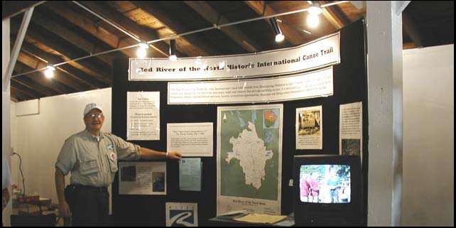
Informational display
4One of the reasons River Keepers was selected to develop the initial draft of a Red River Master Plan for canoe and boating was the extensive groundwork they had already accomplished. For example, they recently had worked with the National Park Service on the first 133 miles.
Generally, the tone at the public input meetings was extremely enthusiastic about developing infrastructure to support increased canoeing and boating on the Red River. The usual concerns were expressed about the river (e.g., is it clean? is it safe? what about the undercurrents?) and how elements of a master plan might be accomplished and by whom. Most evident at these meetings was a need for: 1) increased public awareness about the river as a recreational resource; 2) access to information about the Red such as water quality, and 3) clarification of the fishing and boating regulations on the river.
G-15 Have information about the Red River readily available to the public in printed, electronic (Internet), and human response (i.e., 1-800-number) format.
G-2 Clarify interstate boating regulations on the Red River.
Members of the two advisory boards were selected based on their familiarity with the river and their interests in enhancing its recreational uses. One meeting of each board was held in late spring 2002 and again in the fall. In between meetings, board members were kept informed of the progress in the planning process, and were used as both information sources and liaisons with groups in their area.
Solicitation of public input at large, by chance, or as needed, provided the planning team with a broad source of ongoing information and feedback. Planning team members had many opportunities to travel the region and to attend scores of meetings and functions where they could engage the public in discussions about the River. In fact, the original impetus for developing the first 133 miles was voiced at a public meeting in 1998 when two dozen interested people came together as the “Red River Trails Committee”. Most of those two dozen people were involved in this planning process.
The VISION that came out of this process was:
Increased canoeing and boating uses of the Red River of the North with emphasis on safety; interpretive, historical, and environmental awareness; and economic development.
Given that vision, the next three steps in the strategic planning process are to (1) encourage ongoing buy-in, (2) describe the current situation, and (3) promote enhanced public use and private development. The final step is sustaining the planning process, recognizing that the plan is both a guide for short-term implementation and, in the longer run, a dynamic tool subject to social, economic, environmental, and political change.
5Goals will be presented throughout the plan numerically following “G-” and listed in the Executive Summary.

B. Encouraging Stakeholder Buy-In
Given the strong justification for enhancing the infrastructure to support increased canoeing and boating uses of the Red River, it was not difficult getting stakeholder buy-in. River Keepers had already developed a strong stakeholder network in the Red River basin. There are many individual stakeholders and stakeholder groups interested in Red River development (Appendix B-3). These stakeholders, as well as others that are identified in the future, should be kept intimately involved with plan implementation and periodic goal assessment.
G-3 Involve stakeholders in periodic, ongoing assessment and implementation of the plan.

C. Describing Current Situation
The current situation regarding canoeing and boating on the Red River involves the management or administrative organization and the infrastructure necessary to support those uses. Currently there is no organized effort to manage the development of infrastructure to support canoeing and boating on the Red River. However, there is some infrastructure in place to support modest, current use of the River.
1. Organization
Currently, the only organized entity whose primary mission is to promote recreational uses specifically on the Red River is River Keepers. Their primary geographic scope is the Fargo-Moorhead area, roughly Cass County, North Dakota, and Clay County, Minnesota. However, there are many entities – public and private, local to national – whose purview includes some aspect or some portion of the river.
Local public: Many local units of government (LUGs) in the Red River basin have boards, commissions, committees, or units whose responsibilities include recreation, the river, or economic development. These government units include cities, counties, townships, park districts, water resource districts, and others. Their geographic scope is naturally limited relative to the 394 miles of the Red River in the U.S., as is their financial ability. However, development of recreational infrastructure to support canoeing and boating on the Red River may be relatively important to LUGs who may have limited alternatives for economic development.
Local private: There are many local, private organizations whose missions are somehow related to various aspects of the Red River. These might include sportsmen’s clubs, economic development groups, civic organizations, and social and fraternal groups. These groups are important stakeholders and allies in soliciting resources for plan implementation.
Homeowner and his dock
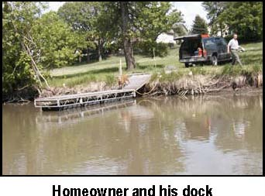
State level, public: Both states, Minnesota and North Dakota, have several state agencies or divisions responsible for various aspects of the Red River. The Department of Natural Resources in Minnesota is primarily responsible, through several divisions, for recreational uses (namely fishing and boating) of the river. Other state agencies are interested in economic development, water quality, safety, and emergency response. The North Dakota Parks and Recreation Department and the Game and Fish Department both have interests in Red River recreation. Additionally, the North Dakota State Water Commission and both States’ Health Departments are concerned with water quantity and quality issues.
State-wide, private: State-wide private groups interested in recreation on the Red River include the Minnesota Canoe Association, chapters of The Wildlife Society, Audubon, Sierra Club, and many others. State-wide private groups interested in economic development include the Minnesota State Chamber of Commerce and the Greater North Dakota Association. Encouraging private development of infrastructure needs to be accompanied with technical assistance. The various confusing and complex regulations that are in place on a Federally Designated Waterway could be overwhelming for the average person wanting to start a marina or an outfitting/guide service.
Regional and multi-state: Several public, quasi-public, and non-public regional and multi-state organizations exist with an interest in the Red River. For example, most of the North Dakota counties adjacent to the Red River are within the Garrison Diversion Conservancy District, which has a proactive recreational and environmental program. Also, the recently formed Red River Basin Commission includes representation from throughout the basin and has broad interests in water issues, including recreation.
Federal: The federal government has several agencies with purview over Red River issues, including the National Park Service, the U.S. Coast Guard, the Fish and Wildlife Service, the Federal Emergency Management Agency (FEMA), the
U.S. Army Corps of Engineers, the Environmental Protection Agency, and others. These federal agencies are organized into regions, some of which encompass the basin in a single agency region, others of which are represented by more than one region within the basin, often using the Red as the dividing line.
This plan is being developed for the Minnesota Department of Natural Resources, Division of Trails and Waterways. For successful implementation of a comprehensive canoe and boating plan, it will take involvement and cooperation from Minnesota and North Dakota entities.
G-4 Involve entities in both Minnesota and North Dakota in planning for and implementing recreational infrastructure along the Red River (i.e., public-public, and public-private partnerships).
2. Economic Contributions
Recreational users of the Red River make tangible and intangible contributions to economic activity in the region. There are currently no studies that estimate what that impact might be specifically for the Red River, although many studies exist for other geographic areas and natural resource uses. The categories of economic impacts from existing and potential recreation on the Red River might include (National Park Service 1996):
-increases in real property values
- expenditures by residents (who might otherwise spend their recreation money outside the area)
- commercial uses (outfitters, concessions, special events)

-agency expenditures (e.g., MN DNR)
- expenditures made by tourists
G-5 Develop base-line estimates of the economic impact of Red River recreation to use in project feasibility analysis and overall route development justification.
3. Recreational Opportunities
Basin-wide, water-based recreational opportunities are largely limited to do-ityourself type activities, with the exception of some limited fishing guide services6 and pontoon and canoe rental in Moorhead. There are currently about 10,000 hours of canoeing, 75,000 angler hours of on-the-water fishing on the Red River, and 75,000 anglers hours of shore fishing (Table 1, page II-16). “White water” kayaking is limited to only a couple sites – the retrofitted dams – and to perhaps less than 100 hours of activity per year. Kayak touring is included in the estimate for canoeing.
In order to keep the plan strategic, details about facilities, potential trips, access, stakeholders, etc., are contained in the appendices. The general vision and scope of the plan will not change much over time, but the detail regarding what should be done next year, vis a vis a few years from now, will change as planning components are implemented, priorities change, and funding opportunities arise.
The presentation of current opportunities uses 42 air photos – each covering about 5 miles north to south – as the basic information benchmark (Figure 2). The baseline photos show river miles (RM), dams, tributaries, cities, road and railroad crossings, landmarks, access sites, and more. These photos are intended for use by those responsible for implementing the plan as well as recreational users. A full set of the
6Fishing guides on the Red River include www.catchbigcats.com and backwtrl@fishingminnesota.com.
The “S.S. Ruby” (used for tourist rides on the Red River), docked in Moorhead
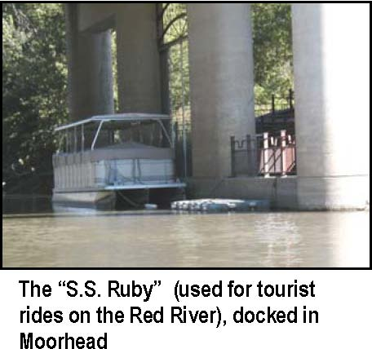
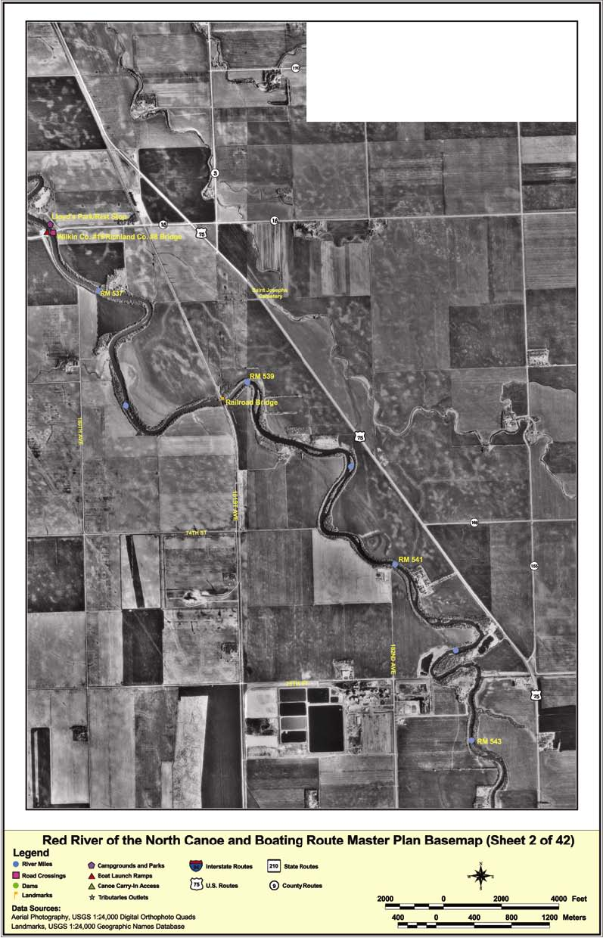
Figure 2 – Sample Photo Basemap
42 photos is included as an appendix (Appendix A-9). Since the photos were taken in 1991 and 1992, it is advisable to review the photography and consider updating in areas where significant change has occurred. The actual river channel is not likely to change much over a 10-year time period. In addition, the photos are available electronically (Appendix A-10) and should ultimately be made available via the Internet for use by recreationists as well as persons, agencies, and organizations interested in developing additional opportunities. The Internet version should be augmented with useful information about, and links to, all aspects of canoeing and boating activity.
G-6 Maintain air photo base maps with photography updated as significant changes are evident.
G-7 Develop and maintain Internet “Red River Canoe and Boating Route” site.
a. Access: Most on-the-water recreation is dependent on access to the river. Access varies from physically arduous carry-in sites to concrete boat ramps (Figure 4, Appendix A-3). Canoers generally travel downstream, necessitating an upstream access site to put-in and a downstream site to take-out. Boaters, anglers, and white water kayakers normally put in and take out at the same site. The suitability of existing access sites varies from marginal carry-in sites to well-developed landings depending on a number of site characteristics (e.g., river bank characteristics, carry in/out distance) and services available (e.g., parking, public water, camping). Some items pertinent to access site suitability include:
-site development (i.e., carry-in, concrete ramp)
-parking (day, overnight)
-road access
-ADA access -lighting
-firewood, fire rings
-restrooms, showers -potable water
-camping (primitive, developed)
-retail services nearby (e.g., food, bait, lodging)
Site design criteria are available in the MN DNR’s River Operation manual. Most of the design/criteria in the manual are suitable for the Red River. However, due to the high variability of flows/depths and the steep and muddy riverbanks, research and development needs to be done regarding canoe landings and riverbank access.
G-8 Include Red River criteria and designs in the MN DNR’s River Operations Manual.
At this time only a few access sites are situated near established overnight campgrounds (Figure 3, Appendix A-4). Family or leisurely canoeing on the Red River requires overnight stops about every 12 to 15 miles. Experienced canoeists can log 25 to 30 miles or more a day, depending on portages and wind.
Getting around the Red River Valley is fairly easy, with most roadways running north-south or east-west. Major roads are marked on the air photo base maps (Appendix A-9 and A-10). There are 32 road bridges that cross the Red River in the U.S. (Appendix A-5). In addition, five railroads and four pedestrian bridges cross the Red River (Appendix A-2). U.S. Highway 75 runs parallel to the river on the Minnesota side from the headwaters to Shelly (RM 358), usually no more than a few miles east of the river. Interstate 29 runs parallel to the river on the North Dakota side, usually less than 10 miles to the west. Interstate 94 crosses the Red River in Fargo-Moorhead.
There are ten overnight campgrounds adjacent to the river for use by canoeists (Figure 3, Appendix A-4). Many other campgrounds exist within 20 miles of the river, which may be suitable for anglers operating from a single access site.
There are 21 named tributaries and 3 coulees entering the Red River between the Headwaters and the Canadian border (Appendix A-6). Many of these tributaries provide access to the Red River’s main stem. Summer season flows on tributaries vary from little or no flow to over 1,000 cfs. It is important for canoeists and boaters to be aware of river flows before embarking on the water. Low relative flows can make power boating hazardous, while high flows can be dangerous for canoeists and boaters, due to increased currents and floating debris.
Camping on the Red at Fargo’s Lindenwood Park
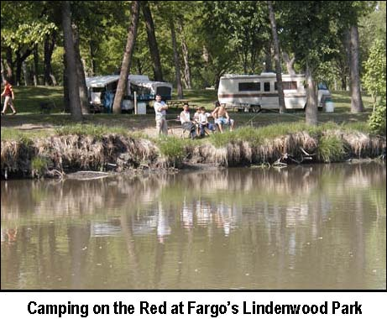
Rocks are more exposed during low flows
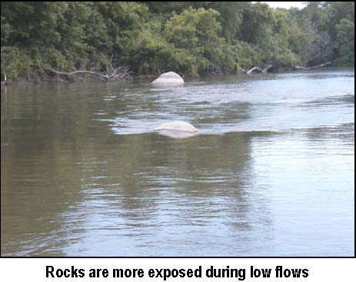
b. Canoeing: There are many existing opportunities for canoe trips of from an hour long to all day, especially near more densely populated areas (Figure 4).
Examples of Red River Canoe Trips
1 hour Through Wahpeton-Breckenridge, 2 miles 1 hour Moorhead: Mid-town Dam to toll bridge, 3 miles 1 hour Moorhead: North Dam to MB Johnson Park, 3 miles 2 hours Forrest River Estates (RM 467) to Convent Landing, 5 miles 2 hours Moorhead: MB Johnson Park to Wall Street, 6.5 miles 3 hours Ft. Abercrombie to Wilkin County Hwy 28 bridge (RM 514.9),
8 miles 4 hours Hendrum to Halstad, 11 miles 6 hours Brushvale to Ft. Abercrombie, 13 miles 5 hours Breckenridge: Kidder Recreation Area to Brushvale, 10 miles 8 hours Minn. #9 to Grand Forks-E. Grand Forks, 20 miles 10 hours Through Mhd.-Fgo: Convent Landing to MB Johnson Park, 22 mi.,
3 portages 10 hours Minn.175 & N. Dakota 5 bridge (RM 179.6) to Pembina, 19.5 mi. 10 hours Ft. Abercrombie to Wolverton, 20 miles 12 hours Shelly to Bellmont Park, 26 miles 12-14 hours MB Johnson Park to Georgetown, 30 miles 12-14 hours E. Grand Forks to Oslo, 27 miles 3-4 days Headwaters to Fargo-Moorhead, 90 miles 4-5 days Headwaters to Georgetown, 130 miles However, access suitability varies
considerably, from concrete ramps with adjacent campgrounds and convenient, hard surfaced parking, to using a bridge right-ofway to enter or exit the river. River Keepers has developed a canoeing map for the 22mile stretch of river through Fargo-Moorhead (Appendix A-7).
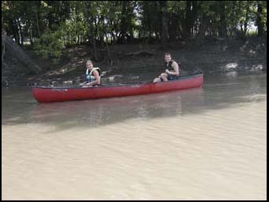
Canoeing on the Red
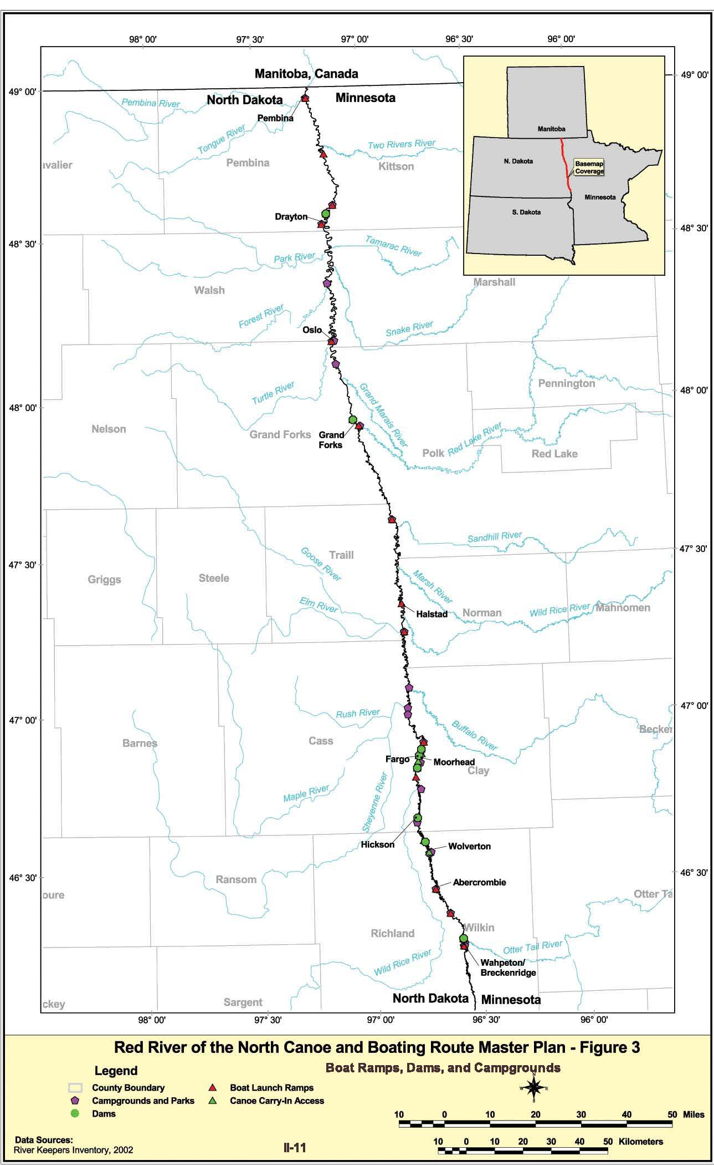
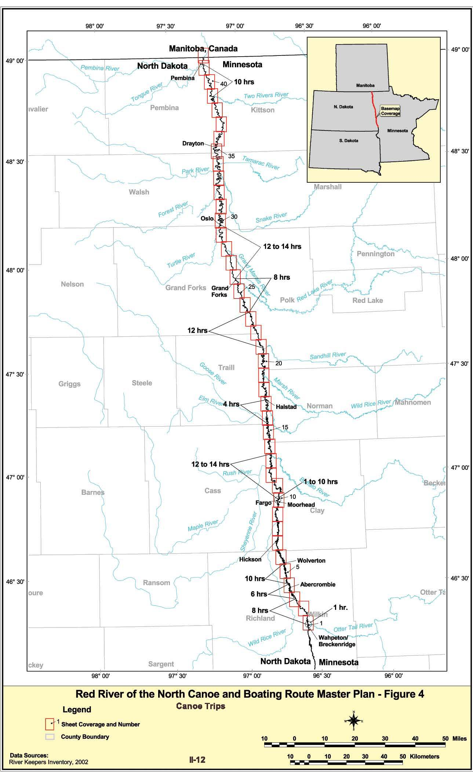
G-9 Develop paper copies of maps of selected river segments (e.g., RK’s FM map).
Shuttling support vehicles to downstream locations is necessary for one-way canoe trips, making careful trip planning important. One option for shuttling vehicles is to bring a bicycle along in the canoe and bike back to the vehicle. Canoeists need to know their abilities so they can plan an appropriate pick-up point and they need to know their options for exiting the river.
To make existing canoeing opportunities more enjoyable, more inviting to a broader range of abilities, and safer; several steps should be taken:
-develop comprehensive maps showing access sites, rest stops, and other pertinent information; ideally these maps should be part of an interactive trip planning Internet site.
-remove or make more user friendly obstacles to canoeing, such as the dams, by legalizing and developing portages.
-include canoe trip information on maps produced for other purposes (e.g., city maps in the telephone books)
G-10 Develop and legalize all portages, especially at low-head dams.
G-11 Encourage others to include canoeing information on all printed and electronic trip planning materials.
Suggestions for Canoeing the Red

Do
- Wear your PFD
- Plan your trip, allow for windy conditions
- Take adequate water
- Let someone know your plan
- Carry a cell phone
- Be aware of other boaters and unmarked dams
- Respect the property and privacy of shoreowners
- Check the USGS web site for flow information (nd.water.usgs.gov/canoeing/)
- Check the weather forecast
- Keep track of your location
- Carry a weather alert radio
- Avoid the spread of exotics by using appropriate techniques (www.dnr.state.mn.us/exotics/aquatic/index.html)

Don’t
- Attempt to exceed your abilities
- Trespass on private property
- Litter
- Cross the US-Canadian border without checking w/Customs
- Leave your vehicle parked illegally

Table 2 Standards for Selected Canoe Uses of the River
 | Primitive | Developed
access | legal carry-in | hard surface access to river, w/parking
rest stops | legal place above Ordinary High Water (OHW) | developed egress route from river w/picnic sites and bathrooms
rest stop intervals | every 10 to 15 miles | every 4 to 6 miles
overnight stop interval | 30 miles or more | 20 miles or less
overnight stop | legal place above OHW | see MN DNR River Operations Manual
river-road access points | legal access with legal parking | hardened route from parking area to river
See DNR River Operation Manual for site specifications. R&D effort is needed to develop resilient canoe “ramps” given the wide fluctuation in Red River flows.

c. Boating/Fishing: Opportunities for power boating, primarily for fishing but also pleasure boating, on the Red River are restricted by river flows, the width of the river, and the number and adequacy of boat ramps (Appendix A-3). There are concrete ramps at 17 locations along the Red River (Figure 3), some of which are in excellent shape, others need considerable repair. Because of the river’s fluctuating flows, especially frequent flood flows, efforts should be made to design flood resilient boat ramps and other facilities. Boaters should be aware of river flows before traveling on the River (for flow rates, refer to www.water.usgs.gov/waterwatch/).
Much of the Red River in the U.S. is under 200 feet wide. In part of the southern valley it is under 100 feet wide. Construction of additional ramps will result in more boats using the river. As additional ramps are proposed for construction there needs to be adequate discussion on potential environmental and safety concerns resulting from additional on-the-river traffic.
G-12 Maintain the existing 17 boat launching facilities and develop new facilities as needed.
G-13 Conduct research and development efforts to design facilities compatible with physical characteristics of the Red River (e.g., varying flows, muddy banks).
Fishing on the Red River is a largely underutilized recreational resource. As many as 80 species of fish have been documented in the U.S. portion of the Red River (Koel and Peterka 2001). It is known as one of the premier channel catfish rivers in North America (Leier 2002) and has a largely unfished
World’s largest catfish statue at population of trophy walleye (“Fishing in Kidder Recreational Area
ND” 2002; Red River Anglers’ Guide).
Little data is available on the number of anglers or time spent angling specifically on the Red River. However, two angler surveys, one in1994 by Minnesota DNR (MN DNR 1996) and the other in 2000 by the North Dakota Game and Fish Department (ND Game & Fish 2002), offer some insights into a baseline level of fishing activity. The total angler hours estimated for 1994 was nearly 160,000, with 71 percent done from shore (Table 1). In 2000, the total number of angler hours was approximately the same–
Girl proudly shows
137,000–with 55 percent from shore. Of course it is
fish caught indangerous to base trends on just two data points, especially Red River
Using boat ramp north of Midtown Dam (Fargo)
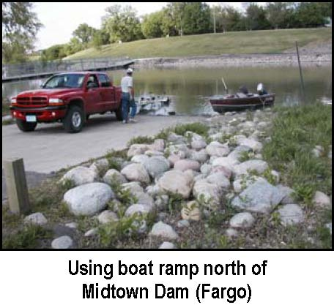
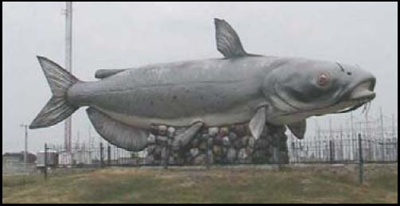
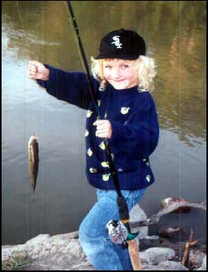
when there are so many variables that might influence annual fishing activity. For instance, there was an unprecedented summer flood in Fargo-Moorhead in June 2000, which may have adversely affected fishing that summer.
Table 1. Angler activity (hours) on the Red River, 1994 and 2000
1994 2000 Location Shore Boat Shore Boat
Headwaters to Fargo 21,307 3,560 14,507 14,376 Fargo-Moorhead area 18,453 1,011 14,337 5,022 Between F-M and Grand Forks 23,365 3,476 7,881 2,398 Grand Forks area 32,566 12,777 15,718 27,916 Grand Forks to Drayton 13,805 8,331 4,226 2,385 Drayton to Canada 4,511 16,560 18,563 9,254 TOTALS 114,007 45,715 65,232 61,351
Sources: ND Game and Fish, 2002; MN DNR, 1996.
Creel surveys of Red River anglers indicate that most anglers are from North Dakota or Minnesota, with only 5 percent from other areas. Nearly half of the anglers interviewed said walleyes were their primary fish, although anglers harvested about seven times as many channel catfish as walleyes.
Angler activity on the Red River is expected to continue to increase due to better
access and promotion (partly as a result of this plan), and Canadian restrictions on
U.S. anglers. The primary constraints to increased levels of boat fishing are access points; information, education, and promotion; and fluctuating water levels. More Red River fishing information is becoming available on the Internet (www.state.nd.us/gnf/fishing/redbro, www.catchbigcats.com).
G-14 Include boating/fishing information on all printed/electronic materials.
G-15 Keep the Red River fishing guide up-to-date and make it available in alternative languages.
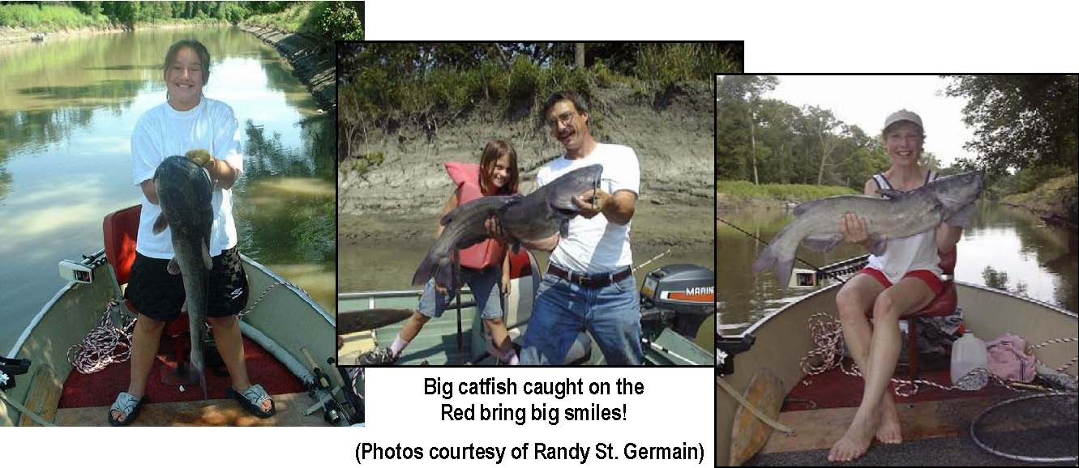
Big catfish caught on the Red bring big smiles!
(Photos courtesy of Randy St. Germain)
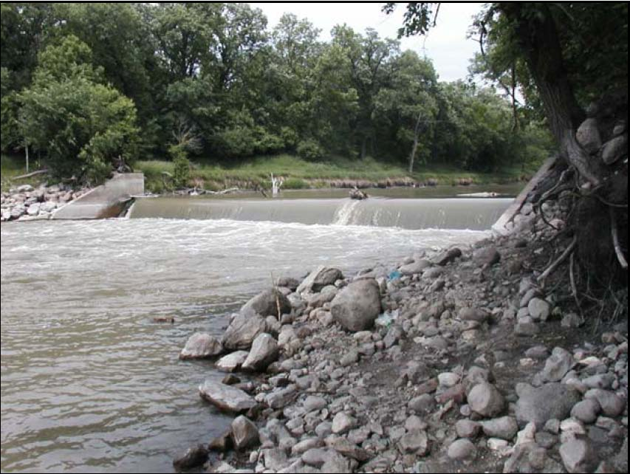
The Hickson Dam has a dangerous undertow
Suggestions for Boating the Red
Do
- Wear your PFD.
- Be aware of others using the river, especially other non-powered watercraft
- Observe boating rules and etiquette
- Check the MN DNR web site for fish consumption advisories (www.dnr.state.mn.us) or call 1-800-657-3908)
- Watch for floating debris and submerged hazards
- Carry a cell phone
- Keep track of your location
- Carry a weather alert radio
- Avoid the spread of exotics by using appropriate techniques (www.dnr.state.mn.us/exotics/aquatic/index.html)

Don’t
- Operate a power boat near dams
- Operate a power boat at speeds greater than that which allows you to react, especially at sharp bends in the river where visibility may be limited
- Create problems with your wake, especially in developed areas

Suggestions for Fishing the Red
Do
- Know the fishing regulations
- Practice catch and release (bring a camera along)
- Minnesota TIP (Turn In Poachers): 1-800-652-9093
- N. Dakota RAP (Report All Poaching): 1-800-472-2121

 | Table 3 Standard for Boating/Fishing Uses of the Red River
 |  | Primitive | Developed
access |  | concrete or plank ramp | plank or concrete ramp w/surfaced parking, fish cleaning
ramp interval |  | every 20 or 25 river miles | every 15 or 20 river miles

1) Boating Regulations: A summary of boating regulations illustrates some inconsistencies and a potential for confusion about boating regulations, enforcement, and watercraft licensing requirements on the Red River, caused primarily by the river being the border between Minnesota and North Dakota. The basic question is: Which state’s regulations apply? (1) the state of the operator’s residence, (2) the state in which the watercraft was launched, or (3) the side of the river the watercraft is operated on.
Speed:
North Dakota7 - No person may operate a motorboat or vessel within 100 feet of a person fishing from a shoreline, swimmer, swimming diving raft, or an occupied, anchored or non-motorized vessel; or within 250 feet of a reduced speed or slow or no wake sign at greater than slow or no wake speed.
Minnesota8 - It is against the law to operate a watercraft so that its wash or
wake endangers, harasses or interferes with any person or property.
Issue: If the increased use results in shoreline erosion or endangers other users, should regulations be developed to control wake size and speed? Does excess speed create dangerous user conditions or conflicts?
Registration:
North Dakota - All boats powered by any motor shall be registered with the North Dakota Game and Fish Department and numbered, or by the owner’s state of residence.
7 North Dakota’s boating regulations are at www.state.nd.us/gnf/boating. 8 Minnesota boating regulations are at www.dnr.state.mn.us/boating.html (MN DNR, 2002).
Minnesota - All watercraft, including canoes, must be registered in Minnesota or the state of residence, even if that state does not require canoe registration. Exceptions to this law: Duck boats during the duck hunting season and non-motorized watercraft 9 feet in length or less.
Issue: Do North Dakota residents need to register their non-motorized watercraft if they use them in the Red River, half of which is in Minnesota?
Trespass:
North Dakota - No mention of trespass laws in the printed regulations of watercraft.
Minnesota - A stream or lake is lawfully accessible if there is a public access, or if public land or a public road right-of-way abuts the surface of the water, or if you have permission to cross private land to reach the surface of the water. Landowners need only post their land once a year. The signs must be placed at intervals of 1,000 feet (500 feet in wooded areas) or signs may be placed at primary corners and at access points to the property.
Issue: Is the river bank under or adjacent to all roadway bridges public right-of-way on both sides of the river?
Age of Boat Operators:
North Dakota - No person under 12 years of age may operate a motorboat propelled by a motor over 10 horsepower unless the operator is accompanied by a person 18 years of age or older. No person 12 through 15 years of age may operate a motorboat propelled by over a 10 horsepower motor unless the operator is accompanied by a person 18 years of age or older or the operator has taken and passed a boating course approved by the Game and Fish Department.
Minnesota - If an operator is less than 12 years of age there are no restrictions if 25 horsepower or less. With 25 through 75 horsepower an operator under 12 must have someone at least 21 years of age on board within reach of the controls. Persons less than 12 cannot operate a watercraft with over 75 horsepower, even with adult on board. If the operator is from12 to 17 years of age and the watercraft has 25 horsepower or less, there are no restrictions. If the operator is from 12 to 17 and the watercraft is over 25 horsepower, the operator must have a watercraft operator's permit or someone at least 21 years of age on board within reach of the controls.
Issue: Can a 10-year-old Minnesota motorboat operator legally cross the centerline of the river if the boat has 20 HP and there is no one onboard over the age of 18?
Personal Flotation Devices (PFD):
North Dakota - It is unlawful for any person to operate or to be a passenger on any vessel less than 27 feet in length unless all persons, ten years of age or younger present on the vessel, wear an appropriately sized and properly fastened United States Coast Guard approved Type I, II, or III wearable
personal flotation device while the vessel is in operation.
Minnesota - On all boats regardless of length, there must be readily accessible United States Coast Guard approved Type I, II, III or V wearable PFD for each person on board. In addition, on boats 16 feet or longer (except canoes and kayaks), there must also be at least one United States Coast Guard approved Type IV throwable device, such as a buoyant cushion or ring buoy immediately available for each boat. The law does not state the PFDs must be worn, only that they are readily accessible expect for personal watercraft such as Jet Skis.
Issue: Which regulation applies when boats are launched on the opposite side of the river from where they are registered?
Personal Water Craft (PWC):
North Dakota - PWC operators must wear a PFD. PWCs must be operated at slow-no wake speed within 100' of a person fishing from shore, or an occupied, anchored, or non-motorized vessel.
Minnesota - PWCs are motorboats and must follow all regulations that govern other motorboats. Operators must wear PFDs. PWCs must be operated at slow-no wake speed (5 mph or less) within 150' of shore. PWCs may only be operated between 9:30 am and one hour before sunset. Some age restrictions apply to PWC operators.
The Minnesota DNR has developed a working agreement with the Wisconsin DNR that states:
a) MN registered boats obey MN rules and laws
b) WI registered boats obey WI rules and laws
c) Non-residents (not from either state and having another state registration) are not covered and officer discretion must prevail
d) Laws that are similar (life jackets, fire extinguishers, noise, WI, slow-no wake, etc.) are enforced by either side since they are similar
A similar agreement could be developed for the Red River between Minnesota and North Dakota.
When regulations are developed both safety and environmental concerns
should be addressed.
G-16 Develop, promote, and enforce boating rules and regulations on the Red River between Minnesota and North Dakota that are clearly understood.
2) Fishing Regulations: Fishing regulations have been clarified by the two states and are clearly spelled out in the states’ fishing synopses (MN DNR 2002a). Both state’s regulations have sections devoted to border waters, including the Red River.
North Dakota9 - Residents of North Dakota and Minnesota holding a valid resident fishing license from their respective state and persons of other states who either have nonresident North Dakota or Minnesota fishing licenses may fish in the Red River and may transport such fish with them by the most convenient route to the state in which they are licensed. If the laws of the states differ, anglers must comply with the laws and rules of the state in which they are licensed. (Note: This includes children who are not required to have a license.)
Minnesota10 - When Minnesota's fishing regulations differ with North Dakota's, Minnesota residents must comply with Minnesota regulations and may not exercise more liberal fishing privileges in the waters of the bordering state.
Issues: (1) Can anglers with a Minnesota fishing license shore fish from the North Dakota side of the river? (2) Which regulations are applicable to a Minnesota resident with a non-resident North Dakota fishing license, or vice versa?
3) Fish Contaminants: The Red River of the North, like most fisheries in the state, has consumption advisories. Currently, advisories on the Red are based on mercury contamination levels. PCB levels have declined to the point where they no longer are the basis for any advisories. The latest advisories are available in print or from the Department of Health website http://www.health.state.mn.us/divs/eh/fish/index.html. The North Dakota Department of Health refers inquiries to the Minnesota data.
4) Invasive Aquatic Species: As recreational use of water increases, there is a danger of spreading exotic species. Users of the Red River should be informed as to the danger of exotics and the methods in which they are spread. This information should be included on maps, brochures, signage and electronic media. The responsibility of all resource users in stopping the spread should be emphasized (www.dnr.state.mn.us/exotics/aquatic/index.html).
The State of Minnesota Department of Natural Resources has raised the issue of the possible introduction of exotic species through various water project proposals currently being discussed in North Dakota. As a shared water resource the issues of introducing aquatic exotics into the Red River are complex and at times controversial. Discussions and studies need to continue in order to insure that water quality is not degraded by water projects.
9North Dakota fishing regulations can be found at www.discovernd.com/gnf/licenses/fishguide-2002.html. 10Minnesota’s fishing regulations can be found at www.dnr.state.mn.us.

D. Crosscutting Issues
Several issues were identified in the plan development process that may need resolution or that offer opportunities during plan implementation. Funding is always an issue with projects involving public goods, common property issues, and economic development. Well-developed route signage and emergency response procedures will contribute to increased user satisfaction and safety. Identification of public lands adjacent to the River will facilitate current users and aid planning for future infrastructure development. Information about stream flow and water quality is important to all users in contact with the water as well as other stakeholders and plan managers. Finally, issues relating to trespass and collection of artifacts need to be clarified.
1. Development/Operations Funding
Implementation of most elements of this Canoeing and Boating Route Plan will require allocation of agency resources (in-kind) as well as financial resources, which could come from a variety of sources, including user fees, all levels of government, general fund revenues, and the private sector. Examples of potential sources of funds include:
-MN DNR Water Recreation Account,
-Legislative Commission on Minnesota’s Resources (LCMR),
-Legislative appropriation,

-Land Water Conservation Fund (LWCF),
-Partnerships of LUGs, private non-profit (e.g., clubs and organizations), and state/federal government agencies,
-Watershed districts,
-Federal appropriations through appropriate agencies,
-User fee-based revenue (e.g., a Red River canoeing “stamp” or increased canoe license), or
-Endowments from major commercial sponsors or foundations.
Since half of the Red River is in North Dakota, comprehensive planning and plan implementation should include consideration of potential funding sources from that state as well. In addition to the complementary programs on both sides of the River, other North Dakota sources include:
-ND Recreational Trails Program, a federal grant program for trail projects in North Dakota (701-328-5357, www.ndparks.com)
-Water Resource Districts
Lloyd’s Park, Brushvale – the only private park on the Red open to public
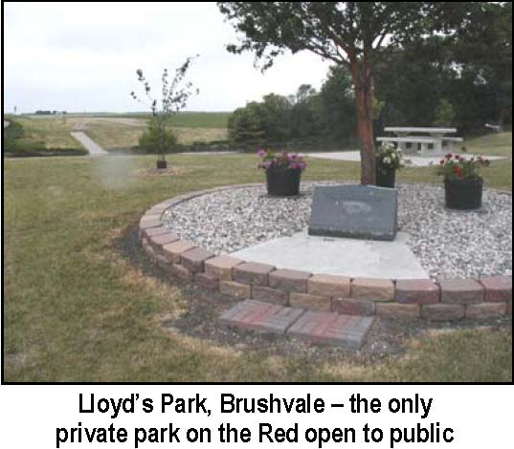
-The North Dakota Department of Transportation will participate in the cost of construction and maintenance of access roads to, and roads within, recreational, tourist, and historical areas (ND Century Code 24-02-37 and 2402-37.1). The NDDOT’s financial participation will be limited to 60 percent of the construction cost, except, within state-owned areas, up to 100 percent may be available. The maximum financial participation will be limited to $250,000.
-Garrison Diversion Conservancy District.
The importance of state and local government, and government and private partnerships cannot be overstated if elements of this plan are to be successfully implemented and sustained. State government may be necessary to initiate projects, but local support is needed to cost-share and provide ongoing maintenance.
G-17 Develop a one-stop-shop for individuals/groups interested in obtaining financial assistance for developing canoeing and boating infrastructure on the Red River.
2. Signage
Outside of urban areas, there is virtually no signage currently in place to specifically inform recreational users of the Red River. Three types of signs could be developed. First, information signs, for safety and orienting, need to be developed for on-thewater users (Figure 5). These signs should be in place at landings, access sites, dams, and all river crossings. They should inform river users of location by river mile (RM) and by name of the landmark (i.e., Interstate-94). Second, signs should be placed that help users find river access locations from major highways. Third, there are many cultural, geologic, and natural history sites along the route that could be identified with interpretive signs. Finally, all of the Red River “Canoe and Boating Route” signs should have a common, unique logo for easy recognition.
G-18 Key all planning elements to a river mile (RM) to minimize repetition and facilitate user needs.
Figure 5. Sample Content of Signs of the Red River Canoe and Boating Route

Red River Route
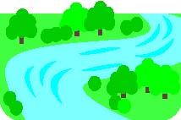
RM _____
On-the-Water Safety and Orienting Sign
Red River Route
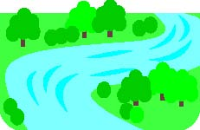

I-94
Fargo Moorhead
RM 455.4
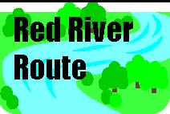
Minnesota’s Champion Peach-Leaf Willow Tree
RM 451.3
Interpretive Sign
Route Information Sign
Adequate signage is an important complement to good maps and brochures– recreational users need to be able to find locations on the ground that are noted on maps. Good maps and signs are critical to a safe, enjoyable experience. Signs and maps make the user more aware of the natural science and cultural amenities of the area as well as help to prevent unintentional trespassing.
G-19 Develop a logo for the Red River Canoe and Boating Trail and use on all signage and electronic/printed material.
G-20 Develop safety and information signs using standard icons to be seen from the water.
G-21 Develop information signs to assist users from major roadways to river access sites.
3. Public Safety and Emergency Response
Safety is of the utmost importance while canoeing and boating on the Red River. In the event of an incident requiring emergency medical or law enforcement assistance, river users need to know how to contact assistance and how to relay their location on the river. For example, a canoeist may need emergency medical assistance in a stretch of the river that is 10 miles from a landing or crossing either upstream or downstream. How does that canoeist summon emergency response? When available, a cell phone and a GPS unit with charged batteries should be carried. Awareness of their river mile (RM) is also helpful. Likewise, emergency responders should have maps showing river miles or GPS. River users may need to get out of the river channel and away from heavy tree cover to acquire an adequate cell phone or GPS signal.

Where appropriate, all electronic and printed canoeing and boating information for the river should include information on how to contact emergency assistance and how to tell the responders where assistance is needed. One factor complicating emergency response is the state border. All emergency responders in all counties and cities in both states need to know, in advance of an emergency, who is responsible for responding.
Dams are a safety concern and two Red River dams – Christine and Hickson – do not have public road access, which could be a problem in an emergency.
G-22 Develop an emergency response system/network for the river with it clearly identified who is responsible for the first response.
G-23 Key emergency response requests to river mile (RM) and/or GPS location.
G-24 Develop road access to all dams for emergency purposes.
4. Public Land
Access and rest sites at appropriate intervals are important for developing a variety of canoeing and boating experiences along the Red River. Clearly, route proponents do not want to condone trespassing on private land except in valid emergency situations. An attempt was made by project staff to identify and catalog public lands adjacent to the Red River. This turned out to be a far greater undertaking than expected, since few of the counties adjacent to the river have their land records in a computerized format suitable for sophisticated searches. Thus, the only reliable method to find public lands, specially recently acquired FEMA or HUD properties, is to manually search records in county recorders’, auditors’, or assessors’ offices.
An alternative to developing a list of public lands prior to knowing where development will likely take place is to search for such land once the general location for a development has been identified. Land ownership for a few miles both up- and downstream of a proposed site should be ascertained to see if any public land within the project area is suitable and available. Whenever possible public lands adjacent to the river should be considered as locations for access and infrastructure development of Canoe and Boating Routes. This will help minimize development costs and avoid land acquisition or easement controversies. However, the opportunity to make use of public land should not automatically override the use of a more strategic location for development.
G-25 Clearly identify public lands (where feasible) on canoeing and boating route maps.
G-26 Acquire river shore access through easements or fee title to meet the recreational and safety needs of Red River canoers and boaters.
5. Multi-Purpose Visits/Achieving Critical “Attraction Mass”
While canoeing may be a destination activity for some travelers to the area, augmenting a canoe trip with other activities might increase the levels of non-local use, leading to opportunities for entrepreneurship and economic development. Other established trails crossing, adjacent to, or near the river need to be identified and copromoted with river activities. Examples include:
National Bicycle Trail Network
(www.adventurecycling.org) Highway 75 King of Trails Coalition North Country National Scenic Trail (www.northcountrytrail.org)
Pine to Prairie Birding Trail, Minnesota’s first, over 200 miles from Fergus Falls to Warroad, 43 sites and 273 species of birds (32-page guide from Minnesota Office of Tourism, 1-800-657-3700)
In addition, Red River Canoeing and Boating Route information needs to be made available to other established trail users, tourism outlets, and vice versa. For example:
Dakota Birding (www.dakotabirding.com) Lewis and Clark Trail (www.ndlewisandclark.com) Casinos (dakotamagic.com) CVB’s (http://www.grandforkscvb.com), (http://www.fargomoorhead.org) Canada’s Trans Canada Trail (www.tctrail.ca)
Pedestrian bridge betweenBreckenridge and Wahpeton at River Mile 547.5
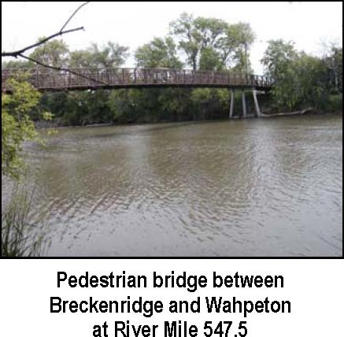
Red River State Recreation Site
(www.dnr.state.mn.us/parksrecreation/redriver/index.html)
6. Water Quality
While the Red River carries a high suspended solids load resulting in turbidity, water quality is generally good for recreational uses. River users should check with reliable sources about water quality issues in the areas they intend to use. There are both Internet locations and toll free telephone numbers to access current water quality. The Red River of the North Basin National Water-Quality Assessment Program report and associated links are available at www.mn.cr.usgs.gov/redn/abs/awra.
Advisories regarding consumption frequencies of fish caught in the Red River should also be consulted when fish are kept for eating.
7. Stream Flows
Red River stream flow is extremely variable. It varies seasonally, from one location to another, from year to year, and hourly or daily depending on current rainfall amounts. A flow of 1,000 cfs (cubic feet/second) may be good for canoeing and boating near the Headwaters, but insufficient near the Canadian border. Likewise, there may be low flows in one stretch of the River and flood flows in another stretch, especially where major tributaries (Appendix A-6) enter.
Peak Mean Low Flow LocationFlow (cfs) Year Flowof Record
Red River, Wahpeton, ND | 12,800 | 1997 | 636 | 1.7
Red River, Fargo, ND | 28,000 | 1997 | 573 | 0
Red River, Grand Forks, ND | 137,000 | 1997 | 2,760 | 1.8
Red River, Emerson, MB | 133,000 | 1997 | 3,630 | 0.9

Users need to be aware of what “normal” flows might be in the stretch of the river they intend to use and compare that to current flow information available on the Internet (www.nd.water.usgs.gov/ public/realtime/rt_red_river.html). There are currently 7 gaging stations along the Red River main stem (Figure 1) for which up-to-date flow data are available.
Users should also be aware of the relationship between stream flow (measured in cfs) and river stage (measured in vertical feet, in relation to flood stage). Trip planning materials should include some coverage of this issue, with reference to where more detailed information is available.
8. Historical Artifacts
River users may come upon natural and cultural artifacts in or near the river. Clearly, any artifact on private land is private property and should be treated as such. Natural artifacts on public property – anything below the normal low water mark – might include animal skulls or other bones, clamshells, driftwood, and living plants and animals. Cultural artifacts could include Native American items or items associated with European exploration and development, such as with the fur trade or steamboat eras.
Log jam
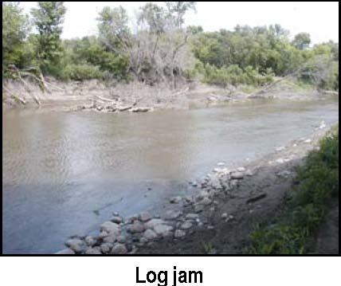
Federal and state statues have wide ranging prohibitions on the removal of items from state (and their political subdivisions) or Federal lands. Removing vegetation, living or dead wildlife or parts, such as antlers and nests, ruins, archaeological or historical artifacts is basically prohibited without a license or permit. Items on state and federal land are illegal to pick up unless not picking them up would result in their immediate loss, in which case they must be turned over to the appropriate landowner with a record of the location where they were found.
Minnesota: Under Minnesota Statutes 138.31 - 138.42, unlicensed field archaeology, defined as the “study of the traces of human culture at any land or water site by means of surveying, digging, sampling, excavating, or removing objects...” is prohibited on any state site. State sites are any “ land or water area, owned or leased by or subject to the paramount right of the state, county, township, or municipality where there are objects or other evidence of archaeological interest”. Bottles or ceramics manufactured after 1875 are not considered historic remains. Minnesota state rules also specifically prohibit removing artifacts from state park and forest lands. Title 6100.0900 specifically outlines “no person...shall disturb, injure, damage, deface, molest, or remove any state property, including but not limited to, wildflowers or vegetation of any kind dead or alive, ruins, archaeological artifacts or sites, ....” Exceptions include legally taken wild animals, and vegetation damaged by ordinary recreational uses.
North Dakota: North Dakota law state has similar provisions. Title 55, Chapter 5502-07 of the North Dakota Administrative Code prohibits the removal of “any historical or archaeological artifact or site that is found or located upon any land owned by the state or its political subdivision...”. State Parks and State Wildlife Management Areas also have similar prohibitions. “No person my destroy, deface, or remove, or disturb, in any manner, any real, personal, or public property, including, but not limited to, geological formation or features, historical and cultural artifacts. (Chapter 58-02-08-10 of the ND Administrative Code). Regulations regarding State Wildlife Management Areas are established in Chapter 30-04-02 of the ND Administrative Code.
Federal: Federal jurisdiction is divided between the Forest Service (Department of Agriculture), National Park Service (Department of the Interior), and the U.S. Army Corps of Engineers (Department of Defense). Possessing, destroying, removing or disturbing, living or dead wildlife or fish or parts, such as antlers or nests, plants, or cultural or archeological resources is prohibited on Federal land managed by the National Park Service (36 CFR- Chapter1-Part 2). Similar regulations are outlined in 36 CFR-Chapter II-Part 261 for land in the National Forest System and in 36 CFR-Chapter III-Part 327 for water resource development projects, either complete or under construction, administered by the U.S. Army Corps of Engineers.
At some sites there may be more stringent regulations. The Red River Valley has a variety of historically and culturally significant sites. Every opportunity should be taken to include information on historical and cultural resources in canoeing and boating maps, Web pages, signs and kiosks. Fort Abercrombie, and Belmont Park (Appendix A-4) are two of several public parks that are located at historically significant sites. Many historically significant locations are on private property such as the Hudson Bay Company site at Georgetown. Excellent discussion on Red River Valley history and cultural resources can be found at: http://www.hjemkomstcenter.com/rrv/main.htm, http://www.state.nd.us/hist/, and http://nrhp.mnhs.org/. In addition, several counties either have or are developing Web sites.

E. Promoting Public Use and Strategic (and Opportunistic) Development
Given what appears to be more than ample physical capacity and growing demand, canoeing and boating uses of the Red River could increase several fold without negatively impacting the resource or reducing the value of individual experiences. Obviously, there are three areas that need deliberate attention in order to realize the stakeholders’ vision for recreational use of the Red River. First, an implementation strategy is needed for the master plan. Second, an active information and education (I&E) campaign is necessary to raise the levels of awareness and knowledge about recreational uses of the Red River. Finally, an ongoing management strategy is important to sustain the plan over time. I&E efforts alone will move some elements of the plan forward, maintenance or modest modification of current infrastructure will accomplish other elements, but investment in new infrastructure will be required to realize the full potential envisioned in the plan.
1. Plan Implementation Strategy
Many goals have been identified throughout the plan. For each of those goals to be met and the overall vision to be accomplished, a prioritization of goals as well as identification of management responsibility need to be developed. Implementing and sustaining a vision requires leadership, accountability, passion, and dedication. The potential for successfully implementing a strategy or plan increases dramatically when a single organizational entity is identified as accountable for implementation and plan sustainability.
The book, River Runs North (Krenz and Leitch 1998), describes the many entities at all government levels and the private sector involved with water management issues in the Red River basin. In addition, there are numerous public and private organizations involved with recreation and economic development (Appendix B-3). However, it is unlikely that a private or not-for-profit organization could maintain the resource base necessary to provide operational expenses to implement and manage the plan without public sector support. However, citizen passion–such as an active canoeing users group–is vital to encouraging support from other public and private stakeholders.
Organizational options for implementing the Canoe and Boating Route Plan include:

- multi-national group, such as International Joint Commission (IJC) or Red River Basin Commission (RRBC)
- Federal government agencies
    - National Park Service (two regions: Rocky Mtn & Midwest)
    - U.S. Fish and Wildlife Service
    - -a new regional group, such as Tennessee Valley Authority
    - - State agencies (need to include both MN and ND)
    - -MN DNR or one of its divisions
    - -ND Parks
    - - ND State Water Commission
    - -ND Tourism -MN Tourism
    - - a new group created through a bi-state compact
    - - Local government
    - collaboration of cities, counties, and other LUGs
    - existing special districts, such as Watershed Districts

-joint powers
-private, non-profit groups
- River Keepers
Although the Trails and Waterways Division of the Minnesota DNR administered development of this plan, which was initiated by the Minnesota Legislature, they are but one option for ongoing plan implementation and infrastructure maintenance. At least one entity already exists whose scope is Red River water management, the Red River Basin Commission (RRBC), which would be a potential candidate for overseeing the plan.
G-27 Identify and support a single responsible entity, existing or new, to implement and sustain the plan.
Fortunately, almost any single component of the plan could be implemented in isolation. That is, nearly all components of the plan can stand alone and could be accomplished as resources are made available. Local governments or special interest groups do not need to wait to implement elements of the plan that are key to their areas. Similarly, plan components covering a broader geographic area can be implemented before or after local projects.
Once the plan administration and management is established, the plan can be implemented in three phases (Table 4).
Construction projects or modification of the riverbank may require a variety of permits. Some of the permitting agencies may include townships, counties, state, federal and water districts.
Table 4. Plan Implementation
YEAR: 1 2 3 4 5 6 7 8 9 10 11+
<====================>
1) PHASE I: Headwaters to Georgetown
(RM 548.7 to RM 415.9) Estimated cost: I&E, $165,000; Canoe, $870,000; Boating/Fishing, $65,000
<======================>
2) PHASE II: Georgetown to Canadian Border
(RM 415.9 to RM 155) Estimated cost: I&E, $75,000; Canoe, $1,725,000; Boating/Fishing, $425,000
<================================>
3) PHASE III: Enhance Infrastructure
(RM 548.7 to RM 155) Estimated cost: I&E, $100,000, Canoe, $1,500,000; Boating/Fishing, $575,000
<============================================> Plan management and infrastructure maintenance Estimated cost: $200,000 to $700,000+/year
a. Information and Education. An active I&E program needs to be established and maintained. This should include internet sites, hard copies of materials (primarily maps), a 1-800 phone number, and a physical location. As I&E material is developed, adequate collaboration should take place with local, state and federal agencies. One of the opportunities is for collaboration with the current development of the Red River State Recreation Area. I&E material should include cultural, historical and safety information as well as promotion of other regional recreational opportunities.
Care must be taken however, to limit active promotion to opportunities currently available. Current increased interest in the opportunities for recreational use of the Red River has resulted in some frustrated users. Appropriate infrastructure must be developed to satisfy the user.
Recommendations for specific implementation activities include:
PHASE I: I&E, the first 133 miles, from now to 5 years out
Interactive internet site for canoeing, fishing, and boating uses of the first 133 miles [$20,000 to establish]11.
Paper copies of a river map for the first 133 miles including detailed inserts, or separate maps for Wahpeton-Breckenridge and Moorhead-Fargo. See, for example, MN DNR canoe route maps (“Canoeing the St. Croix,” September 2002, is an excellent example)and Mississippi Headwaters Board (www.mhbriverwatch.dst.mn.us) river trail maps [$35,000].
Canoeing guides (American Canoe Association [www.aca-paddler.org]1996) to encourage safe and enjoyable canoeing [$25,000].
Red River information added to MN DNR’s existing 1-800- information line [$10,000].
Signs on 22 road bridges and 4 pedestrian bridges with identification and River Mile [$15,000].
Red River Canoe and Boating Route information kiosk in Breckenridge at headwaters [$25,000].
Historic sites directory by River Mile, RM 548.7 through RM 415.9 [$30,000].
PHASE II: years 3 through 8–the next 264 miles from Georgetown to Canadian border
Enhance the Internet site to include the next 264 miles [$10,000].
Paper copies of a river map for the next 264 including detailed inserts, or separate maps for East Grand Forks-Grand Forks [$35,000].
Historic sites directory by River Mile, RM 4159 through RM 155 [$30,000].
PHASE III: completed by the end of year 10
Red River Canoe and Boating Route information kiosk in Moorhead at Hjemkomst Center[$25,000].
Red River Canoe and Boating Route information kiosk in East Grand Forks [$25,000].
Signage for historic sites (i.e., ox cart trails) on the river and at surface transportation locations [$50,000].
b. Canoeing: In order to make current uses as safe and as enjoyable as possible and to increase use from an estimated 10,000 hours/year to 30,000 hours/year in five years and 45,000 hours/year in ten years, several developments must happen.
11The costs included in brackets are estimates, based on approximate current costs and
development/construction done to State standards. Costs would be shared by development partners, including state
agencies, federal agencies, local government units, and private organizations. Maintenance costs could be assumed
to be from 3 to 10 percent of initial development costs.
PHASE I: from now to 5 years forward–the first 133 miles
Campsite and canoe access at Wolverton (RM 504), canoe egress from river, toilet, fire rings, picnic tables, boundary identification, campsites, signs, landowner easement [$75,000].
Ten road access sites for canoeists with parking, river egress/ingress, and signage [$20,000 each, $200,000 total].
Legal (easement) portages around Christine and Hickson dams, signs, canoe egress from river [$20,000/dam].
Georgetown/Ruperts Landing (see Appendix B-6 for Georgetown Park lease information) terminal site of 133-mile route and roadside monument, w/canoe access, parking, primitive camping [$100,000].
In-stream safety marking policy for dams [$5000].
Basic, 2-acre canoeist rest stops approximately every 5 river miles, with river egress/ingress, no services, 13 new rest stops are needed to meet this goal (e.g., RM 542, 531, 518, 510, 496, 491, 485, 482, 477, 472, 433, 428, 423) [$10,000 each, $130,000 total].
Overnight campsites approximately every 15 to 20 miles. Three are required in addition to those existing or currently under development:
Overnight campsite near Red-Sheyenne confluence, approximately RM 430
[$100,000].
Overnight campsite at Hickson, approximately RM 483 [$100,000].
Overnight campsite at MB Johnson Park, approximately RM 446 [$100,000].
Portage at Moorhead’s North Dam (RM 448.9) [$20,000].
PHASE II: years 3 through 8–the 264 river miles from Georgetown to the Canadian border. Phase II would extend the opportunities for canoeing for another 264 river miles.
Identify detailed canoe and boating route infrastructure needs (i.e., as in Phase I) [$25,000].
Approximately 50, 2-acre canoeist rest stops to meet 5-mile interval goal [$10,000 each, $500,000 total].
Ten overnight campsites to meet 15 - 20 mile interval goal [$100,000 each, $1-million total].
Ten canoeing road access sites with parking [$15,000 each].
Actively market the Headwaters to Georgetown canoe and boating route to destination visitors [$50,000].
PHASE III: completed by the end of year 10
Bring selected reaches of the canoe and boating route into ADA compliance
[$500,000].
Enhance primitive overnight campsites, access sites, and rest stops [$1 million].
c. Boating/Fishing: In order to make current uses as safe and as enjoyable as possible; encourage development of private guiding and outfitting businesses; and to increase use from an estimated 150,000 hours/year to 300,000 hours/year in five years, and to 450,000 hours/year in ten years, several developments must happen.
PHASE I: from now to 5 years forward–the first 133 miles
ADA shore fishing, overlook, and canoe/boat use compliance at Headwaters in
Welles Park [$25,000].
Shore fishing pads at Wolverton [$10,000]. Shore fishing pads downstream of Fargo-Moorhead’s North Dam; remove hazards [$30,000 ].
PHASE II: years 3 through 8–the next 264 miles from Georgetown to Canadian border. Double boat ramp at East Grand Forks [$100,000]. Actively market Red River fishing opportunities to destination anglers [$50,000]. Repair/replace the boat ramps at Hendrum and Halstad [$125,000]. Replace boat ramp at river miles179.6 and 236 [$200,000].
PHASE III: completed by the end of year 10
Boat ramp at Georgetown/Ruperts Landing [$75,000].
Shore fishing pads with access paths and parking at all river access locations (i.e., canoe access sites, camp sites, boat ramps) and in strategic locations in more densely populated areas [$500,000].
2. Plan Maintenance Strategy
Once leadership/responsibility for plan implementation is established, and implementation of the plan has started, an ongoing effort needs to be made to encourage all stakeholders to “buy into” the plan. Stakeholders need to support the plan politically, financially (if appropriate), and morally. The plan and its components will not likely be implemented without buy-in among stakeholders. Encouraging buy-in involves starting with a sound plan that is easily articulated to stakeholders and keeping them involved.
Public input is crucial during plan implementation and route operational stages. There should be ample, convenient, and encouraging mechanisms for the public to comment. All printed, electronic, and video materials should include an invitation for public input. Input could be invited through printed feed back forms, Internet connections, a 1-800 telephone number, and the names of selected individuals to contact.
Plan proponents need to encourage the organization of an active river users group to serve as the private sector “cheerleaders” for ongoing development of the Red River canoe and boating route.
Process for ongoing stakeholder input during all implementation Phases
Maintain advisory board(s) [$5,000/year].
Maintain comprehensive stakeholder directory and mailing list and distribute paper and electronic newsletters/mailings to stakeholders [$10,000/year].
Create a visible booth presence at meetings, county fairs, ... [$10,000/year].
Canoe and boating route maintenance. Maintaining the infrastructure, the printed and electronic materials, a dynamic plan, and coordinating ongoing plan implementation will require an annual outlay of resources. If all suggested developments listed under Phases I through III are implemented, the ongoing operation and maintenance costs could be $200,000 to $700,000 or more per year. These costs would include both hard costs (actual dollar expenditures) and soft costs (in-kind and volunteer services) and would be shared by the many partners involved in each of the individual elements of the overall plan.
3. What next?
The plan should be distributed widely throughout the Red River Valley and to agencies and groups outside the valley with interest or responsibility for recreational uses of the Red River.
G-28 An active, comprehensive web site for the Red River (www.rrbdin.org) exists and should be used to disseminate the plan and display informational materials (e.g., maps).
If the Minnesota DNR wants to keep the plan active, an entity needs to be identified to be responsible. An example of such a cross-boundary private, non-profit entity is River Keepers.
Go to work on Phase I, with an emphasis on the Headwaters site and the Georgetown terminal site keystone projects for the first 133 miles.
III. REFERENCES
Arrowhead Regional Development Commission. 1997. Carlton County Recreation Plan for the St. Louis River Corridor. In cooperation with Carlton County (Minnesota), City of Cloquet (Minnesota) and Minnesota Department of Natural Resources.
American Canoe Association. 1996. Introduction to Paddling: Canoeing Basics for Lakes and
Rivers. Menasha Ridge Press, Birmingham, Alabama (www.menasharidge.com). Baltezore, James F. and Jay A. Leitch. 1990. Projected Needs in Outdoor Recreation in North Dakota: 1990-2000. Agricultural Economics Miscellaneous Report No. 125, Agricultural Experiment Station, North Dakota State University, Fargo.
Breining, Greg. 1999. Paddling Minnesota. Falcon Publishing Inc., Helena, Montana. Carter, Mary. 1980. “Canoeing on the Red.” Horizons 10(3):20-27. “Connecting with Minnesota’s Urban Rivers.” www.nextstep.lstate.mn.us/update.cfm. “Fish, Wildlife, and Outdoor Recreation.” 2000. Red River Basin Board. A part of Red River
Basin Board, Inventory Process, Final Reports, CD-R, December 2000. “Fishing in ND.” 2002. North Dakota Game and Fish Department,
www.state.nd.us/gnf/fishing/redbro.
Hilderman-Thomas-Frank-Cram. 1998. Canadian Heritage River System: Red River Background Study. Prepared for Parks Canada, Department of Canadian Heritage, Winnipeg.
“Greenway on the Red” RiverWatchOnline, www.riverwatchonline.org/greenway.
IJC (International Joint Commission). 2000. Living with the Red. Washington, DC and Ottawa.
Krenz, Gene and Jay Leitch. 1998. A River Runs North: Managing an International River (2nd printing). Red River Water Resources Council, Bismarck, North Dakota (State Water Commission).
Koel, Todd M. and John J. Peterka. 2001. “Distribution and dispersal of fishes in the Red River basin.” Chapter 6, pp. 57-62 in Jay A. Leitch and Mariah J. Tenamoc (eds.), Science and Policy: Interbasin Water Transfer of Aquatic Biota, Institute for Regional Studies, North Dakota State University, Fargo.
Leier, Doug. 2002. “Catfishing on the Red.” North Dakota Outdoors 55(1):11-14.
Minnesota Atlas & Gazetteer: Topo Maps of the Entire State. 1994. DeLorme, Yarmouth,
Maine. MN DNR. 2002. Minnesota Boating Guide: a summary of laws & rules. St. Paul (www.dnr.state.mn.us/boating.html) .
MN DNR. 2002a. Minnesota Fishing Regulations. St. Paul (www.dnr.state.mn.us) .
MN DNR. 1996. Red River of the North Angler Survey, 1994. Division of Fish and Wildlife, Minnesota F-29-R(P)-12, Study 4, Job 322, St. Paul. MN DNR and ND Game and Fish. 1996. Red River Angler’s Guide. National Park Service. (1996). Economic Impacts of Protecting Rivers, Trails and Greenway
Corridors. Washington, D.C.
North Dakota Environmental Directory. May 2001. North Dakota Natural Science Society and North Dakota Chapter of The Wildlife Society. ND Game and Fish Department. 2002. Angler Use and Sport Fishing Catch Survey on Red
River, North Dakota, March 15 through October 31, 2001. Project F-2-R-48, Study 3, Bismarck.
North Dakota Parks and Recreation. 1995. North Dakota Outdoor Adventure Guide. Bismarck. Pich, Wilmer and Fred Ryckman. 1987. “The Red River of the North: The Rodney Dangerfield River.” North Dakota Outdoors:30-34.
Prchal, Davy and Utreu. 1995. North Dakota 1996-2000 State Comprehensive Outdoor
Recreation Plan. 1996. North Dakota Parks & Recreation Department, Bismarck. Prchal, Douglass, Karen Assel, Jay A. Leitch, Steven A. Hirsch, and Darla J. Christensen. 1995. North Dakota 1996-2000 State Comprehensive Outdoor Recreation Plan. North Dakota Parks and Recreation Department, Bismarck.
Red River Basin Board. 2000. Red River Basin Board: Inventory Process Final Reports. Fish, Wildlife & Outdoor Recreation (Final Draft). CD format, Moorhead, Minnesota
Schlueter, Lynn. 1995. “The Red River of the North.” North Dakota Outdoors:6-10. Sevareid, Eric. 1968 (first published in1935). Canoeing with the Cree: A 2,250-mile voyage from Minneapolis to Hudson Bay. Minnesota Historical Society Press, St. Paul.
State of Minnesota BaseMap’99. 1999. MNDOT-GIS-1002, CD-R, Minnesota Department of Transportation.
Stockdill, Particia. 2002. “It’s more than a border between Dakota and Minnesota, it’s a great fishery.” Dakota Country 16(5):62-63.
USGS. (Brochure) Canoeing North Dakota’s Rivers. Water Resources Division, Bismarck, North Dakota. (See http://nd.water.usgs.gov/canoeing/)
Water Trail Directory. 2002. www.watertrails.org.
White House Millennium Council. 2001. Honor the Past–Imagine the Future. U.S. Government Printing Office, Washington, DC.
IV. WEB ADDRESSES
www.aca-paddler.org American Canoe Association www.adventurecycling.org National Bicycle Trail Network http://backwtrl@fishingminnesota.com Fishing Minnesota www.bayoutrails.org Atchafalaya (Louis.) Water Trails www.catchbigcats.com Catch Big Cat’s Guide Service http://www.cr.nps.gov/linklaws.htm Federal Regulations www.dakotabirding.com Dakota Birding www.dakotamagic.com Dakota Magic Casino www.dnr.state.mn.us Minnesota DNR Trails and Waterways http://files.dnr.state.mn.us/education_safety/safety/boatwater/drowningmachine.pdf http://files.dnr.state.mn.us/rpl/regulations/boatwater/boatinguide02.pdf http://www.fargomoorhead.org Fargo-Moorhead Convention Bureau www.fmmetrocog.org/mbpc/bikemap.pdf Fargo-Moorhead Metro Bicycle Map http://www.grandforkscvb.com Grand Forks Convention Bureau http://www.hjemkomst-center.com/rrv/main.htm Hjemkomst Center www.hvpaddle.org Housatonic (Conn.) Valley River Trail www.ijc.org International Joint Commission www.mhbriverwatch.dst.mn.us Mississippi Headwaters Board www.mn.cr.usgs.gov/redn/abs/awra Red River Water Quality Assessment Program www.ndlewisandclark.com Lewis and Clark Trail www.ndparks.com North Dakota Parks and Recreation
www.nd.water.usgs.gov/canoeing/ Canoeing North Dakota’s Rivers http://nd.water.usgs.gov/public/realtime/rt_red_river.html USGS Water Resources Site www.northcountrytrail.org North Country Trail http://nrhp.mnhs.org Minnesota Historical Society www.quickfacts.census.gov U.S. Census Bureau www.redriverbasinboard.org Red River Basin Commission http://www.revisor.leg.state.mn.us/st02/138 Minnesota Statutes 2002 http://www.revisor.leg.state.mn.us/st2000/85/32.html Minnesota Statutes 2000 www.rrbdin.org Red River Basin Disaster Information Network www.rrbdin.org USGS www.rrv.net/hendrum City of Hendrum, Minn. www.shawecovillage.com Susquehanna (Maryland) River Water Trail Extension www.state.nd.us/gnf North Dakota Game and Fish http://www.state.nd.us/hist/ North Dakota Historical Society http://www.state.nd.us/lr//information/rules/admincode.html ND Administrative Code www.state.nd.us/ndparks North Dakota Parks and Recreation www.tetrail.ca Canada’s Trans Canada Trail www.topowest.com FreeTopo maps www.trgt.org Tennessee River Blueway www.water.usgs.gov/waterwatch/ USGS flow info
APPENDICES
(Sources: US Army COE, 1987, Dam Inventory: Red River Basin, North Dakota, St. Paul District and other sources) MSL
APPENDIX A-1. DAMS
River Mile | Name/Description | Elevation | Portage | Road Access
546.4 | Kidder Dam (0718075) Retrofitted w/boulders in 2001 Owner: City of Wahpeton |  | Yes, Minn. side Yes, stairway on ND side (under development)
496.5 | Christine Dam (0718103) (FM Water Task force has recommended a study) Owner: City of Fargo |  | Difficult |  | None
482.7 | Hickson/Fargo #3 (0718112) (FM Water Task force has recommended a study) Owner: City of Fargo |  | Difficult |  | None
458.1 | Fargo South Dam (0719133) At River Oaks Park Emergency ramp on ND side downstream, no public access Dam planned for winter 2003 retrofit Owner: City of Fargo, built in 1933 |  | yes, ND side under development as part of 2003 retrofit |  | No road access on either side carry- in on MN side at River Oaks Park

APPENDIX A-1. DAMS (cont.)
MSL
River Mile | Name/Description | Elevation | Portage | Road Access
452.2 | Fargo Mid-Town Dam 10’h, 120' wide; Purpose: water supply Rebuilt w/boulders in 2000 Owner: City of Fargo First built in 1961 | 880' | ND side using boat ramps | excellent on ND side, paved, parking None on MN side
448.9 | Fargo North Dam 7.7’ high, 108’ wide Rebuilt w/boulders in 2002 Purpose: water supply Owner: City of Fargo First built in 1933 | 869' | MN side has dirt trail | good when dry on MN side City Park on ND side
296.1 | Grand Forks Dam Rebuilt w/boulders in 2001 13'H, 100'L Riverside Park Dam | 798' | yes, ND side has dirt trail | ND side has gravel road access with parking space. Good when dry.
 | Purpose: water supply Owner: City of Grand Forks First built in 1925
203.4 | Drayton Dam 12' high, 145' wide (Under study by COE) Purpose: water supply Owner: City of Drayton Built in 1964 | 763' | yes | excellent on ND side when dry, campground parking on ND side

APPENDIX A-2. LANDMARKS
Significant landmarks not included in Appendices A-1 through A-6.
River mile Description Photo name *GPS Coord. 1 GPS Coord. 2
547.7 Golf Course Pedestrian Bridge 0718072 685162 5127757 Railroad Bridge 682063 5135964
454.2 Pedestrian Bridge P6050023 668776 5191301 P6050024
452 Pedestrian Bridge (Seasonal) 669080 5193288
Railroad Bridge 669410 5193603 Railroad Bridge 669469 5194169
450.45 Oak Grove Park Pedestrian Bridge P8140177 670035 5194053 Railroad Bridge 647524 5309925 Railroad Bridge 647133 5310078 Railroad Bridge 638063 5339527 Railroad Bridge 630041 5429305
*GPS coordinates are in UTM 14 NAD83.
APPENDIX A-3. BOAT LAUNCH RAMPS AND CANOE ACCESS SITES
Boat Launch Ramps
River Mile | Description |  | Photo | *GPS Coord. 1 |  | GPS Coord. 2
548.7 | Headwaters, confluence of the Bois de Sioux & Otter Tail Concrete plank ramp w/paved parking lot, fishing pier, picnic shelter, Friendship sculpture, additional parking in adjacent Welles Memorial Park and Fairgrounds Owner: City of Breckenridge No fees, open 24/7 |  | 0718066 | 685034 |  | 5126219
546.3 | Kidder Recreation Area, north Wahpeton, concrete ramp w/dock Owner: Wahpeton Park District No fees, open 24/7 |  | P6120030 | 685100 |  | 5129011
536.3 | Brushvale, Brushvale Bridge Recreation Area, concrete ramp on ND side, parking available Lloyd’s Park picnic area on MN side Owner: Richland County No fees, open 24/7 Primitive camping allowed, no toilets |  | P6120047 | 680124 |  | 5137801
523.2 | Abercrombie, concrete boat ramp on ND side, new in 2002 Owner: City of Abercrombie No fees, open 24/7 |  | 0718085 | 674986 |  | 5146221
462.0 | Ivan Park/Convent Landing, concrete ramp on ND side, parking New in 1998 Owner: Fargo Park District No fees, open 7 am to 10 pm - seasonal |  | 0719129 | 667913 |  | 5185818
*GPS coordinates are in UTM 14 NAD83.

APPENDIX A-3. BOAT LAUNCH RAMPS AND CANOE ACCESS SITES (cont.)
Boat Launch Ramps (cont.)
River Mile |  | Description |  | Photo | *GPS Coord. 1 |  | GPS Coord. 2
458.1 | Emergency concrete ramp, no public road access Scheduled to be replaced in 2003-04 Owner: City of Fargo Walk in only, daylight use only, no fees |  | P6050002 |  |  | 668305 | 5188902
454 | Lindenwood Park, between campground and pedestrian Bridge, dirt ramp, carry in only, parking Owner: Fargo Park District No fees, closes at 10pm – seasonal |  | P6050019 |  |  | 669653 | 5191005
454.2 | Lindenwood Park, immediately downstream of pedestrian Bridge, dirt ramp, carry in only, no parking Owner: Fargo Park District No fees, closes at 10pm |  | P6050026 |  |  | 668720 | 5191351
452 | Fargo Mid-town dam/upstream, 20' w X 60' long concrete ramp on ND side, new in 2000, paved parking Owner: Fargo Park District No fees, open 24/7 seasonal |  | P6120038 |  |  | 668965 | 5193137
451.8 | Fargo Mid-town dam/downstream, 20’ x X 60’ long concrete ramp on ND side new in 2000, paved parking Owner: Fargo Park District No fees, open 24/7 seasonal |  | P8200014 |  |  | 668955 | 5193372

*GPS coordinates are in UTM 14 NAD83. *GPS coordinates are in UTM 14 NAD83. *GPS coordinates are in UTM 14 NAD83.
APPENDIX A-3. BOAT LAUNCH RAMPS AND CANOE ACCESS SITES (cont.)
Boat Launch Ramps (cont.)
River Mile | Description | Photo | *GPS Coord. 1 | GPS Coord. 2
445.7 | MB Johnson Park on MN side, twin concrete ramps, paved parking Owner: City of Moorhead No fees, closes at 10 pm - seasonal | P8200013 | 670636 | 5198059
386.3 | Hendrum, concrete plank boat ramp, NEEDS REPAIR Owner: Norman County Open 24/7, no fees | P1010026 | 663779 | 5237161
375 | Halstad, previous concrete plank boat ramp, removed in 1999, located under Highway 200 bridge, If dry, depending on river elevation, boat launch possible Site for potential ramp Open 24/7 | P1010034 | 663028 | 5246620
332.8 | Belmont Park, Frog Point, boat ramp on ND side, east of Buxton Concrete ramp, parking, camping, toilets Owner: Traill County Park Board No ramp fee, camping $5/day, closes at 10 pm | P1010053 | 659302 | 5276709
298 | East Grand Forks Owner: City of East Grand Forks No fees, open 24/7, area is under reconstruction in 2002 | P8190005 | 647698 | 5309947

APPENDIX A-3. BOAT LAUNCH RAMPS AND CANOE ACCESS SITES (cont.)
Boat Launch Ramps (cont.)
River Mile | Description | Photo | *GPS Coord. 1 | GPS Coord. 2
296.0 | North Forks landing, concrete ramp, 1.5 miles N of US Hwy #2 Owner: City of Grand Forks No fees, open 24/7 | P8190010 | 645044 | 5312549
271.3 | Oslo, N side of Hwy #1, concrete ramp, floating dock Picnic tables, parking Owner: City of Oslo No fees, open 24/7 | P1010072 | 638249 | 5339660
208.x | Hastings Landing, downtown Drayton, concrete ramp, parking, fishing platform East of city water tower Owner: City of Drayton No fees, open 24/7 | P1010088 | 634437 | 5380266
203.4 | North of Drayton, downstream of dam, concrete ramp, campsite, fire rings, fish cleaning station, bathroom Owner: City of Drayton No fees, open 24/7 | P1010095 | 636174 | 5384618
 | Catfish Haven, private ramp3 miles east, 3 ½ miles north of Drayton, ND Located on MN side of river | P1010097 | 638684 | 5388002

APPENDIX A-3. BOAT LAUNCH RAMPS AND CANOE ACCESS SITES (cont.)
Boat Launch Ramps (cont.)
River Mile Description Photo *GPS Coord. 1 GPS Coord. 2
179.6 MN #175 bridge, NE side, 10 miles west Hallock 635337 5405423 of Hallock, reported to have a concrete plank ramp Ramp Unable to locate planks in two site visits Owner: No fees, open 24/7
158.4 Pembina, concrete ramp, campground Pembina br 628851 5425127 Fish cleaning station, parking Owner: State of North Dakota No fees, open 24/7, camping fees, no swimming or sunbathing at ramp
Canoe Carry-in Access Sites
*All of the boat ramps can be used for canoe access. *Most of the 32 road crossings can be used as canoe access sites–check the list of road crossings for carry-in suitability.
503 Wolverton, proposed site for canoe access/campground 0718101 673088 5159171 Owner: City of Wolverton
494.85 Wilkin Co. #190, 120th St. bridge (bridge is gone) P8190002 670749 5163396 Canoe access site
454 Several carry-in sites at Lindenwood park, parking
Adjacent to campground P6050018 667660 5191273
Canoe access site w/parking P6050019
Pedestrian bridge abutment P6050024
South of pedestrian bridge P6050026
Owner: Fargo Park District
No fees, open 7am to 10pm seasonal
*GPS coordinates are in UTM 14 NAD83.
APPENDIX A-3. BOAT LAUNCH RAMPS AND CANOE ACCESS SITES (cont.)
Canoe Carry-in Access Sites
River Mile | Description | Photo | *GPS Coord. 1 | GPS Coord. 2
451.4 | SS Ruby landing, ADA ramp, paved parking Owner: City of Moorhead No fees, open 24/7 | 8140163 | 669089 | 5193913
 | Oak Grove Park, River Front Park, parking on MN side Owner: Fargo Park District and Moorhead No fees, parks close at 10pm | 8140177 | 669893 | 5194063
449.2 | Mickelson Field, canoe landing just south of toll bridge on ND side Owner: Fargo Park District No fees, open 24/7 | 8140184 | 669461 | 5195270
 | Fargo North Dam, canoe landing possible downstream of dam on both sides of the river Owner: City of Fargo owns the dam No fees, Moorhead side is open 24/7, Fargo side 7am to 10pm - seasonal | P8130121 | 0669791 | 5195567

*GPS coordinates are in UTM 14 NAD83.
APPENDIX A-4. PARKS AND CAMPGROUNDS
River Mile Name (photo)
548.7 Headwaters Park (0718070) Established 1918 Picnic shelter 3 acres connected to Welles Park w/pedestrian bridge Electrical Hook-up site $10 Flush restroom, 5/1 to 10/1, picnic shelters
548.7 Welles Park (0718053) Owner: City of Breckenridge Fees: No fees for park use, fees for camping Hours: closed except for campers from 10:30 pm to 5:30 am Phone/web: 218-643-3455 www.breckenridge.net Address: 100 Nebraska Avenue Services: five primitive campsites, 2 w/electricity, parking, fire ring w/free wood, tables, flush toilets, ADA
547.7 Chahinkapa campground (0718071) Owner: Wahpeton Parks and Recreation Fees: $10/night/vehicle; $7/night for tents; reservations for $5 extra Hours: 24/7 Phone/Web: 701-642-2811 www.wahpeton.com Location: 2nd Street and 8th Avenue North Services: 8 trailer sites w/hookups, tenting areas, showers, restrooms, zoo, golf, shelters
546.6 Kidder Recreation Area (0718077) Owner: Wahpeton Parks and Recreation Fees: $10/night/vehicle; $7/night for tents; reservations for $5 extra Hours: 24/7 Phone/Web: 701-642-2811 www.wahpeton.com Location: south side of the Hwy. 210 bypass. Entrance is north of 18th Avenue. Services: Eight trailer sites with electrical and water hookups, tenting areas (unlimited stay), showers, restrooms, fish cleaning station, picnic shelter, boat ramp and fishing piers. Shower room and restroom.
APPENDIX A-4. PARKS AND CAMPGROUNDS (cont.)
River Mile Name (photo)
536.3 Brushvale Bridge Recreation Area Wilkin Co. #18 bridge (P6120046) (Richland Co. #8); boat ramp, N of bridge on ND side. Primitive camping allowed adjacent to the ramp, Lloyd McKibben Park on Minnesota side (private, open to public w/picnic table) 1 mi. west of Hwy. 75.
523.2 Ft. Abercrombie (0718092) Owner: North Dakota Historical Society Fees: admission charge for museum, camping free Hours: site open 24/7; museum open 5/16 to 9/15 Phone/Web: www.state.nd.us/hist/ Services: Site includes recreational facilities, local museum, and historic site. No hookups, primitive camping, fires in designated locations only, self-contained RV’s allowed. Modern facilities in the museum available when museum open. Boat ramp.
504 Wolverton primitive (0718099)- PROPOSED Construction of canoe landing and primitive campground pending.
503.4 Wolverton City Campground (0718098), one-mile walk from river Owner: City of Wolverton Fees: $10/night; $150/month Hours: 24/7 Phone/Web: 218-995-2526 Services: Four campsites with water, sewer, electricity, picnic table at each campsite, tents ok, no showers or restrooms (seasonal restrooms available at nearby ball diamond), picnic tables and shelter.
485+/-Phase III overnight campsite (Oxbow CC, Hickson Dam possible sites)
467.3 Forrest River Estates primitive (0719124) - PROPOSED
APPENDIX A-4. PARKS AND CAMPGROUNDS (cont.)
River Mile | Name (photo)
455 | Lindenwood Park (P6050014) Owner: Fargo Park District Fees: RV campsite $20/day; tent $10/day; limit 14 nights/month Hours: 24/7, May 1 through Oct 15 Phone/Web: 701-232-3987, 701-241-1350, www.fargoparks.com Services: Multi-use park with five picnic shelters, six softball diamonds, a baseball diamond, landscaped campground, two tot playgrounds, restrooms, six sand volleyball courts, 45 campsite with water and electricity, 12 tent sites without water.
446 | MB Johnson Park (P8200013) Owner: City of Moorhead Fees: none
 | Hours: park closes at 10:00 p.m. Phone/Web: 218-299-5340, www.cityofmoorhead.com No services, no water or electricity, camping allowed with permission, chemical toilets usually available, picnic tables and shelter, boat ramp
427.5 | Catch Big Cats Guide Service (no photo) Owner: Dennis Flom
 | Fees: $75 to $175/day depending on service Hours: flex.
 | Phone/Web: 701-484-9395, www.catchbigcats.com Services: Private catfish guiding and lodging.

430+/-(Midway between MB Johnson (RM 446) and Georgetown (RM 416) - PROPOSED
APPENDIX A-4. PARKS AND CAMPGROUNDS (cont.)
River Mile | Name (photo)
417 | Georgetown County Park (P1010016) Terminus of 130-mile route Adjacent to site of historic Hudson Bay site Owner: Clay County Hours: Not open to the public (site leased to local blackpowder club), see Appendix B-4 Services: none
386.3 | Hendrum (P1010025) - PROPOSED
386.3 | Hendrum Community Park (P1010030) (2 miles EAST of the Red River and ½ mile east of Hendrum, on the Wild Rice River, accessible by canoe depending on river elevations). Owner: City of Hendrum & Hendrum Township Fees: donations Hours: 24/7 Phone/Web: 218-861-6210 Services: Three RV hookups with electricity and water, tents ok, restroom, no showers, fire rings
375 | Halstad (P1010035) - PROPOSED
332.8 | Belmont Park Frog Point (P1010055) Owner: Traill County Park Board Fees: Camping $5/day, no ramp/park fee Hours: closes at 10:00 p.m. Services: Bathrooms, electricity, shelter, boat ramp
297.5 | Red River State Recreation Area (UNDER DEVELOPMENT) (In city of E. Grand Forks) Owner: MN DNR Phone/Web: 218-773-4950, www.dnr.state.mn.us/parks_recreation/redriver/index.html

APPENDIX A-4. PARKS AND CAMPGROUNDS (cont.)
River Mile Name (photo)
280.7 Turtle River Snowmobile Club, POTENTIAL campsite, 200' off the river Owner: Turtle River Snowmobile Club Phone: Dave @ 701-775-5403
271.3 Oslo (P1010076), Primitive camping Picnic tables, dock Owner: City of Oslo Fees: None Hours: 24/7 Phone/Web: 218-695-3841, www.ci.oslo.mn.us
271.0 Oslo City Campground (P1010079), 4 blocks from river Owner: City of Oslo Fees: $6/night Hours: 24/7 Phone/Web: 218-695-3841, www.ci.oslo.mn.us Services: Electricity and water hookup for trailers, tenting ok, restrooms, no showers, picnic tables, 2 large shelters with electricity, boat ramp 4 blocks away
242 Joliet Ferry State Wildlife Management Area (560 acres), new in 2002, primitive camping allowed, no facilities, potential boat ramp site Owner: State of North Dakota
APPENDIX A-4. PARKS AND CAMPGROUNDS (cont.)
River Mile Name (photo)
208 Drayton City Park/Schumacher Park (P1010089), no fishermen allowed
Owner: Drayton Park District
Fees: $7/night US; $12/night Canadian
Hours: 24/7
Phone/Web: 701-454-3830 or 701-454-3502, www.draytonnd.com/parkdist
Services: Electric and water hookups, dump station, restrooms with flush toilets, showers, shelter with picnic tables,
tennis court, basketball court, playground, ball diamonds
203.4 North of Drayton, downstream of dam, concrete ramp, campsite, fire rings, fish cleaning station, bathroom (P1010095) Owner: City of Drayton No fees, open 24/7
197.5 Catfish Haven (private) (P1010096) Located 3 miles east, 3 ½ miles north of Drayton, located on MN side of river Owner: recently sold, check local listing for current contact information Services: full hook ups, tenting, fish cleaning station, boat ramp
158.4 Fort Daer Campground (P1010103), at mouth of Pembina River Owner: City of Pembina Fees: $10/night for modern sites; $7/night for tent sites Hours: 24/7 seasonal Phone/Web: 701-825-6819, pcityofc@polarcomm.com Services: 12 sites with electricity and water, tent sites, shower, modern restrooms, sewer, picnic tables, shelter, fire rings, boat ramp, fish cleaning station with running water.
Rest Stops *River travelers can stop at any public boat ramp, bridge crossing right-of-way, public park, public campground; but be aware of the condition of the riverbank at some of these areas. The majority of the river bank is privately owned.
APPENDIX A-5. ROAD CROSSINGS
River Mile Description546 Hwy. 210 Bridge
536.3. Wilkin Co. #18 Bridge (Richland Co. #8)
523.65 Wilkin Co. #22 Bridge (Richland Co. #28)
514.9 Wilkin Co. #28 Bridge (Richland Co. #4)
502.1 Wilkin Co. #30 (Richland Co. #2)
494.85 BRIDGE OUT (Wilkin CO. #90, 56th St.)
485.1 Clay Co. #2 Bridge (Cass Co. #18)
474.1 Clay Co. #8 Bridge (Cass Co. #16)
PhotoP6120028
P6120046
0718083 0718095 0718102 P8190002 0718110 0719114
AccessUse Ramp S of Bridge on ND side Boat ramp, N of bridge on ND side Emergency only Road right-of-way Road right-of-way POTENTIAL Road right-of-way Right-of-way on MN side
Nearest Town Wahpeton, ND
Brushvale, MN 1 East
Abercrombie, ND Abercrombie, ND 3
South Christine, ND ½ West Christine, ND Hickson, ND Rustad, MN 2 East
1Crossings are named on the base maps and their RM location is noted.
APPENDIX A-5. ROAD CROSSINGS (cont.)
River Mile | Description | Photo | Access | Nearest Town
462.05 | Clay Co. #74 Bridge | 0719131 | Emergency only | Fargo, ND
455.4 | I-94 Bridge | P6050011 | MN side under bridge | Fargo/Moorhead
451.7 | Main Avenue (Fargo/Moorhead) | P8140151 | Emergency only | Fargo/Moorhead
451.6 | Center Avenue (Mhd.) (NP Avenue, Fargo) | P8140155 | Emergency only | Fargo/Moorhead
451.4 | 1st Avenue N. (Fargo/Moorhead) Bridge | P8140162 | SS Ruby dock w/ADA access on MN side | Moorhead
449.05 | 15th Avenue North (Mhd.), private toll bridge | P8140182 | Carry-in access on ND side at Mickelson Field | Fargo/Moorhead
440 | Clay Co. #1 Bridge (N. Broadway, Fargo) | P8130013 | Emergency only | Fargo
439.15 | Clay Co. #22/Wall St. (Cass Co. 20) | P8130015 | Emergency only | Fargo C-store 0.5 East
433 | Clay Co. #26 Bridge | P1010009 | Right-of-way ND side | Harwood, ND, 3 West
415.9 | Clay Co. #36 Bridge (Cass Co. 34) Rupert’s Landing | P1010011 | Right-of-way | Georgetown, MN, 1.5 Southeast
403.6 | Clay Co. #39 Bridge (Cass Co. 26) | P1010024 | Right-of-way | Perley, MN, 1.5 East

APPENDIX A-5. ROAD CROSSINGS (cont.)
River Mile | Description | Photo | Access | Nearest Town
386.3 | Norman Co. #25 Bridge (Traill Co. 1) | P1010025 | Boat access on MN side Needs repair, parking | Hendrum, MN, 1.5 East
375.2 | Hwy. 200 Bridge | P1010033 | Right-of-way | Halstad, MN, 1 East
358.9 | Norman Co. #3/Norman Ave. Bridge | P1010037 | Right-of-way Good rip-rap on MN side | Shelly, MN, 2 East
347.7 | Polk Co. #1 Bridge (Traill Co. #17) | P1010040 | Right-of-way | Nielsville, MN, 2 East
335.5 | Polk Co. #7 Bridge (Traill Co. #21) | P1010043 | Right-of-way NE corner | Climax, MN, 2 East
317.7 | Polk Co. #9 Bridge Thompson Road | P1010056 | Right-of-way | Thompson, ND, 8 West Crookston, MN, 15 East
298.1 | Minnesota Ave./5th Street | P1010059 | Right-of-way | East Grand Forks, MN
297.6 | Demers Ave. (Grand Forks) Bridge | P1010066 | Right-of-way MN side, North | East Grand Forks, MN
296.95 | US Highway 2 Bridge | P1010071 | Right-of-way, SW side | Grand Forks, ND
271.2 | MN #1 Bridge (ND #54) | P1010074 | Ramp, NE side | Oslo, MN
236 | MN #317 Bridge (ND #17) | P1010081 | Right-of-way, NW side | Grafton, ND

APPENDIX A-5. ROAD CROSSINGS (cont.)
River Mile | Description | Photo | Access | Nearest Town
206.7 | MN #11 Bridge (ND #66) | P1010084 | Right-of-way, SE side | Robbyn, MN/ Drayton, ND
179.6 | MN #175 Bridge (ND Hwy. #5) | P1010100 | Boat ramp | Joliette, ND
158 | MN Hwy. #171 Bridge (ND #59) Last U.S. crossing – 3 RM to U.S.Canada Intl. border | P1010111 | Right-of-way | Pembina, ND/ St. Vincent, MN

APPENDIX A-6. TRIBUTARIES
Monthly Average cfsa
River
Mile |  | Name (MN or ND) |  | Navigable? |  | Year | May | June |  | July | Aug.
521.85 |  | Whiskey Creek (MN) |  | unlikely |  | 1964-1996 | 9.00 | 10.3 |  | 2.49 | 1.56
477.7 | Wolverton Creek (MN) |  | unlikely |  |  |  | none
470.2 | Wild Rice River (ND) |  |  | marginal |  | 1932-2000 | 157.0 | 115.0 | 139.0 |  | 32.3
427.5 | Sheyenne River (ND) |  |  | yes |  | 1903-2000 | 486.0 | 282.0 | 230.0 |  | 131.0
417.1 | Buffalo River (MN) |  |  | marginal |  | 1931-2000 | 246.0 | 219.0 | 211.0 |  | 73.7
387.3 | Elm River (ND) |  |  | no |  | 1955-1986 | 5.26 | 15.9 | 4.61 |  | .42
381.1 | Wild Rice River (MN) |  |  | marginal |  | 1944-2000 | 653.0 | 490.0 | 410.0 |  | 162.0
357.9 | Goose River (ND) |  |  | yes |  | 1931-2000 | 139.0 | 81.3 | 72.3 |  | 25.2

APPENDIX A-6. TRIBUTARIES (cont.)
Monthly Average cfs*
River
Mile | Name (MN or ND) | Navigable? | Year |  | May |  |  |  | June |  |  |  | July |  | Aug.
357.2 | Marsh River (MN) | marginal | 1944-2000 |  | 126.0 |  |  |  | 87.0 |  |  |  | 75.8 |  | 18.8
344.4 | (MN) | no | ----------------------not available----------------------
336.3 | Sand Hill River (MN) | marginal | 1943-2000 |  | 133.0 |  | 103.0 |  |  |  |  |  |  | 83.8 |  | 40.3
306 | Cole Creek (ND) | no | ----------------------not available----------------------
298 | Red Lake River (MN) | yes |  | 1950-1985 |  | 2,030 |  | 1,640 |  |  |  | 1,290 |  |  |  |  | 815
288.6 | Marais River (ND) | no | ----------------------not available----------------------
285.6 | Grand Marais Creek (MN) | no | ----------------------not available----------------------
273.6 | Turtle River (ND) | marginal | 1945-2000 |  | 105.0 |  |  |  |  | 52.8 | 19.7 |  |  |  |  | 5.91
274 | N. Marais River (ND) | no | ----------------------not available----------------------

APPENDIX A-6. TRIBUTARIES (cont.)
River Mile 243.3 |  |  | Name (MN or ND) Forest River (ND) |  | Navigable? marginal |  | Year 1944-2000 |  | May June July 102.0 47.8 34.4 Monthly Average cfs* |  |  |  |  |  |  | Aug. 16.4
230.2 |  |  | Snake River (MN) |  |  | marginal |  | 1992-1996 |  | 152.0 |  |  | 17.5 | 82.4 |  | 477.6
222.3 |  |  | Park River (ND) |  |  | marginal |  | 1931-2000 |  | 118.0 |  |  | 46.0 | 34.0 |  | 13.5
291.5 |  |  | Tamarac River (MN) |  | marginal |  | --------------------not available--------------------
175.1 |  |  | Two Rivers (MN) |  |  | marginal |  | 1945-1955 |  |  | 378.0 | 198.0 |  |  | 80.1 |  | 21.4
157.9 |  |  | Pembina River (ND) |  |  | yes |  | 1903-2000 |  |  | 729.0 | 346.0 |  |  | 190.0 |  | 113.0
COULEES | 460.65 | Rose Coulee (ND) |  | no |  |  | none
 | 326.6 | Buffalo Coulee (ND) |  | no |  |  | none
 | 294.2 | English Coulee (ND) |  | no |  |  | none

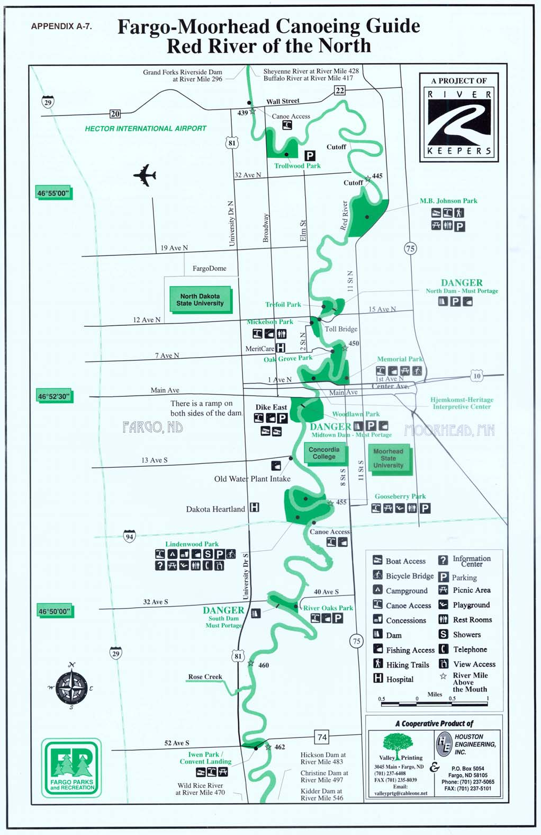
This is a description log of items that a canoeist/boater would encounter while on the water. A similar log could be developed for the remainder of the river and used for trip planning and navigation.
APPENDIX A-8. RED RIVER LOG, HEADWATERS TO GEORGETOWN
River Mile | Description
548.7 | Headwaters | In Breckenridge1 (pop. 3559), Headwaters Park, 100 Nebraska Ave. (concrete boat ramp, asphalt parking, picnic shelter, pier fishing, historic monument, Friendship sculpture), Welles Memorial Park (overnight camping, historic cabin, picnic shelter, ADA bathroom), confluence of the Bois de Sioux and Otter Tail Rivers. Otter Tail is navigable by canoe for about 160 miles, limited overnight camping. Bois de Sioux is the border between North Dakota and Minnesota to the south. Historic Red River Chateau w/ADA restroom, one room schoolhouse est. 1918, 30-acre Welles Memorial Park and Fairgrounds, arboretum, 3 Rivers Performance Stage, sculptures
548.6 | Overflow | Otter Tail River overflows into the Red River at high flows.
547.7 |  | Pedestrian bridge (0718072), Chahinkapa Zoo (701-642-8709); 85-acre Chahinkapa Park (701-642-2811), (campground w/hookups, picnic shelters)
546.6 | Kidder Rec. Area | 26 acres on north edge of Wahpeton (pop. 8,751) (701-642-8744) www.wahpchamber.com, www.wahpeton.com, campground (hookups, bathrooms, fish cleaning station), stairway access to Kidder Dam (retrofitted w/rocks), canoe portage under construction on MN side, world’s largest catfish, garden plots, arboretum, concrete boat ramp on ND side downstream of dam w/dock for boat launching and fishing. From this point to approx. Brushvale ramp (546.3) rock hazards during low water.
546 | Hwy 210 bridge (P6120028) | Emergency access only. Concrete drain inlet on ND side, with tower in background
 |  | Private fish camp

APPENDIX A-8. RED RIVER LOG, HEADWATERS TO GEORGETOWN (cont.)
River Mile Description
542 Concrete drain on ND side, American Crystal Sugar plant to the west
542.5 MN side owned by City of Comstock, Potential rest stop Low hanging highline wires, with tower on MN side
541.2 Rocky bottom, large gray farm elevator on the MN side
538.8 Gr. Northern RR bridge Large concrete drain on ND side ProGold water intake on the ND side, with ProGold plant to the west Large concrete drain w/stone riprap
536.3 Wilkin Co. #18 bridge (P6120046)(Richland Co. #8); boat ramp, N of bridge. On ND side, primitive camping allowed adjacent to the ramp, Lloyd McKibben park on MN side (private but open to public w/picnic table)
Wind generator visible on MN side. 524 McCauleyville historical monument 1/4 mile west
523.65 Wilkin Co. #22 bridge (0718083)(Richland Co. #28), emergency access only
523.2 Abercrombie concrete boat ramp (under construction in 2002), historic Fort Abercrombie (est. 1858, free and open year around, admission charge for seasonal museum 701-553-8513), public campground (no hookups, fires in designated areas, beverage vending, pit toilets), short walk to city of Abercrombie w/groceries and telephone.
APPENDIX A-8. RED RIVER LOG, HEADWATERS TO GEORGETOWN (cont.)
River Mile Description
521.85 Whiskey Creek enters from MN side.
514.9 Wilkin Co. #28 bridge (0718095)(Richland Co. #4), limited canoe access in road right-of-way, parking.
503.4 Wolverton, potential canoe access and primitive campground, pump station visible on MN side, no retail services in Wolverton, no public telephone. City of Wolverton campground ½ mile east (w/hookups, bathroom) Fees: $10/night; $150/month, Phone: 218-995-2526 Services: Four campsites with water, sewer, electricity, picnic table at each campsite, tents ok, no showers or restrooms (restrooms available at nearby ball diamond), picnic tables and shelter.
502.1 Wilkin Co. #30 bridge (0718102)(Richland Co. #2), road right-of-way access.
496.5 Christine Dam, seasonal buoys and warning signs may be in place, rugged portage on MN side on private property (Fargo-Moorhead Water Task force has recommended a study)
494.85 Wilkin Co. #190, 120th St. bridge (bridge is gone) Canoe access site (P8190002)
485.1 Clay Co. #2 bridge (0718110)(Cass Co., #18), rugged access through road right-of-way
482.7 Hickson Dam/Fargo #3, seasonal buoys and warning signs may be in place, rugged portage on either side, adjacent to Oxbow Country Club (clubhouse open to the public) and Hickson w/limited services (Fargo-Moorhead Water Task force has recommended a study)
476.7 Wolverton Creek enters from MN side
474.1 Clay Co. #8 bridge (0719114), ROW on MN side, SE; Rustad, MN is 2 miles east (Cass Co. #16)
APPENDIX A-8. RED RIVER LOG, HEADWATERS TO GEORGETOWN (cont.)
River Mile Description
472.3 Rest stop, canoe access, ND side
470.2 Wild Rice River (0719120) enters from North Dakota, Cass County is establishing greenway along the Wild Rice River. Public use regulations are not yet developed.
467.0 Forrest River Estates, CAMP SITE and canoe access under development (River Keepers, ND Game & Fish, Cass Co.)
462.05 Clay Co. #74 bridge (0719131), City of Fargo (pop. 74,111) on the N. Dakota side for the next 22 river miles 52nd Ave. S., Fargo
462.0 Ivan Park/Convent Landing & I-29, concrete ramp on ND side, parking, new in 1998, chemical toilet, owned by Fargo Park District, open until 10:00 p.m., seasonal
460.65 Rose Creek (0719132) enters on ND side, 15-acre Lions Conservancy Park, shore fishing, no services on site, in Fargo City limits
458.1 Fargo South Dam (Fargo Dam #2) (0719133) River Oaks Park on MN side, Lemke Park on ND side (day use only) Emergency ramp on ND side downstream, no public access Planned for winter 2002/2003 retrofit Owner: City of Fargo, built in 1933 Portage under development on Fargo side (w/City of Fargo and US ACE)
455.4 I-94 bridge (P6050011), road access on the MN side under bridge
APPENDIX A-8. RED RIVER LOG, HEADWATERS TO GEORGETOWN (cont.)
River Mile Description
455 Lindenwood Park (P6050015), Full service, owned by Fargo Park District
Fees: campsite $20/day; tent $10/day; limit 14 nights/month
Hours: 24/7, May 1 through Oct. 15
Phone/Web: 701-232-3987, 701-241-1350, www.fargoparks.com
Services: Multi-use park with five picnic shelters, six softball diamonds, a baseball diamond, landscaped campground, two tot
playgrounds, restrooms, six sand volleyball courts, 45 campsites with water and electricity, 12 tent sites without water.
Several carry-in sites at Lindenwood Park:
1 – Adajcent to campground (P6050018)
2 – Canoe access site w/parking (P6050019)
3 – Pedestrian bridge abutment (P6050024)
4 – South of pedestrian bridge (P6050026)
454.2 Pedestrian bridge (P6050023), portage on ND side Bridge is between Lindenwood Park on the Fargo side and Gooseberry Park (51.5 acres, shelters, rest rooms, picnic tables) on the Moorhead side
Large storm drain on MN side (P6050030) 452 Boat ramp (P6050038), Fargo Mid-town dam/upstream, 20' w X 60' long concrete, ramp on ND side, new in 2000, paved parking 452 Floating ped. Bridge (Seasonal) (P6050036), portage on ND side
452.2 Fargo Mid-Town Dam (P8200014), portage on ND side at boat ramp, paved, parking 10’h, 120' wide, Rebuilt w/boulders in 2000, owned by City of Fargo, first built in 1961for water supply
451.8 Boat ramp, downstream of Fargo Mid-town dam, concrete ramp on ND side, paved parking Concrete drain on MN side
451.7 Main Ave. (Fargo-Moorhead) bridge (P8140151), scheduled for replacement in 2003
APPENDIX A-8. RED RIVER LOG, HEADWATERS TO GEORGETOWN (cont.)
River Mile | Description
451.6 | NP RR bridge
451.5 | Center Ave. (Moorhead) (P8140155)
 | (NP Ave., Fargo)
 | Emergency boat ramp on MN side
 | Swivel bridge base, a large round concrete structure left over from the riverboat era
451.4 | 1st Ave N (Fargo-Moorhead) bridge (P8140163), SS Ruby dock w/ADA on MN side
451.3 | Minnesota’s largest peach leaf willow tree
 | RR bridge, with limestone base protected with wood planking
 | Several river overlooks on the MN side, connected to bicycle trail
 | Rock bank stabilization project on the MN side, done in 2001
 | Red Bear Bar and Grill’s river overlook
450.45 | Oak Grove Park pedestrian bridge (P8140177)
449.05 | Private toll bridge connecting 15th Ave. N. (Moorhead) and 12th Ave. N. (Fargo) (P8140182), Carry-in access on ND side at
 | Mickelson Field, off-road parking

448.9 Fargo North Dam (P8130121). Elevation 869', access and portage good when dry on MN side 7.7’ high, 108’ wide, rebuilt w/boulders in 2002, built in 1933 for water supply. Trefoil Park on ND side, paved parking.
APPENDIX A-8. RED RIVER LOG, HEADWATERS TO GEORGETOWN (cont.)
River Mile | Description
 | Emergency boat ramp on ND side
 | Bank stabilization project on the ND side
 | El Zagel monument
 | VA Hospital on ND side
 | Demolition concrete weir from the ND side, potential hazard
 | River splits during high water due to manmade cutoff, stay to the right
445.7 | Boat access, MB Johnson Park (106 acres) on MN side, twin concrete ramps, paved parking, picnic tables, chemical toilet, owned
 | by City of Moorhead, open 7 am to 10 pm
445 | Downstream “outlet” of cutoff
 | River splits during high water due to manmade cutoff, stay to right
440 | Bridge connecting Clay Co. #1 and N. Broadway (Fargo) (P8130013)
 | Trollwood Park
 | Bank stabilization project
439.15 | Bridge connecting Clay Co. # 22/Wall St. Ave. and Cass Co. 20 (P8130015), egress downstream on MN side, C-store, 0.5 east,
 | bridge scheduled for 2004 replacement

Bridge connecting Clay Co. # 26 bridge and Cass Co. #22 (P1010009), egress in ROW on ND side, Harwood, ND, is 3 miles west
APPENDIX A-8. RED RIVER LOG, HEADWATERS TO GEORGETOWN (cont.)
River Mile | Description
427.5 | Sheyenne River enters from the ND side, navigable upstream for several miles, access at private landing (Dennis Flom, 701-4849395, www.catchbigcats.com, lodging available
417.1 | Buffalo River enters from the MN side
415.9 | Bridge connecting Clay Co. # 36 and Cass Co. #34 (P1010011), egress in ROW, Georgetown, MN, is 1.5 mi. SE, historic site known as Rupert’s Landing.
 | End of 133-mile tour from Breckenridge.

APPENDIX A-9. 42 PHOTO BASE MAPS WITH ANNOTATIONS
APPENDIX A-9. 42 PHOTO BASE MAPS WITH ANNOTATIONS

Landmarks are from USGS 1:24,000 Geographic Names Database. They were not confirmed with site visits.
River miles (RM) were extrapolated using U.S. Army Corps of Engineers data.
www.mvp-wc.usace.army.mil/RRN/landmarks
Errors in USACE data were incorporated resulting in some duplicate RMs – sheets 22, 24, 31, 38, and 42.
GPS readings were taken with a hand-held “consumer” instrument. These instruments are reported to be accurate to 30-100 feet.
APPENDIX A-10. CD W/42 PHOTO BASE MAPS, MASTER PLAN, AND PICTURES REFERENCED IN APPENDICES
䠀漀洀攀漀眀渀攀爀愀渀搀栀椀猀搀漀挀欀
吀栀攀ᰠ匀⸀匀⸀刀甀戀礀ᴠ⠀甀猀攀搀昀漀爀琀漀甀爀椀猀琀爀椀搀攀猀漀渀琀栀攀刀攀搀刀椀瘀攀爀⤀Ⰰ搀漀挀欀攀搀椀渀䴀漀漀爀栀攀愀搀
䌀愀洀瀀椀渀最漀渀琀栀攀刀攀搀愀琀䘀愀爀最漀ᤠ猀䰀椀渀搀攀渀眀漀漀搀倀愀爀欀
刀漀挀欀猀愀爀攀洀漀爀攀攀砀瀀漀猀攀搀搀甀爀椀渀最氀漀眀昀氀漀眀猀
唀猀椀渀最戀漀愀琀爀愀洀瀀渀漀爀琀栀漀昀䴀椀搀琀漀眀渀䐀愀洀⠀䘀愀爀最漀⤀
䰀氀漀礀搀ᤠ猀倀愀爀欀Ⰰ䈀爀甀猀栀瘀愀氀攀ጠ琀栀攀漀渀氀礀瀀爀椀瘀愀琀攀瀀愀爀欀漀渀琀栀攀刀攀搀漀瀀攀渀琀漀瀀甀戀氀椀挀
倀攀搀攀猀琀爀椀愀渀戀爀椀搀最攀戀攀琀眀攀攀渀䈀爀攀挀欀攀渀爀椀搀最攀愀渀搀圀愀栀瀀攀琀漀渀愀琀刀椀瘀攀爀䴀椀氀攀㔀㐀㜀⸀㔀
䰀漀最樀愀洀

