RED RIVER HABITATS
Grade Level: MN: 3rd
ND: 3rd

Time Required: 30 minutes

MN Standards: 3.1.1.2.1
3.1.1.2.3
3.4.1.1.2

Fargo Standards: 3.2.3
3.2.3.a
3.4.3.a
3.4.3.b

RECOMMENDED LOCATION
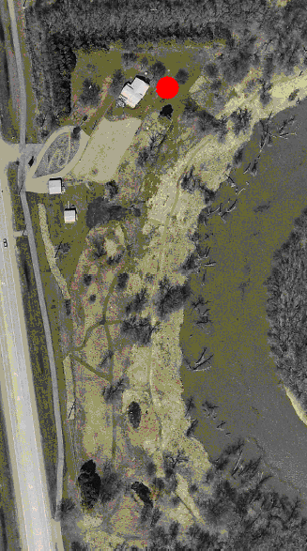

OBJECTIVES
- Students will learn the different habitat types present along the Red River.
- Students will name attributes of each habitat type.
- Students will learn what types of animals live in each habitat type.

METHOD
Students will explore the Living Lab to find as many different habitat types as they can, make observations about them, and look for any wildlife present.

BACKGROUND
The landscape of the Red River Watershed provides a variety of habitats for wildlife. For instance, wetlands are a summer home for ducks and geese, uplands provide a home to birds and white-tailed deer, and riparian areas house many types of frogs and turtles. There are eight main habitat types in the Red River Watershed, and they are uplands, lowlands/riparian areas, deciduous forests, coniferous forests, prairies, wetlands, lakes, and shelterbelts. These habitats provide an array of options for animals to live in, depending on the size of the animals, whether they need trees around, whether they live in water, etc. This lesson introduces students to the different habitat types present locally.

MATERIALS
- Paper and pencils for each student.

PROCEDURE
- Ask students what habitat types are present in the Red River Watershed. The complete list should include:
  - Upland: higher elevations away from the river and wetlands
  - Lowland/riparian: borders the river and streams; contains thick vegetation.
  - Deciduous forest: trees that lose their leaves in the fall every year.
  - Coniferous forest: evergreen forest.
  - Prairie and agricultural areas: open lands and farm fields that support many species of wildlife.
  - Wetlands: shallow ponds and marshes surrounded by cattails and rushes.
  - Lakes: permanent bodies of fresh water.
  - Shelterbelts: trees planted in rows to reduce wind erosion.
- Give each student (or pair or students) paper and pencil, and tell them they have 15 minutes, or however long the teacher deems appropriate, to explore the Living Lab and find as many of these habitat types as they can. When they find a habitat type, they should write down where they found it, its main attributes, and what types of animals they think may live there.
- Have students gather back together. The teacher should name off each habitat type one-by-one, asking students to raise their hands if they found the habitat type just named. The only habitat type NOT present at the Living Lab is lakes, so students should not report finding these.
- After the teacher names a habitat type and the students raise their hands if they found it, ask what students observed as the main characteristics, and what animals they think may live there. After students give their input, the teacher should give a short list of animals that live in that habitat type.
- When you get to the lake habitat, tell the students where they might find a lake and a few animals that live there.
- Discuss that animals choose their habitat type based on their specific needs for food, water, and shelter. For instance, squirrels often choose forests because they can easily find acorns and other nuts and seeds. Frogs often choose riparian areas or wetlands because they live both on land and in water.

EVALUATION
Give each student four small sheets of paper, or one large sheet of paper split into four parts. Have them illustrate four of the eight habitat types, including the main attributes of the habitat and at least one animal that lives in that habitat type.

