DEER IN A HABITAT
Grade Level: MN: 3rd / 5th
ND: 3rd / 4th / 5th

Time Required: 45 minutes

MN Standards: 3.1.1.2.3
5.1.3.4.1
5.4.2.1.1

Fargo Standards: 3.1.2
3.2.3
3.4.3
4.1.3
4.4.3
4.7.1
5.1.2
5.4.2.b
5.4.3.a

RECOMMENDED LOCATION
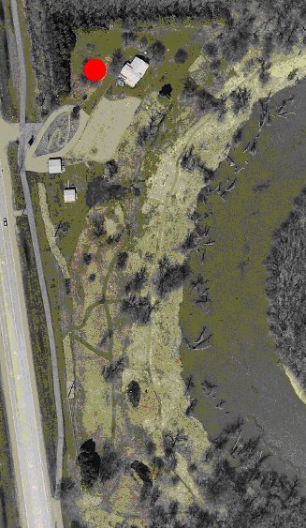

OBJECTIVES
- Students will identify food, water, and shelter as three essential components of a habitat.
- Students will understand the importance of good habitat for animals.
- Students will recognize that fluctuations in wildlife populations are natural.

METHOD
Students act as deer and attempt to search out food, water, and shelter within their habitat through an active game.

BACKGROUND
A variety of factors affects the ability of wildlife to successfully reproduce and to maintain their population over time. Limiting factors serve to prevent wildlife populations from reproducing in numbers greater than their habitat can support. However, an excess of such limiting factors leads to endangering entire species. The main limiting factors (and the main requirements of all species) are food, water, and shelter. Without a combination of these things, no animal can survive. This activity teaches students that a shortage or surplus of food, water, or shelter can cause an entire population to fluctuate. As a result, populations of animals do not stay at a static number, but rather change from year to year.

MATERIALS
- Large playing field
- Whiteboard or large piece of paper to graph population fluctuations

PROCEDURE
- Tell the students that food, water, and shelter are the most critical components of any habitat.
- Split the students into four groups. Mark two parallel lines on the floor 10 to 20 yards apart. Have one group of students stand behind one line, and have the remaining three groups stand behind the other line.
- Tell the one group of students behind the first line that they are deer. When a deer is looking for food, it should clamp its hands over its stomach. When it is looking for water, it puts its hands over its mouth. When it is looking for shelter, it holds its hands together over its head. A deer can choose to look for any one of its needs during each round. However, the deer cannot change what it is looking for during a round.
- Tell the three groups behind the second line that they are either food, water, or shelter. Each student gets to choose at the beginning of each round which component he or she will be during that round. The students will depict which component they are in the same way the deer show what they are looking for; that is, hands on stomach for food, etc.
- The activity begins with all players lined up on their respective lines and with their backs to the students at the other line.
- The teacher asks the students to make their signs – each deer deciding what it is looking for, each habitat component deciding what it is. Give the students a few moments to get their hands in place either over their stomachs, mouths, or heads.
- When the students are ready, count “ONE, TWO, THREE!” At the count of three, each deer and each habitat component turns to face the opposite group, continuing to hold their signs clearly.
- When deer see the habitat component they need, they are to run to it. Each deer must hold the sign of what it is looking for until getting to the habitat component person with the same sign. Each deer that reaches its necessary habitat component takes the “food,” “water,” or “shelter” back to the deer side of the line. This is to represent the deer’s successfully meeting its needs and successfully reproducing as a result.
- Any deer that fails to find its food, water, or shelter dies and becomes part of the habitat. That is, in the next round, the deer that died is a habitat component and is so available as food, water, or shelter to the deer that are still alive.
- The teacher should keep track of how many deer there are at the beginning of the activity, and at the end of each round the teacher should record the number of deer as well. This is to keep track of the population fluctuations.
- Continue the game for 10 to 15 rounds. At the end of all the rounds, gather the students together to discuss the activity. Encourage them to talk about what they experienced and saw. For example, they saw a small herd of deer begin by finding more than enough of its habitat needs. The population of deer then expanded until the habitat was depleted. At that point, many deer died.
- Using a whiteboard or large sheet of paper, post the data recorded during the activity, with the X-axis representing the round and the Y-axis representing how many deer were present at the beginning of each round.
- The students should notice that the deer population fluctuated over the different rounds. This is representative of what happens in real life. Fluctuation is natural as long as the limiting factors do not become excessive. Wildlife populations tend to peak, decline, and rebuild as long as there is good habitat and enough animals to successfully reproduce.
- In discussion, summarize that animals need food, water, and shelter. These three components can all act as limiting factors to keep a population within a healthy range.

EVALUATION
Have students name the three essential components of habitat. Have them describe how different amounts of each of these three components affect wildlife populations.

