DEADLY LINKS
Grade Level: MN: 5th
ND: 4th / 5th

Time Required: 40 minutes

MN Standards: 5.4.2.1.1
5.4.2.1.2
5.4.4.1.1

Fargo Standards: 4.7.1
5.4.2
5.4.2.c
5.4.3.a

RECOMMENDED LOCATION
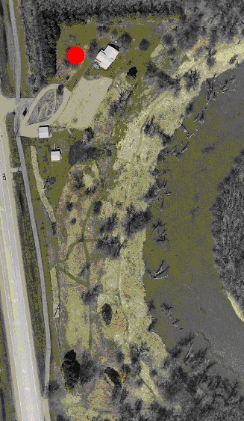

OBJECTIVES
- Students will learn how a food web works
- Students will understand how energy flows through an ecosystem
- Students will learn how pollutants and humans can impact entire ecosystems.

METHOD
Students will play an active game demonstrating how a food web works and then gather for discussion questions.

BACKGROUND
A food web is a model that shows all the possible feeding relationships between organisms living in an ecosystem. A food web is more complex and accurate than a food chain, because most organisms depend on more than one species for food. In a food web, plants are the producers since they can harvest energy directly from the sun. Many different herbivores and omnivores depend on these plants for their energy. In turn, carnivores eat the various herbivores and omnivores to attain their energy. Consequently, energy flows from the sun through the different types of plants and animals which are all interconnected in the food web. Pollution can also enter a food web in many different ways. For instance, a plant could be sprayed with pesticides, which would enter the system of any herbivores that ate it, and it would ultimately end up in the carnivore that ate the herbivore. It is therefore impossible to isolate pollution within a food web, since it spreads quickly to all organisms involved.

MATERIALS
- At least 10 soda bottle caps or milk jug caps or lima beans per student participating, half of which should be marked with a large X.
- Jerseys or bandanas or some other marker to distinguish between the three different groups.

PROCEDURE
- Describe what a food web is and how food webs help energy flow through a system. Explain the different energy requirements of organisms in the food web. For example, carnivores, herbivores, and plants all have different energy requirements.
- Introduce terms such as plant (an organism that photosynthesizes to create its own food using energy from the sun), herbivore (an organism that consumes plants as its energy source), carnivore (an organism that consumes other animals as its energy source), and omnivore (an organism that consumes both plants and animals as its energy source).
- Scatter the soda caps, lima beans, or whatever material you’ve chosen to use around the playing space. For the first round of the game, no attention should be paid to the Xs that are on half of the caps.
- Assign half of the class to be plants (i.e. cattails, reeds, algae). Two thirds of the remaining students will be herbivores (i.e. muskrats, ducks, insects). The rest will be carnivores (i.e. fox, coyote, crayfish). So if there are 24 students, then there will be 12 plants, 8 herbivores, and 4 carnivores.
- Explain to the students that each soda cap (or lima bean, etc.) represents energy from the sun that plants can collect in order to grow. Only plants are able to use this energy directly, so they are the only ones who can pick the soda caps up off the ground.
- Allow the plants to run around collecting energy for 45 seconds, and then release the herbivores into the ecosystem. The herbivores can tag the plants in order to “eat” them. When a plant is tagged, it surrenders all of its soda caps to the herbivore that tagged it. The plant can then continue collecting soda caps from the ground. The herbivores try to collect as many soda caps in this manner as possible.
- After the herbivores have been in the ecosystem for about a minute, release the carnivores into the ecosystem as well. The carnivores can only tag the herbivores. When a carnivore tags an herbivore, the herbivore surrenders its soda caps to the carnivore. After being tagged, the herbivore can then continue to collect energy by tagging plants. Since the carnivores will be collecting many soda caps, they can stockpile them outside the ecosystem.
- Stop the game at this point and gather the students for a few discussion questions:
  - Who has the most soda caps? (carnivores) Why?
  - How did the energy from the sun flow through the ecosystem?
- After the discussion questions, repeat the game. Switch the students who were plants with the students who were herbivores and carnivores. Mention to the students that this time there are two different types of soda caps in the ecosystem, one with an X and one without. Encourage them to collect both kinds.
- At the end of the game, gather the students for discussion:
- Who has a soda cap with a black X in their hands right now? Who had a soda cap with a black X at any point during the game?
- Explain to the students that the soda caps with a black X represent pollution in the ecosystem and that anyone who has one or had one at any point is diseased.
- Discuss where pollution comes from, how it flows through the ecosystem, and how it biomagnifies (concentrates in the top predator, or carnivore).
- Review how energy flows from the sun to each member of a food web. Review the role of plants, herbivores, and carnivores. Review how pollution makes its way through the entire food web.

- HELPFUL HINTS FOR GAME PLAY:
  - Right before each group enters the ecosystem, review with them who they are allowed to tag, who is allowed to tag them, and that they should continue to collect soda caps after they are tagged.
  - Feel free to take some of the stockpiled soda caps and toss them back into the ecosystem, or keep some caps in reserve before beginning the game to toss in. This ensures extended game play.

EVALUATION
Since this is a game and the discussion questions should help the students absorb the information adequately, no immediate assessment is required. An option would be to give the students a quiz on the material learned once you’ve returned to the classroom.

