ANTENNA EYES
Grade Level: MN: 3rd
ND: 3rd / 4th

Time Required: 30 minutes

MN Standards: 3.1.1.2.1
3.1.3.4.1
3.4.1.1.1

Fargo Standards: 3.4.1
4.4.2
4.4.3

RECOMMENDED LOCATION
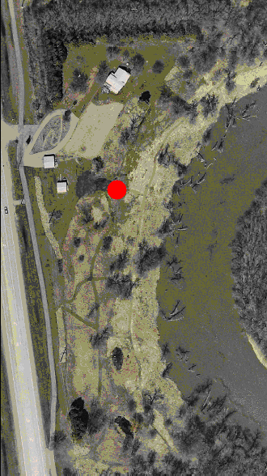

OBJECTIVES
- Students will understand the function of an antenna.
- Students will understand that an antenna acts as an ant’s hands, eyes, and nose.

METHOD
Students will learn how insects differ from humans through an interactive game where students are blindfolded and can only use their hands to touch and see.

BACKGROUND
Like all insects, ants have three body parts: the head, the thorax, and the abdomen. They also have six legs. However, perhaps their most important body part is their antenna. When ants meet, they communicate by touching each other’s antennae. Ants cannot see well, so they use their antennae as a touch organ to find out where they are going. The antennae also serve as an organ for smelling.

MATERIALS
- One blindfold for every group of two students.
- Either a photo of an ant or a real ant for students to examine.
- Optional: magnifying glasses for the students if they are examining a real ant.

PROCEDURE
- Teach students that ants are a type of insect. Like all insects, ants have three body sections and six legs. Tell them that the three sections are the head, the thorax, and the abdomen.
- Show a picture of an ant or have students observe some real ants on the ground. See if they can identify all three body sections, and if they can count six legs.
- Tell students that ants cannot see well. Ask them, “how would you know where you were going if you couldn’t see?”
- Have students break up into groups of two. Blindfold one student in each group. Have the non-blindfolded student choose a nearby location and explain to the blindfolded student where it is.
- The blindfolded student must then find its way to the location. The student will most likely put his/her hands out to feel their way to the location.
- Have students switch roles.
- Gather for discussion. Ask students what they learned, and explain that ants use their antennae in the same way the blindfolded students were using their hands to “see” where they were going.
- Discuss other types of animals that use this same method. For instance, otters can’t see well and use their whiskers in the same way as ants use their antennae.
- Review the body parts of an ant: 3 body sections, 6 legs, and antennae.

EVALUATION
Have each student draw a picture of an ant. Tell them that their drawings should include all the important body parts that they learned in the lesson. Each student’s drawing should include the three body sections, six legs, and antennae.

