
American Cranberrybush
(Viburnum trilobum)

Native Riparian Plants Series

The American Cranberrybush is a medium to large shrub that produces edible fruit and has excellent fall color. Round-topped and dense, this shrub enjoys well-drained sites with better-than-average moisture. Plant the shrub in partial shade to full sun and watch for visiting birds.

Crown height: 8-12 ft.; crown width: 8-12 ft.

Practical uses:
- Use as a windbreak or to stabilize riverbanks.
- Bird watching: fruit is eaten by a variety of birds.
- Use the fruit to make jam or jelly.

Buds: Greenish-red and smooth, less than ¼-inch diameter

Leaves: Tri-lobed, smooth, 2-5 inches long, 2-3 inches wide
Color: medium to dark green
Autumn color: yellow to reddish purple

Flowers White, soft, berry-like, 1/3-inch long

Fruit: Bright to scarlet red

Diseases and pests: Dogwood borers

For more information:
River Keepers
325 7th St. S. Ste 2A
Fargo, ND 58103-1846
(701) 235-2895
info@riverkeepers.org
www.riverkeepers.org

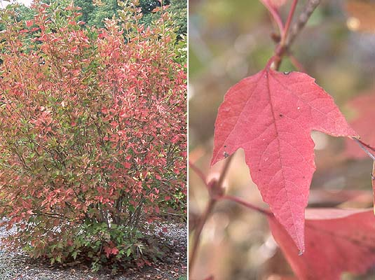
Cranberrybush shrub and leaf in autumn

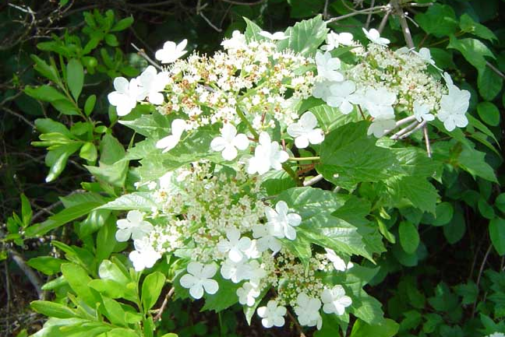
Cranberrybush flower

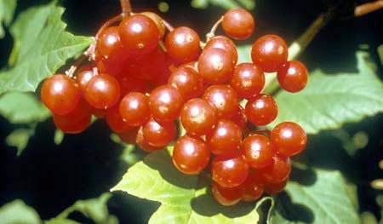
Cranberrybush fruit

September 27, 2006

